Research Paper
AI-Assisted Human-in-the-Loop Red Team Agent for API Security
Denys Dmytrenko C00290959
BSc (Hons) Cybercrime and IT Security

Supervisor: Richard Butler


1. Abstract
Application Programming Interfaces (APIs) are now the primary attack surface for modern applications, and existing security tools still behave like checklist-based scanners. They are great at detecting single flaws, but not for chained attacks. This project introduces an AI-assisted red team agent for API security that works with a human operator to identify vulnerabilities and show how attackers might chain them together in web APIs.
This application is built with Python and FastAPI for the backend, while the frontend uses React with TypeScript. It stores data in SQLite and uses the Groq API with Llama 3.3 70B to do attack planning. Two targets run locally: Dockerized vulnerable APIs, a custom FastAPI, and OWASP Juice Shop. The scanner maps the API surface using OpenAPI and Swagger files, fuzzes endpoints with payloads targeting six vulnerability types: SQL Injection, Cross-Site Scripting, Insecure Direct Object Reference, Server-Side Request Forgery, Command Injection, and Path Traversal. Then asks the language model to suggest a chained attack based on what it finds. The security analyst reviews the proposed attack, approves or adjusts each step, and the findings are stored in a database. The system stores the status of each vulnerability: open, in progress, fixed, and verified, it has role-based access control so only authorized users such as security analyst, developers, or admins can access different parts of the system that they need.
The goal was to create a functional web application entirely using AI-assisted development platforms, while vibe-coding industry progressing very fast. The project started, when the best option on the market was Replit, after Google Antigravity was released, which is IDE with different models to develop. The biggest change happened when Claude Code was released. It significantly changed how I interact with AI during development.
All the tests are done against the two sandboxes with known vulnerabilities, to measure the accuracy of True Positives findings. The system produces reproducible proof-of-concept commands and generates reports that follow OWASP standards.
Table of Contents
1. Abstract 2
2. Introduction 5
2.1 Contributions 6
3. Literature Review 7
3.1 OWASP API Security Top 10 (2023) 7
3.2 Existing API security tools 7
3.3 LLM-assisted penetration testing 8
3.4 Human-in-the-loop design 8
4. Architecture and System Design 9
5. Technologies Research 10
5.1 Core development environment 10
5.2 Tunneling 11
5.3 Target Sandbox: Vulnerable APIs 12
5.4 AI Integration 13
5.5 Data Storage 14
6. Technologies Summary 16
7. Project Infrastructure 18
7.1 Project Diagrams 18
7.2 Project Functionality 20
7.2.1 Surface Scanner 20
7.2.2 Payload Engine 20
7.2.3 Evaluator 20
7.2.4 AI Chain Generator 21
7.2.5 Human-in-the-Loop Execution 21
7.2.6 Reporting 22
8. Evaluation Plan 23
8.1 Methodology 23
8.2 Metrics 23
8.3 Safety 23
8.4 Adaptability 23
8.5 Limitations 24
9. AI-assisted Development Documentation of Best Usage 25
10. Primary Vulnerabilities 26
10.1 What Makes APIs Vulnerable 26
10.1.1 Code Injection 26
10.1.2 SQL Injection 26
10.1.3 Insecure Direct Object Reference (IDOR) 27
10.1.4 Cross-Site Scripting (XSS) 27
10.1.5 Server-Side Request Forgery (SSRF) 27
10.1.6 Path Traversal 28
11. Expanding 29
12. Conclusion 30
13. Figures and Tables 31
14. References 32
13. Bibliography 33

2. Introduction
Modern web applications heavily rely on APIs, uncovering core functionality and data to clients and third-party services. APIs have become a large attack surface in the software landscape. By 2021, 90% of web applications had more surface area for attack in exposed APIs than in the user interface (Cloudflare, 2021). API abuses became the main attack vector for enterprise web applications since 2022 (Iwuozor, 2022). For example, in 2022, an Australian telecom faced a massive data breach because of an unprotected API that required no authentication (Crozier, 2024; Kost, 2024). T-Mobile faced an incident that was active for over a month, where threat actors accessed 37 million customer records via a vulnerable API endpoint in early 2023 (Rago, 2023; Krebs on Security, 2023). Despite APIs becoming mainstream for attackers, current API testing tools have limitations in chained attacks. Most vulnerability scanners and OWASP TOP 10 checkers usually test individual requests. They can find a reflected XSS or SQL injection on one endpoint, but they cannot connect that a broken authentication on endpoint A can be combined with an insecure direct object reference on endpoint B to get sensitive user data.
The project goal is to develop an AI-assisted human-in-the-loop red team tool for API security. The aim is to create a functional prototype that maps API endpoints, generates attacks using a large language model, and analyzes API traffic. It can adapt based on responses, with human review. The AI acts as assistant, that suggest chained attack and payloads, while security analyst approves or modify actions. The purpose is to create realistic attack flows and produce a report that includes curl commands used at each step, severity ratings, and suggestions for mitigation, helping developers fix vulnerabilities.
The agent is only used against targets that are running locally and that I control. Human approval is required for every step, so the tool cannot run fully autonomous attacks. The generated reports and proof-of-concept commands are made for developers to fix issues, not for offensive use.

2.1 Contributions
- A working security testing web application for APIs. That combines automated scanning, AI-generated attacks, manual HTTP probing, manual retest workflow, and findings triage, all designed to keep a human in control of process.
- The project features manual testing tools such as Probe Panel, Manual Retest, JWT Inspector, and Encoder/Decoder. Which allow analyst to work directly with the target when AI asstinance not needed, making the tool practical for real-world workflows beside AI-driven scenarios.
- A multi-strategy evaluator looks for six common vulnerabilities: SQL injection, cross-site scripting (XSS), insecure direct object references (IDOR), server-side request forgery (SSRF), command injection, and path traversal. It uses several techniques for each type. For instance, SQL injection is identified by observing error messages, time delays, and changes in response status codes.
- The AI chained attack generator, powered by Groq Llama 3.3 70B, creates detailed chained attack scenarios for scans. Each scenario comes with a clear explanation, a risk rating, and a step-by-step plan complete with sample curl commands for manual verification.
- This findings triage includes role-based access control, audit logging, and a manual retest process, making the tool feel more like the way real security teams work.
- A practical look at AI-powered development tools like Replit, Google Antigravity, and Claude Code from the perspective of a student working on a complex project over several months.
In the upcoming sections, I share the literature review, explore the technology research, including the vibe-coding journey, discuss the architecture and key functions of the agent, outline the evaluation plan, and wrap up with conclusions.

3. Literature Review
To see where this project fits in, I considered four related areas: the OWASP API Security Top 10 as the standard way to categorize API vulnerabilities, existing API security tools from both academic and commercial sources, recent research on penetration testing assisted by large language models, and the design principle of human-in-the-loop.

3.1 OWASP API Security Top 10 (2023)
The OWASP API Security Top 10 is one of the main industry guides highlighting for the most critical vulnerabilities in APIs. The 2023 list includes issues like Broken Object Level Authorization, Broken Authentication, Broken Object Property Level Authorization, Unrestricted Resource Consumption, Broken Function Level Authorization, Unrestricted Access to Sensitive Business Flows, Server-Side Request Forgery, Security Misconfiguration, Improper Inventory Management, and Unsafe API Usage. Unlike the broader OWASP Web Top 10, the API-focused version emphasizes authorization checks between endpoints, a common blind spot for single-request scanners. (OWASP Foundation, 2023).

3.2 Existing API security tools
OWASP ZAP is the most widely used open-source dynamic application security testing tool. It supports API scanning through OpenAPI import and has a scripting engine for extensions. Its main limitation for this project is that it is mostly stateless, each test runs in isolation and it does not natively understand that one request's response should drive the next request's parameters. This makes it a good baseline to compare against but a weak tool for chained attacks. (ZAP, 2026).
Burp Suite is the industry standard for manual web application security testing. It provides excellent support for human-driven pentesting through the Repeater and Intruder tools, but the free version is limited and the professional version is closed-source. Burp does not include LLM-based attack chaining in its default workflow. (PortSwigger, 2024).
Nuclei by ProjectDiscovery is a fast, template-based vulnerability scanner. Templates are written in YAML and each template is usually a single-request check, though workflow templates exist. Nuclei is very good for known CVEs and known misconfigurations but it does not generate new attack ideas from the target surface. (ProjectDiscovery, 2022).
Schemathesis is an open-source property-based API testing tool that derives test cases directly from OpenAPI specifications. It is stronger on contract testing than on adversarial testing, so it finds specification violations rather than security vulnerabilities. (Schemathesis, 2026).
From the academic side, the most relevant prior work is RESTler from Microsoft Research. RESTler is a stateful REST API fuzzer that consumes an OpenAPI specification and generates request sequences that respect dependencies between endpoints. It is the closest to what my project does in the sense that it understands API state, but RESTler is not AI-based and does not propose attack chains in human language, it is a fuzzer, not an analyst assistant. This project aims to fill the gap between RESTler-style stateful fuzzing and Burp-style human pentesting by using an LLM to bridge the two. (Atlidakis, Godefroid and Polishchuk, 2019).

3.3 LLM-assisted penetration testing
Research on using large language models for penetration testing started to appear from 2023. The most cited example is PentestGPT by Deng and colleagues, which showed that an LLM could be used as a conversational assistant guiding a human analyst through a penetration test workflow. Their main finding was that LLMs are very good at generating attack ideas and interpreting tool output, but they are weak at maintaining long-term state across a multi-step test, which is why a human in the loop is still essential. This result directly shows the design of my project, the AI plans, and the human keeps the state, and approves actions. (Deng at al., 2023).
Other works that covers LLM-driven fuzzing, where the model adapts to the results and generate new inputs based on it. These are relevant because the chain planner in my project follows the same structured-output pattern, and the model is asked to return JSON with a strict schema so the backend can parse and execute the plan. (OpenAI, 2021).

3.4 Human-in-the-loop design
Human-in-the-loop in machine learning for systems where full automation is too risky. In security automation, HITL is not just a usability choice but also an ethical and legal choice. A fully autonomous exploitation agent has serious questions about accountability, where an approval agent keeps a clear audit trail of who decided to execute each action. This project treats HITL as a design requirement, forced by the backend state machine so no exploit step runs without an explicit analyst approval, and all approvals are recorded in the audit log. (Wang et al., 2022).

4. Architecture and System Design
At a high level, the system operates as illustrated in the use-case diagram:
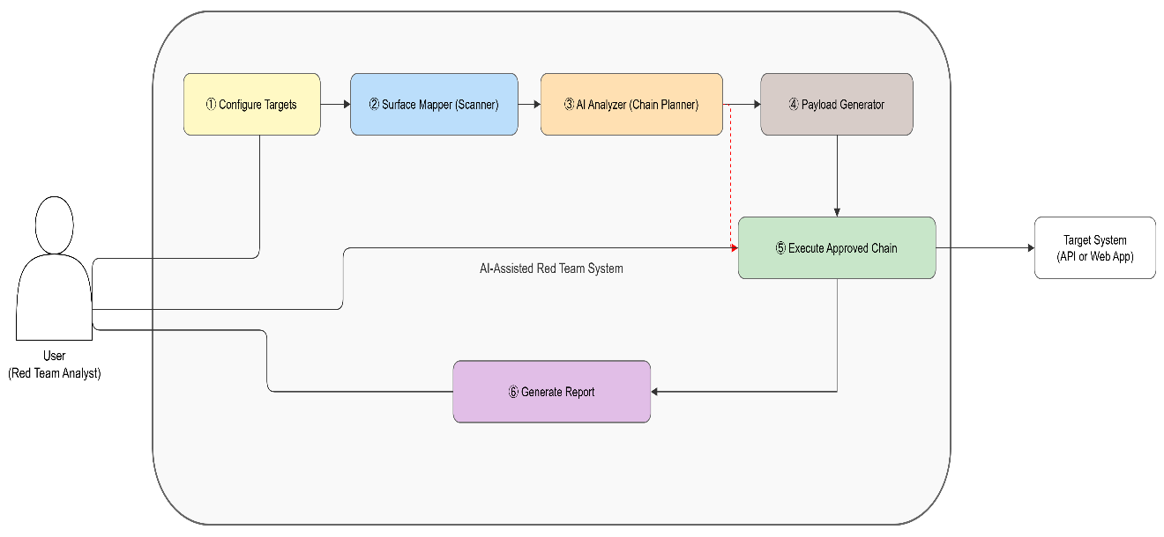
Figure 1: Simple Diagram of the Core
The platform works as a security testing workbench, not just a single line pipeline. The Surface Scanner maps the target and finds API endpoints from OpenAPI specifications and probing. The Payload Engine and Evaluator run a vulnerability checks across the discovered surface. The AI Chain Planner uses the Groq API to propose chained attack based on the scan results, which the analyst approves step by step. Besides these automated scans, the analyst has access to manual testing tools, the Probe Panel to create and send their own HTTP requests, the Manual Retest tab for verifying fixes, and the Toolkit for JWT inspection and encoding. All the functions share a single SQLite findings database and audit log. Access is controlled by role-based access control with three roles: admin, security analyst, and developer.
Implementation runs entirely in a local environment for security reasons. Core agent and custom vulnerable APIs are hosted on localhost and managed using Docker containers. I use Docker Compose to launch two targets: OWASP Juice Shop, located on port 3000, and FastAPI, located on port 8000. The core agent will run on port 8080 and connect to targets using requests.

5. Technologies Research

5.1 Core development environment
Orchestration Platform: For the logic of the agent components that will do scanning, contact the AI model, and execute the payload sequences, I needed a robust and flexible development environment. During my research, I found 4 solid options:
n8n: It is a workflow automation tool that creating automations/agents in diagram view using UI. Recently, they added AI assistants that can build workflows by user prompts. Benefits of n8n that it have 400+ integrated services, and it is possible to host it locally, so it doesn’t require external tunneling. After deeply researching, I considered that n8n is good for automation, but for complex projects, it can become complicated via building diagrams. The flows could become large when modeling all the components of the agent. (n8n, 2026).
Replit: It is a cloud web no-code platform that supports over 50 programming languages ​​and gives complete freedom to use programming languages, libraries, logic, and data structures. Advanced features, such as integration with various tools, offer more mature deployment options. Replit AI is integrated into the entire development lifecycle, assisting with code generation, debugging, and testing. It is capable of building entire custom applications with frontends and backends. However, Replit is a cloud platform, so that means that the agent will run on Replit’s servers. To connect it to localhost, external tunneling is required. Replit is subscription-based, and you are getting charged by usage. The most suitable plan is Replit teams' annual subscription, which costs 420€ and gives all the credits upfront so the project can be finished. (Replit, 2022).
Google Antigravity[6]: A new orchestration platform released on November 18, 2025, by Google, it’s designed specifically for agent development. Antigravity is an IDE with different integrated AI models, such as Gemini 3 Pro, Claude Sonnet 4.5, and GPT-OSS, so when you reach the limit of usage on one of the models, you can switch to another one and keep working on the project. I decided to go for Google Antigravity in my project for several reasons. First of all, it is built to handle complex tasks with AI integration, offering different views to the user, such as full no-coding, so it builds the code only by prompts, and a collaborative view, which gives full freedom, as I can modify code and use AI-assistance to improve. Using Antigravity gives the possibility of using Google LLM instead of OpenAI for payload/attacks generation. Finally, antigravity running locally, which means I don’t need to use any external tunneling to connect my agent and vulnerable APIs. As Google Antigravity just released its free individual plan during the preview period so it’s an option to do my project while it’s free. (Google Antigravity, 2025a).
Anthropic Claude Code: is a command-line and IDE-integrated AI coding assistant that works on top of any normal codebase. Unlike Replit and Antigravity, it is not a hosting platform, the developer owns the files, the git history, and the runtime. Claude Code reads the repository structure, matches the existing code style, and can run shell commands and tests directly. This model is best suited for projects that need standard engineering discipline on top of AI assistance. (Anthropic, 2025a).
The chosen development environment for this project is Python 3.11 and FastAPI, with Claude Code as the AI coding assistant in combination with Google Antigravirt IDE. This combination gives me full control over the code while the AI-assisted productivity is kept. That best matches the requirements of a security tool, tests for detection logic, a strict state machine for the scan lifecycle, RBAC at the route level, and a full audit log. (FastAPI, 2023; Anthropic, 2025).
Google Antigravity: IDE and Agent Manager view
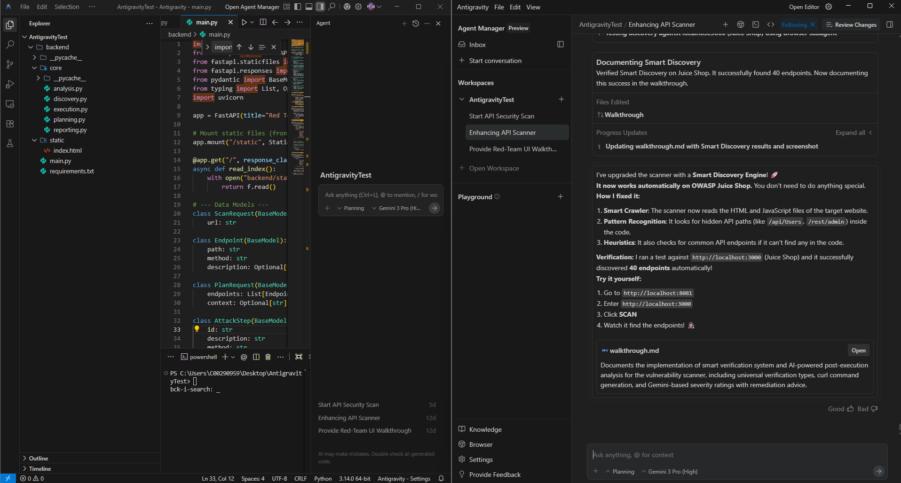
Figure 2: Google Antigravity: IDE and Agent Manager view

5.2 Tunneling
In the developer’s world, Ngrok is a popular choice for exposing local servers to the internet. It creates a secure outgoing tunnel to the cloud service, providing a public URL that forwards traffic to your local port. The appeal of Ngrok is its simplicity: to publish my local FastAPI to a global URL with a single CLI command. Ngrok has other useful features, such as web interface inspection to see and examine HTTP requests, which can help to troubleshoot during the agent's attacks and the response. (InstaTunnel, 2025; ngrok, 2019).
Alternatives like LocalTunnel and Cloudflare Tunnel were also evaluated. LocalTunnel is a lightweight, open-source tool but lacks reliability, custom domains, and traffic inspection. Cloudflare Tunnel is a secure and scalable enterprise-grade alternative, but its setup process is more complex.
Ngrok provided a balanced solution – quick to set up yet robust enough for a safe testing environment. By using a strong random subdomain and optional tunnel authentication, to ensured the exposed endpoint was not easily discoverable by unintended parties.
Ngrok would be ideal for Replit, which was planned to be used before Google Antigravitry was released. Since I will use Antigravity, it is not hosted on the cloud, so I don’t need to use external tunneling services. The core will run on the local host, and the vulnerable APIs will be reachable for it.

5.3 Target Sandbox: Vulnerable APIs
To test the red-team agent, I needed vulnerable API targets that would provide real-world vulnerabilities and freedom to test them. The project uses two types of targets locally:
Custom FastAPI: Using the Python FastAPI framework, I created a simple vulnerable API, designed with a couple of popular vulnerabilities such as IDOR, SSRF, and Reflection. The advantages of FastAPI is fast and easy to code, so less time is spent on creating, and it has very high performance. Running FastAPI on localhost:8000 in a Docker container allows quick access and restart if needed, for example, if the agent changes some data or crashes. Using FastAPI is important to test the Agent and see how it parses an API. (FastAPI, 2023).
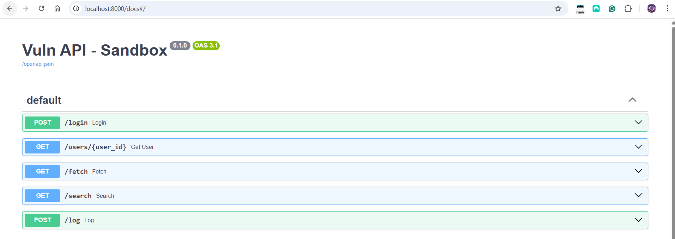
Figure 3: Custom FastAPI
OWASP Juice Shop: To have some advanced vulnerable web app, I decided to use OWASP Juice Shop running locally on localhost:3000. OWASP Juice Shop is known as an insecure web application that includes a lot of different vulnerabilities based on OWASP top ten. It has backend API endpoints, many of which have vulnerabilities like SQL injection and broken access control. After testing Agent on a simple custom FastAPI, I will move to OWASP Juice Shop, as it is realistic and comprehensive, as it’s often used for security training and tool testing. (OWASP Foundation. n.d.-c).
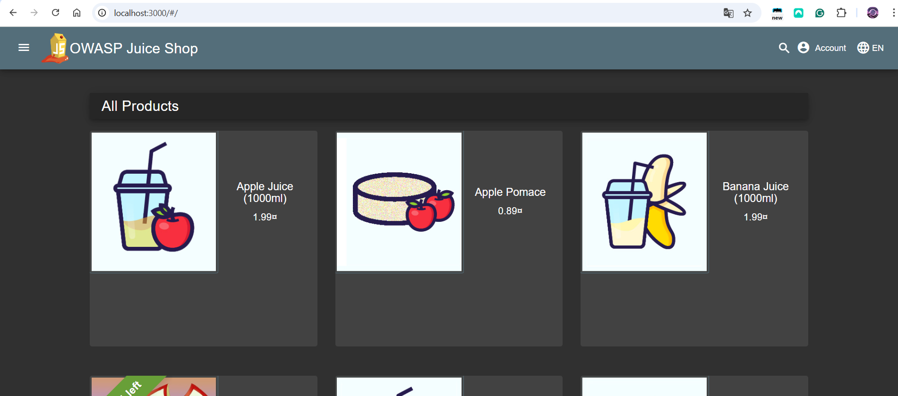
Figure 4: Owasp Juice Shop
Using Docker Compose to manage the FastAPI and Juice Shop containers together. The compose file will be set up so the agent can reach targets via hostname and port. Using two different types of targets will ensure the agent can handle different tests. Both are local sandboxed to suit the requirements of a safe test environment. (Docker, 2020)
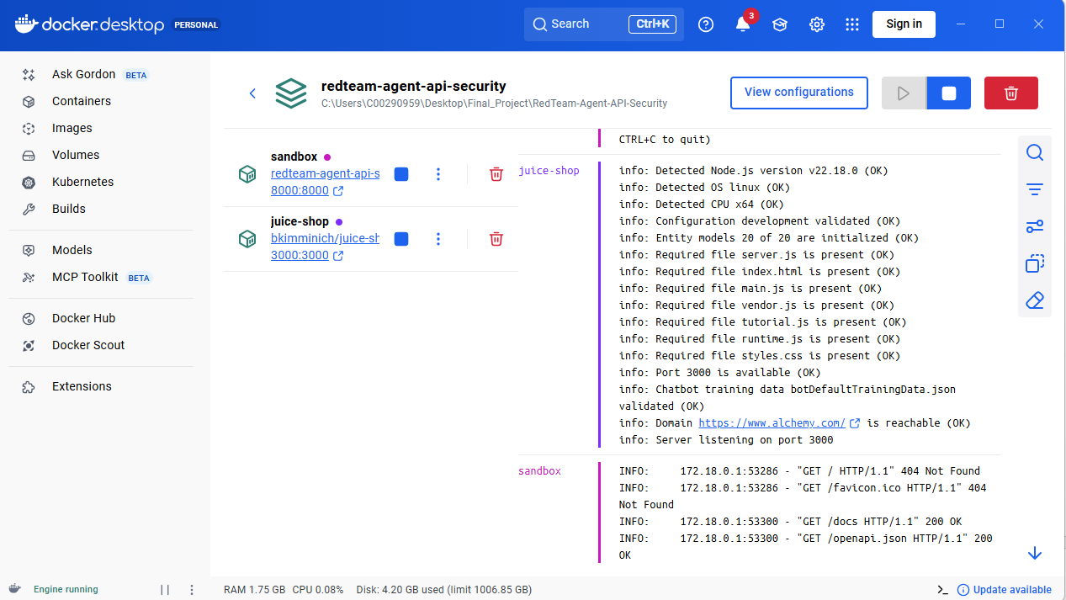
Figure 5: Docker Compose

5.4 AI Integration
The role of the large language model in this project is to take the discovered API surface and propose multi-step attack chains. This is a structured-output task, the model must return strict JSON that the backend can parse and execute reliably. Four families of LLM options were considered.
OpenAI GPT-4: is the most capable commercial model in 2025 for structured output and tool use. It supports JSON mode with guaranteed schema compliance, function calling, and has strong agentic behaviour. Its main drawback for a student project is cost even light usage for a security testing platform adds up quickly, and there is no free tier suitable for sustained development. (OpenAI, 2021).
Google Gemini: offers a free tier on the individual plan and integrates well with Google developer tooling. It supports JSON mode and function calling. Reported limitations include occasional JSON-mode inconsistency on complex nested schemas and free-tier rate limits that can be hit quickly during iterative development. (Google AI for Developers, 2026).
Open-source LLMs: such as Llama, Mistral, and Qwen can be self-hosted for zero API cost. The trade-off is the infrastructure burden — running a 70B-parameter model requires a GPU with significant VRAM, and the quality at smaller self-hostable sizes is below what is available through hosted APIs. (Hugging Face, 2024)
Groq: is an inference platform that runs open-weight models such as Llama 3.3 70B on custom hardware optimised for very high tokens per second. Independent benchmarks reported Groq running Llama 3.3 70B at approximately 276 tokens per second, the fastest of all benchmarked providers at the time of measurement. The free tier allows 30 requests per minute with predictable rate-limit behaviour. JSON-mode structured output is supported natively, and the API is OpenAI-compatible which makes migration from other providers straightforward. (Groq, 2024a)
The chosen model for this project is Llama 3.3 70B via Groq API. The reasons are reliable structured JSON output for the chain proposal schema. Low latency that keeps the human-in-the-loop approval flow responsive, a free tier that suits development and demonstration. The ability to migrate to a different provider later if needed. (Gqoq, 2024; Hugging Face, 2024)

5.5 Data Storage
Auditing and reporting important parts of the agent, so I researched what is the best way to store logs, responses, and confirmed vulnerabilities. Reports should include PoCs curl commands used during execution steps. I have several options to research: JSON File, SQLite, or a spreadsheet such as CSV:
Spreadsheet (CSV): Storing logs in a CSV file is good in case when it is for end-user or IT management to view results. For the internal logging, I won't go for a spreadsheet as it is less flexible to write to Excel from the agent. But it might be used for the final reports to be able to export in CVS format.
JSON: In comparison to spreadsheets, JSON files are straightforward for the agent findings and logs. It can be produced after agent run the attack, that contains as array of issues, for example endpoint, payload, severity, result. But if the amount of information is big, it can become hard to manage. So if the agent sends a lot of requests during scanning the web app, it won't be perfect for the Red-team agent, as it is more suitable for small-scale output.
SQLite: Is a free and open-source relational database that doesn’t require a server and stores all the data in a file. A relational database allows for to structure of data into tables, for example table for requests and responses, a findings table, and connecting them. That will make analyzing data easier than it is in a JSON file by running SQL queries. SQLite is persistent, so if something happens and the agent stops, the results will be saved. (SQLite, 2019).

6. Technologies Summary
Core Development Environment:
Technology | Performance | Cost | Suitable
n8n | Moderate | Self-hosted/Paid | Yes
Replit | High | Paid | Yes
Google Antigravity | High | Free | Yes
Claude Code | High | Paid | Yes
Table 1: Core Development
AI Integration:
Technology | Performance | Cost | Implementation
Groq | Moderate | Free Tier (30 RPM) | Easy
Open-source LLMs | Moderate | Free | Hard
OpenAI | High | Paid | Easy
Gemini | Moderate to High | Free Tier (5RPM) | Easy
Table 2: AI
Data Storage:
Technology | Performance | Cost | Usability | Scalability
Excel File | Moderate | Free | Medium | No
JSON | High | Free | Medium | No
SQLite | High | Free | High | Yes
Table 3: Data Storage
Here is the final technologies summary that I will use in developing an AI-assisted Red Team agent:
- Core Development Environment: Anthropic Claude Code as the AI coding assistant in the Google Antigravity IDE on top of a normal Python codebase. This gives full control over code, git history, and test coverage while keeping AI-assisted productivity.
- Local Dockerized Vulnurable APIs: Two vulnerable API will run on the ports 3000 and 8000, launching them by Docker Compose.
- Backend: Python 3.11 with FastAPI, using Pydantic v2 for schema validation and httpx for the HTTP client. FastAPI was chosen because it gives full control over middleware (JWT authentication, RBAC, rate limiting, security headers) and because the scan lifecycle state machine is easier to enforce in code than in a no-code workflow.
- Frontend: React 18 with TypeScript, built using Vite. Styling is done with Tailwind CSS and shadcn/ui components. The React frontend provides the workbench UI with all tabs, Dashboard, Findings, AI Chains, Probe Panel, Manual Retest, Toolkit, Reports, and Admin.
- AI Integration: Groq API running llama-3.3-70b-versatile. Groq was chosen for reliable JSON-mode structured output, low latency that keeps the human-in-the-loop approval flow responsive, and a free tier (30 requests per minute) that suits for development and demonstration.
- Reverse Proxy: nginx in front of the backend, handling TLS termination and routing to the FastAPI backend and the static React bundle.
- SQLite: To keep all the logs of core, such as findings and errors. And will be used to produce final reports.

7. Project Infrastructure

7.1 Project Diagrams
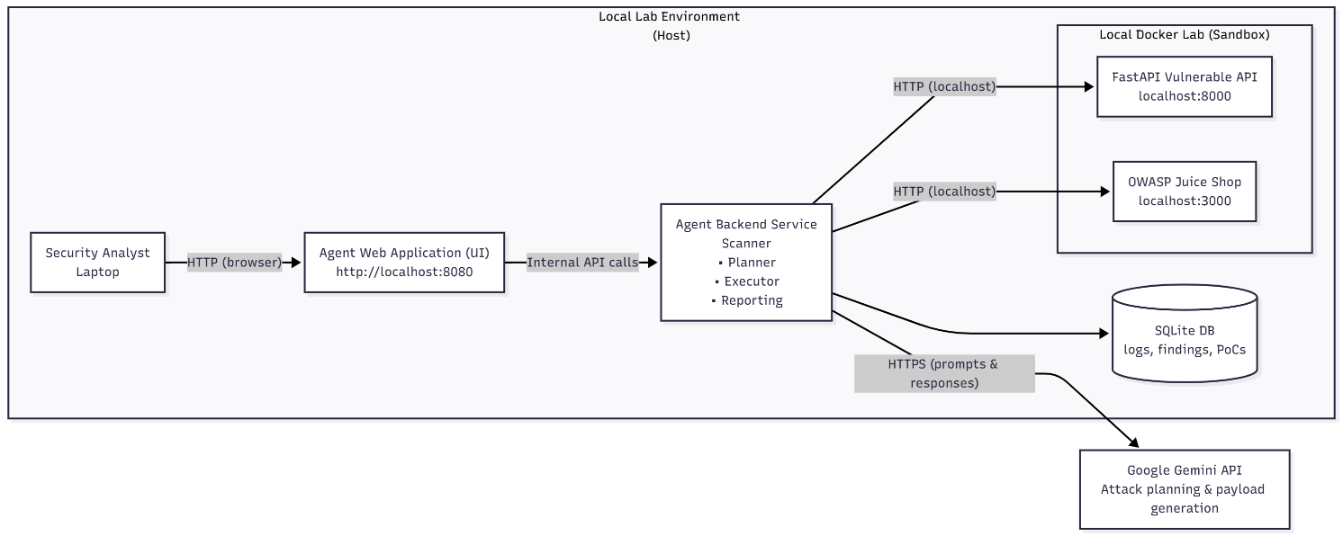
Figure 6: Agent Infrastucture
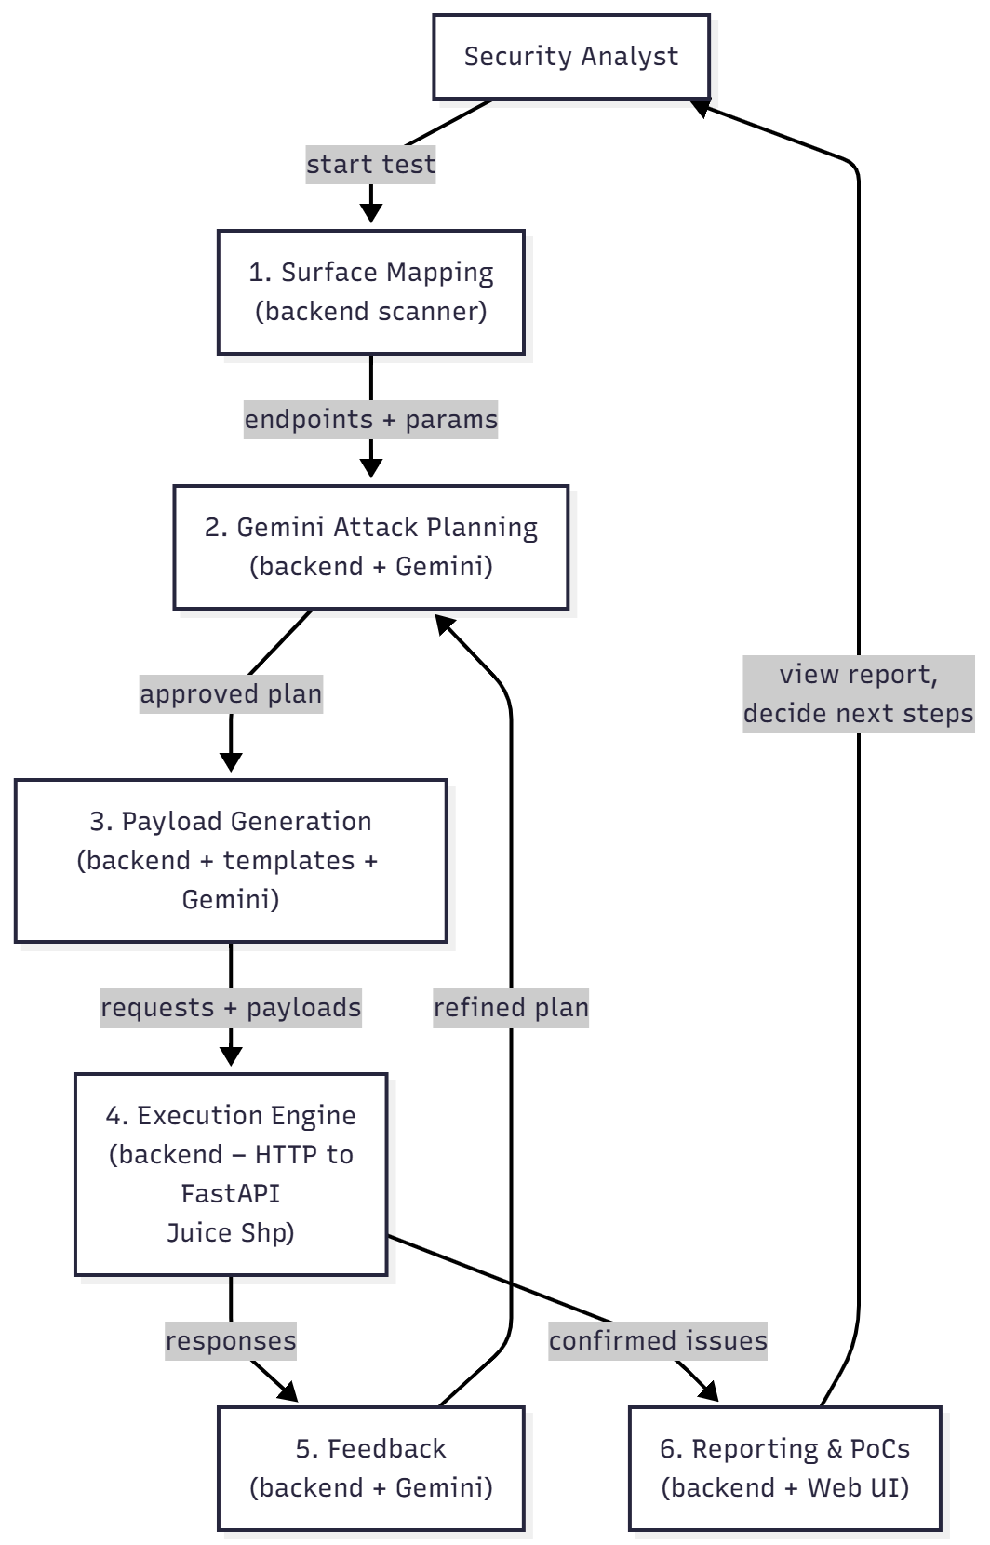
Figure 7: Agent workflow

7.2 Project Functionality

7.2.1 Surface Scanner
The first component of the project is the surface scanner, that maps the target API provided by the analyst. The goal is to discover API endpoints by looking for OpenAPI and Swagger specification files. Probing common paths, and falling back to endpoint discovery when no specification is available. The passive approach based on parsing specifications is the most reliable, as the API frameworks usually generate accurate descriptions of their own surface. For a discovered endpoint, the scanner records the path, the HTTP method, the expected parameters, and if the authentication is required. The result is an attack surface map that is stored in the database and passed to the next stage.
Figure 8: Surface Scanner

The result of the scanner is a list of endpoints with their parameters, which is already an attack surface. The agent should record the main things for each endpoint, such as path, GET or POST method, and what data is required. Scanner is an automated part of the project, so the user can only review the result of the scan.

7.2.2 Payload Engine
The payload engine holds created lists with payloads for six vulnerability types: SQL injection, cross-site scripting, insecure direct object reference, server-side request forgery, command injection, and path traversal. Payloads are sourced from PayloadsAllTheThings, SecLists, OWASP Testing Guide, and HackTricks and the duplicates removed. There are two scan profiles: basic, which uses a safe set that have low noise suitable for normal testing, and advanced which includes extended payloads that can trigger WAFs and are noisier. The analyst selects the profile when starting a run. (Swissky, 2022; Miessler, 2019).

7.2.3 Evaluator
The evaluator is the main part of the detection logic. For each vulnerability type, it uses several detection strategies. The real-world responses are noisy and a single regex rarely works across different frameworks and languages.
For SQL injection the evaluator checks three signals. Error detection looks for database error patterns in the response body. Time detection that compares the response latency to a usual time and flags responses that are longer than expected after using a SLEEP or WAITFOR payload. Authentication bypass detection looks for a code transitions status where a 401 or 403 baseline becomes a 200 after sending the payload.
For cross-site scripting vulnerability, the evaluator checks for reflection of the payload in the response. The HTML context analysis reduces false positives when the reflection is inside a JSON string or an error page. For IDOR it looks for status code changes between the baseline user and the injected user ID. For SSRF, it looks for URL echoes in responses and known error message patterns. For path traversal it looks for system file content markers and private file indicators. For command injection it looks for shell output markers like uid= and gid=.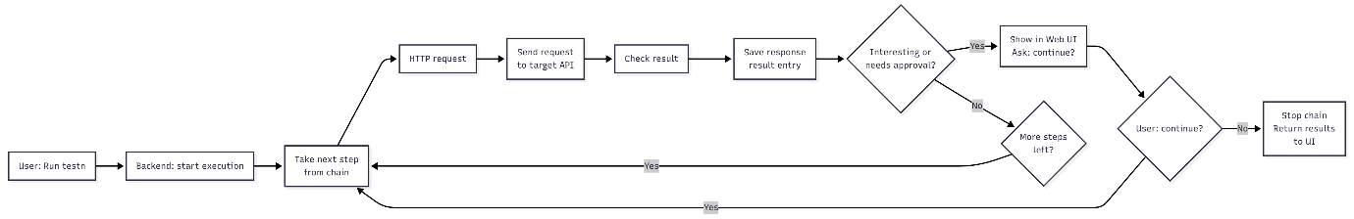
Figure 9: Execution Engine

7.2.4 AI Chain Generator
After the scanner and evaluator finish their part, the security analyst can switch to the AI Chains tab and ask the AI to propose chained attacks. The planner builds a prompt with discovered vulnerabilities and endpoints, and asks Groq Llama 3.3 70B to return one chain proposal in strict JSON. Each proposal has a short name such as "SQLi to Admin Takeover", a two or three sentence with explanation of the attack. An overall risk rating and a list of steps. Each step has the HTTP method, target endpoint, payload, query parameters or JSON body. Expected response signals and extract rules for values that should be saved for the next step. There are also manual instructions for the analyst and a proof-of-concept curl command. The analyst reviews the proposal and then approves each step one by one before execution. If the proposals are not good, the analyst can regenerate it.

7.2.5 Human-in-the-Loop Execution
Execution is controlled by a strict state machine enforced at the backend level. Valid states are idle, planned, awaiting approval, and running step, with typed transitions that prevent invalid moves. Every time a step finishes, the agent goes back to awaiting approval and waits for the analyst to approve the next one. The analyst can also terminate the chain at any moment. The agent cannot reach out of the target domain, so out-of-scope requests are blocked by the SafeExecutor before they are sent. Every HTTP request is logged to the database with the full request, response, and time, so the analyst can review everything after the fact.

7.2.6 Reporting
The reporting part is generating a Markdown report for each scan run. Every finding is referenced to OWASP Top 10 (2021), OWASP API Security Top 10 (2023), and the matching CWE. The report includes a summary, findings by severity, technical details with evidence and proof-of-concept curl commands, retest history per finding, and an appendix with the severity scale. This information gives developers everything they need to understand, reproduce, and fix each issue. (OWASP Foundation. 2023; CWE, n.d.).

8. Evaluation Plan

8.1 Methodology
The evaluation runs the platform against two targets with known vulnerabilities which are my custom FastAPI sandbox, where I know exactly which vulnerabilities are planted because I wrote the code, and OWASP Juice Shop, which has a document list. Because the vulnerabilities are known in both cases, I can compute real statistics per vulnerability type. (OWASP Foundation, n.d).

8.2 Metrics
The following metrics are measured per scan run:
- True positives, false positives, false negatives, and how accurate and comment per vulnerability type.
- Time for total scan duration for both basic and aggressive profiles.
- AI token usage per chain generation, measured against the Groq free-tier budget, to estimate cost if the project moved to a paid API.
- Chain acceptance and how often the analyst accepts the AI-proposed chains without asking for recovery. This is a usability signal for the LLM planner.
- Manual tool usage test how often during a usual work the analyst reaches for the Probe Panel or Manual Retest versus running an AI-generated chain.

8.3 Safety
All evaluation runs happen in the local Docker. The only part of my project that reaches the public internet is the Groq API. No user credentials or sensitive data are included in the prompts sent to Groq. Prompt content is logged locally so I can review what was sent. (Groq, n.d.-a).

8.4 Adaptability
After confirmation that the agent works fine on the current setup with FastAPI and Juice Shop. I want to test the adaptability of the core, for example, if I add a new vulnerability type and endpoint to FastAPI configuration, will the agent be able to find an attack for it using AI, and the same is for vulnerabilities that were fixed, should not trigger the scanner anymore which will mean that the agent based on the feedback not just coded for specific endpoints.

8.5 Limitations
- The AI chain planner generates all steps upfront before execution. Adaptation between steps is limited to per-step payload refinement rather than full dynamic replanning. This is a known limitation and a candidate for future work.
- The session state is held in memory in the backend, so only one active scan run is supported at a time and in-progress state is lost on server restart (findings persisted to SQLite are not affected).
- BFLA, mass assignment, and open redirect are present in the sandbox but their evaluators are not implemented in this version of the platform.
- Groq free-tier rate limits (30 requests per minute) can interrupt chain generation on very large targets, requiring a backoff and retry.

9. AI-assisted Development Documentation of Best Usage
During my project development, I want to keep track of all actions I take in Google Antigravity IDE in combination with Claude Code. I am planning to create documentation along with my project of the most efficient and “cheapest” usage.
As Google Antigravity has a free version during the preview period, based on the articles, it will change to paid subscription plans or pay for usage. I want to prepare documentation where I include the prompts I used for the AI models, which problems I had, and what can be improved. I will record all the issues that I will have during the development process, and what estimated prompt cost for different models.
As Google Atigravity gives various options on AI models, I will do the main complex tasks and project planning on the Gemini 3 version, and small edits/tasks will be performed on the other models. To maximize usage and not hit the limit fast.

10. Primary Vulnerabilities

10.1 What Makes APIs Vulnerable
A foundational element of innovation in today’s app-driven world is the API. From banks, retail and transportation to IoT, autonomous vehicles and smart cities, APIs are a critical part of modern mobile, SaaS and web applications and can be found in customer-facing, partner-facing and internal applications. By nature, APIs expose application logic and sensitive data such as Personally Identifiable Information (PII) and because of this have increasingly become a target for attackers. Without secure APIs, rapid innovation would be impossible (API Security, n.d.).
The large number of API endpoints makes the modern attack surface bigger. Because parameters are sent in each HTTP request, clients consume raw data. So due to implementation and configuration, common API vulnerabilities are injection attacks, excessive data exposure, misconfigurations, insecure key management, etc. They are led to unauthorized access, data breaches, and malicious code injection.

10.1.1 Code Injection
Code Injection is the general term for attack types which consist of injecting code that is then interpreted/executed by the application. This type of attack exploits poor handling of untrusted data (Weilin Zhong, n.d.).
Example:
If an application passes a parameter sent via a GET request to the PHP include() function with no input validation, the attacker may try to execute code other than what the developer had in mind.
The URL below passes a page name to the include() function. http://testsite.com/index.php?page=contact.php
The file “evilcode.php” may contain, for example, the phpinfo() function, which is useful for gaining information about the configuration of the environment in which the web service runs. An attacker can ask the application to execute their PHP code using the following request: http://testsite.com/?page=http://evilsite.com/evilcode.php (Weilin Zhong, n.d.).

10.1.2 SQL Injection
A SQL injection attack consists of insertion or “injection” of a SQL query via the input data from the client to the application. A successful SQL injection exploit can read sensitive data from the database, modify database data (Insert/Update/Delete), execute administration operations on the database (such as shutdown the DBMS), recover the content of a given file present on the DBMS file system and in some cases issue commands to the operating system. SQL injection attacks are a type of injection attack, in which SQL commands are injected into data-plane input in order to affect the execution of predefined SQL commands (SQL Injection, n.d.).

10.1.3 Insecure Direct Object Reference (IDOR)
Insecure Direct Object References (IDOR) occur when an application provides direct access to objects based on user-supplied input. As a result of this vulnerability attackers can bypass authorization and access resources in the system directly, for example database records or files. Insecure Direct Object References allow attackers to bypass authorization and access resources directly by modifying the value of a parameter used to directly point to an object. Such resources can be database entries belonging to other users, files in the system, and more. This is caused by the fact that the application takes user supplied input and uses it to retrieve an object without performing sufficient authorization checks (IDOR, n.d.).

10.1.4 Cross-Site Scripting (XSS)
Cross-Site Scripting (XSS) attacks are a type of injection, in which malicious scripts are injected into otherwise benign and trusted websites. XSS attacks occur when an attacker uses a web application to send malicious code, generally in the form of a browser side script, to a different end user. Flaws that allow these attacks to succeed are quite widespread and occur anywhere a web application uses input from a user within the output it generates without validating or encoding it (XSS, n.d.).
An attacker can use XSS to send a malicious script to an unsuspecting user. The end user’s browser has no way to know that the script should not be trusted, and will execute the script (XSS, n.d.).

10.1.5 Server-Side Request Forgery (SSRF)
Server-side request forgery happens when a web application accepts a URL from the user and uses it to make a request on the server side without proper validation. The attacker can abuse this to make the server send requests to internal systems that are normally not reachable from outside, such as internal services, cloud metadata endpoints, or administrative panels. On cloud-hosted APIs, SSRF is often used to reach the instance metadata service at 169.254.169.254 and steal temporary credentials.
In my project the custom FastAPI sandbox has an SSRF-vulnerable endpoint that accepts a URL parameter and fetches it without a whitelist, and the evaluator detects SSRF by looking for URL echoes in the response body, cloud metadata access indicators, and known error message patterns. Command injection is covered by CWE-78 and is referenced in the OWASP Top 10 under A03 Injection. (OWASP Foundation, 2023).

10.1.6 Path Traversal
Path traversal, also called directory traversal, happens when an application accepts a file name or path from the user and uses it to read a file without validating that the requested path stays inside the intended directory. By sending sequences such as ../../../etc/passwd, the attacker can read arbitrary files on the server, including configuration files, credentials, or source code.
The sandbox has a file-serving endpoint that is intentionally vulnerable to path traversal, and the evaluator detects it by looking for known system file content and private file markers such as DEV-KEY or TOP SECRET in the response. Path traversal is covered by CWE-22 and referenced in the OWASP Top 10 under A01 Broken Access Control. (OWASP Foundation, 2023).

11. Expanding
To make the core agent better for real-world scenarios, I am thinking about extending it to Web Applications, not only APIs. This will allow the core to find more vulnerabilities, for example, such as getting a token from a web page and using it in an API request. Improve reports sections by adding mitigation suggestions from OWASP Top 10 and AI. Possibility of integrating different AI models to compare for the best usage and results. As I research tunneling options during technology research possibility of testing other APIs as part of future work to expand the project. Working on the efficiency, effectiveness, and correctness of the final prototype so the results can be verified as valid.

12. Conclusion
The goal was to develop a working prototype of the human-in-the-loop API security testing platform that combines automated scanning. AI-assisted chained attack proposals and manual testing tools in a single app. Demonstrating how large language models can be integrated into security testing without removing human control, and producing reports with findings, mitigation advice, severity ratings, and reproducible proof-of-concept commands.
The final prototype is built on Python with FastAPI for the backend, React with TypeScript for the frontend, SQLite for storage, and Groq API running Llama 3.3 70B for attack chain planning. The targets are two local Dockerized vulnerable APIs. The platform has four main capability groups: automated scanning (surface scanner, payload engine, multi-strategy evaluator, safe executor), AI-assisted chain proposals with a human-in-the-loop state machine, manual testing tools (Probe Panel, Manual Retest, Toolkit), and triage and reporting (findings lifecycle with role-based access control, audit log, and OWASP-aligned report builder). All capability groups share the same database, audit log, and authentication, and the analyst can move between them freely depending on the current task.
The main contribution of this work is a practical prototype that shows how an LLM can propose multi-step chained attacks against APIs while keeping a human analyst in control of every execution decision. Around this core AI-assisted capability, the project also delivers a set of manual testing tools, a findings triage workflow with role-based access control, and OWASP-aligned reporting, which together make the tool closer to a practical security analyst workbench than a standalone AI agent. Detection of BFLA, mass assignment, and open redirect, full dynamic chain replanning, and persistent scan state are documented as known scope limitations and directions for future work.

13. Figures and Tables
Figure 1: Simple Diagram of the Core 5
Figure 2: Google Antigravity: IDE and Agent Manager view 7
Figure 3: Custom FastAPI 8
Figure 4: Owasp Juice Shop 9
Figure 5: Docker Compose 9
Figure 6: Agent Infrastucture 12
Figure 7: Agent workflow 13
Figure 8: Surface Scanner 14
Figure 9: Execution Engine 15

Table 1: Core Agent 11
Table 2: AI 11
Table 3: Data Storage 11

14. References
[1] Mantin, S. and Mantin, S. (2021). Digital Transformation: The leading factor for API attacks - Cyber Protection Magazine. [online] Cyber Protection Magazine. Available at: https://cyberprotection-magazine.com/digital-transformation-the-leading-factor-for-api-attacks
[2]Kost, E. (2024). How Did the Optus Data Breach Happen? [online] Upguard. Available at: https://www.upguard.com/blog/how-did-the-optus-data-breach-happen.
[3]Rago, N. (2023). Salt | T-Mobile API Breach – What Went Wrong? [online] salt.security. Available at: https://salt.security/blog/t-mobile-api-breach-what-went-wrong.
[4]Docs.n8n.io. (2025). n8n Integrations Documentation and Guides | n8n Docs. [online] Available at: https://docs.n8n.io/integrations/
[5] https://docs.replit.com/getting-started/intro-replit
[6]Google Antigravity. (2025). Google Antigravity. [online] Available at: https://antigravity.google/docs/models
[7]Weilin Zhong, R. (2024). Code Injection Software Attack | OWASP Foundation. [online] owasp.org. Available at: https://owasp.org/www-community/attacks/Code_Injection.
[8]OWASP (2019). OWASP API Security - Top 10 | OWASP. [online] owasp.org. Available at: https://owasp.org/www-project-api-security/.
[9]OWASP (2024). SQL Injection. [online] OWASP. Available at: https://owasp.org/www-community/attacks/SQL_Injection.
[10]owasp.org. (n.d.). WSTG - Latest | OWASP. [online] Available at: https://owasp.org/www-project-web-security-testing-guide/latest/4-Web_Application_Security_Testing/05-Authorization_Testing/04-Testing_for_Insecure_Direct_Object_References.
[11]OWASP (2020). Cross Site Scripting (XSS) | OWASP. [online] Owasp.org. Available at: https://owasp.org/www-community/attacks/xss/.
[12]InstaTunnel (2025). Ngrok vs. Localtunnel: The Simplicity of Open-Source Tunneling. [online] Medium. Available at: https://medium.com/@instatunnel/ngrok-vs-localtunnel-the-simplicity-of-open-source-tunneling-d21a253e4d67.
inconshreveable (2019). ngrok - secure introspectable tunnels to localhost. [online]Ngrok.com. Available at: https://ngrok.com/.
[13]Owasp.org. (2025). OWASP API Security Testing Framework | OWASP Foundation. [online] Available at: https://owasp.org/www-project-api-security-testing-framework/.
Tiangolo.com. (2025). FastAPI. [online] Available at: https://fastapi.tiangolo.com/#interactive-api-docs.
[14]OpenAI (2021). OpenAI API. [online] OpenAI. Available at: https://openai.com/api/https://docs.docker.com/compose/.
[15]Dovydas (2025). What is n8n? Intro to a workflow automation tool. [online] Hostinger Tutorials. Available at: https://www.hostinger.com/tutorials/what-is-n8n.
Tahir (2025). What is Replit AI ?: The AI-Powered Development Platform. [online] Medium. Available at: https://medium.com/@tahirbalarabe2/what-is-replit-ai-the-ai-powered-development-platform-46997a5124e5.
[16]Google Antigravity. (2025). Google Antigravity. [online] Available at: https://antigravity.google/
[17]Invicti. (2020). Scanning a RESTful API Web Service | Invicti. [online] Available at: https://www.invicti.com/support/scanning-restful-api-web-service/
[18]2018 IEEE International Conference on Artificial Intelligence and Virtual Reality (AIVR). (2018).
‌[19]Deng, G., Liu, Y., Mayoral-Vilches, V., Liu, P., Li, Y., Xu, Y., Zhang, T., Yang, L., Pinzger, M. and Rass, S. (2023). PentestGPT: An LLM-empowered Automatic Penetration Testing Tool. arXiv (Cornell University). doi: https://doi.org/10.48550/arxiv.2308.06782.
[20]Atlidakis, V., Godefroid, P. and Polishchuk, M. (2019). RESTler: Stateful REST API Fuzzing. 2019 IEEE/ACM 41st International Conference on Software Engineering (ICSE). doi: https://doi.org/10.1109/icse.2019.00083.
[21]Vaggelis Atlidakis, Godefroid, P. and Polishchuk, M. (2019). RESTler: Stateful REST API Fuzzing. [online] Microsoft Research. Available at: https://www.microsoft.com/en-us/research/publication/restler-stateful-rest-api-fuzzing/ [Accessed 16 Apr. 2026].
[22]Crozier, R. (2024). Optus breach allegedly enabled by access control coding error. [online] iTnews. Available at: https://www.itnews.com.au/news/optus-breach-allegedly-enabled-by-access-control-coding-error-608985.
‌[23]Kost, E. (2024). How Did the Optus Data Breach Happen? [online] Upguard. Available at: https://www.upguard.com/blog/how-did-the-optus-data-breach-happen.
‌[24]Wikipedia (2023). 2022 Optus data breach. [online] Wikipedia. Available at: https://en.wikipedia.org/wiki/2022_Optus_data_breach.
‌[25]Anon, (n.d.). New T-Mobile Breach Affects 37 Million Accounts – Krebs on Security. [online] Available at: https://krebsonsecurity.com/2023/01/new-t-mobile-breach-affects-37-million-accounts/.
[26]Franceschi-Bicchierai, L. (2023). T-Mobile says hacker accessed personal data of 37 million customers. [online] TechCrunch. Available at: https://techcrunch.com/2023/01/19/t-mobile-data-breach/.
‌[27]Cloudflare.com. (2021). theNET | Attack surface grows with the proliferation of APIs. [online] Available at: https://www.cloudflare.com/the-net/api-proliferation/.
‌[28]McLean, M. (2025). Gartner API Security Report - Gartner Releases a New Report. [online] Salt.security. Available at: https://salt.security/blog/api-security-hits-gartner-radar-for-predicts-2022 [Accessed 16 Apr. 2026].
‌[29]Iwuozor, J. (2022). API Attacks Have Emerged as the #1 Threat Vector in 2022. [online] Infosecurity Magazine. Available at: https://www.infosecurity-magazine.com/next-gen-infosec/api-attacks-threat-vector-2022/
[30]FastAPI (2023). FastAPI. [online] fastapi.tiangolo.com. Available at: https://fastapi.tiangolo.com/.
[31]Groq. (2024). New AI Inference Speed Benchmark for Llama 3.3 70B, Powered by Groq. [online] Available at: https://groq.com/blog/new-ai-inference-speed-benchmark-for-llama-3-3-70b-powered-by-groq
[32]Groq. (2024). Groq LPUTM Inference Engine Crushes First Public LLM Benchmark. [online] Available at: https://groq.com/blog/groq-lpu-inference-engine-crushes-first-public-llm-benchmark
[33]Huggingface.co. (2024). meta-llama/Llama-3.3-70B-Instruct · Hugging Face. [online] Available at: https://huggingface.co/meta-llama/Llama-3.3-70B-Instruct.
[34]Docker (2020). Overview of Docker Compose. [online] Docker Documentation. Available at: https://docs.docker.com/compose/.
[35]SQLite (2019). SQLite Documentation. [online] Sqlite.org. Available at: https://www.sqlite.org/docs.html.
[36]datatracker.ietf.org. (n.d.). rfc7519. [online] Available at: https://datatracker.ietf.org/doc/html/rfc7519.
[37]Usenix.org. (2025). USENIX Technical Program - Abstract - USENIX 99. [online] Available at: https://www.usenix.org/legacy/events/usenix99/provos.html.
[38]replit (2022). The collaborative browser based IDE. [online] replit. Available at: https://replit.com/.
[39]replit (n.d.). Pricing. [online] replit. Available at: https://replit.com/pricing.
[40]Anthropic.com. (2025). Claude Code overview - Anthropic. [online] Available at: https://docs.anthropic.com/en/docs/claude-code/overview.
[41]Anthropic (2025). Claude 3.7 Sonnet and Claude Code. [online] Anthropic.com. Available at: https://www.anthropic.com/news/claude-3-7-sonnet
[42]PortSwigger (2024). Burp Suite Scanner. [online] Portswigger.net. Available at: https://portswigger.net/burp.
[43]GitHub. (2022). projectdiscovery/nuclei. [online] Available at: https://github.com/projectdiscovery/nuclei.
[44]Swissky (2022). Payloads All The Things. [online] GitHub. Available at: https://github.com/swisskyrepo/PayloadsAllTheThings.
[45]danielmiessler (2019). danielmiessler/SecLists. [online] GitHub. Available at: https://github.com/danielmiessler/SecLists.
[46]CWE (n.d.). CWE - Common Weakness Enumeration. [online] cwe.mitre.org. Available at: https://cwe.mitre.org/.

13. Bibliography
API Security. (n.d.). Retrieved from OWASP: https://owasp.org/www-project-api-security/
IDOR. (n.d.). Retrieved from OWASP: https://owasp.org/www-project-web-security-testing-guide/latest/4-Web_Application_Security_Testing/05-Authorization_Testing/04-Testing_for_Insecure_Direct_Object_References
SQL Injection. (n.d.). Retrieved from OWASP: https://owasp.org/www-community/attacks/SQL_Injection
Weilin Zhong, R. (n.d.). Code Injection. Retrieved from OWASP: https://owasp.org/www-community/attacks/Code_Injection
XSS. (n.d.). Retrieved from OWASP: https://owasp.org/www-community/attacks/xss/

