Research Paper
AI-Assisted Human-in-the-Loop Red Team Agent for API Security
Denys Dmytrenko C00290959
BSc (Hons) Cybercrime and IT Security

Supervisor: Richard Butler


Executive Summary
This report documents the design, implementation, and evaluation of an AI-assisted human-in-the-loop red team agent for API security. APIs are now the primary attack surface for modern web applications and existing scanners are behaving like checklist tools. They are good at finding single vulnerabilities on individual endpoints, but they are not connecting findings into realistic attack chains. The kind that real attackers actually use.
The project goal was to build a functional prototype that maps an API surface and fuzzes endpoints for six common vulnerability types. After asking a large language model to propose chained attacks that combine those findings. While a security analyst reviews proposed attacks and approves each step before execution so the system is never fully autonomous. This keeps the scanner on a balance between automated scanning and unsafe autonomous exploitation
The final project is built on Python 3.11 with FastAPI for the backend. Frontend is React 18 with TypeScript, SQLite for the storage, and the Groq API running Llama 3.3 70B for attack chain planning. Two vulnerable targets run locally from Docker for testing. a custom FastAPI sandbox with fourteen existing vulnerabilities, and OWASP Juice Shop. Role-based access control with three roles, admin, security analyst, and developer.
One more part of this project is a practical usage of vibe-coding as a development methodology. The project was built almost entirely using AI-assisted tools. During the development, three platforms/tools were changed: Replit in the early planning stage, Google Antigravity as an AI-enabled IDE, and finally Anthropic Claude Code as the primary coding assistant. The report documents the prompt engineering techniques that worked well. The problems that I had during development. An honest review of the quality of the final AI-generated code.

Table of Contents
1. Abstract 2
13. Figures and Tables 5
14. References 6
13. Bibliography 10

Introduction

Background
Modern web applications rely on Application Programming Interfaces (APIs). They are exposing core functionality and data to clients and third-party services. The share of traffic served through APIs has grown to the point where web applications already have more attack surface exposed through their APIs than through their user interfaces (Cloudflare, 2021). From 2022, API abuse became one of the main attack vectors against web applications (Mantin, 2021; Iwuozor, 2022).
In 2022, an Australian telecommunications provider had a significant breach where attackers accessed millions of customer data through an unauthenticated API endpoint (Crozier, 2024; Kost, 2024). In 2023, T-Mobile disclosed that threat actors had been extracting data from 37 million customer accounts for over a month through a vulnerable API (Rago, 2023). In both cases the fundamental failure was not a zero-day vulnerability. It was a combination of weak authorization and enumerable object identifiers. Classic API flaws that individual endpoint scans can miss when they are examined in isolation.
The tools used to test APIs have not fully caught up. Usual vulnerability scanners and OWASP Top 10 checkers typically test endpoints one at a time. They can find a reflected cross-site scripting bug on one endpoint or a blind SQL injection on another. They are not designed to recognize that the token returned by endpoint A can be used to exploit an insecure direct object reference on endpoint B. Attackers think in chains, while most scanners think in checklists. This gap between how real attacks happen and how automated tools test for them is the starting point of this project.

Problem Statement
The problem that this project tries to address can be stated as: automated API security tools are good at finding individual flaws. They do not produce a realistic chained attack that helps developers understand how several small vulnerabilities combined into one attack can lead to a serious data breach. Fully automated exploitations have clear ethical and safety concerns as they can exploit actions against the target that should not be attacked. That’s why my project has a human in the loop design where each critical step must be approved by a security analyst to keep safety design and responsibility for the execution.
An AI-assisted tool can use a large language model to propose chained attacks based on what a scanner discovers. While a human analyst stays in control of every execution decision. The analyst provides a review of the scope and how appropriate the step is. The AI provides creativity in combining findings, and the classical scanner provides raw coverage. This is the design in which the project operates.
Here are few practical restrictions that I have for the project. It must run entirely on a local machine so that testing cannot accidentally reach external systems. It must work with standard API specification formats such as OpenAPI so that it works on realistic targets. It must produce reproducible proof-of-concept evidence so that developers can verify and fix what is reported.

Project Aims
- Build a working prototype that can map an API surface, execute payloads, generate chained attacks against local sandboxes.
- Integrate a large language model to generate realistic chained attacks based on findings.
- Human-in-the-loop concept so all the critical actions are approved by a security analyst.
- Produce scan reports that follow standards and include all the proofs of concept for findings.
- Manual testing tools, so the app is not only an automated scanning tool but also a penetration testing tool that can be used by an analyst to verify vulnerabilities on the target.
- Document the vibe-coding development process and evaluate the quality and security of the AI-generated code.

*. System design

*. Implementation

*.1 Development Environment
The project was developed on a Windows 11 laptop. I used Docker Desktop to containerize components and GitHub for version control. The IDE was Google Antigravity in combination with Claude Code as the primary AI assistant. Python was used for the backend with a virtual environment. For the React frontend, I used Node.js and npm. In my repository, I have two main folders: agent, which has the scanner backend and the frontend. Sanbox folder where my custom FaastAPI is stored. A Docker file that brings up my scanner, sandbox, and OWASP Juice SHOP, an NGINX reverse proxy in a single command.

*.2 Backend Implementation
The backend is built with FastAPI and uses Pydantic v2 for schema validation. For the HTTP client, I used httpx because of its async support and ability to reuse a connection across requests. Backend has roughly thirty REST endpoints grouped into logical routers such as authentication, targets, runs, scans, findings, AI Chains, credentials, retest, toolkit, and report. Each router is in its own file, which keeps the code manageable.
JWT authentication is handled by a security module. Tokens include the user id, username, and role. They are signed with HMAC-SHA256 using a secret that is generated at startup. RBAC is enforced by dependency, for example, routes that require a specific role use a require roles dependency that gives an error if the user’s JWT doesn’t have the expected role.
Database access uses a repository pattern, and all queries are explicit SQL with placeholders. Every query is visible and reviewable for security. The SQLite file is stored in a Docker volume so scan history stays across container restarts.

*.3 Frontend Implementation

*.4 Scanner Core
The scanner core is organized around three modules: surface mapper, basic scanner, and evaluator. The basic scanner has the fuzzing loop, iterating over discovered endpoints, payloads, sending requests by the executor, and sending responses to the evaluator. Vulnerabilities are tested in priority order, with the highest first, so if something goes wrong, the most critical vulnerabilities will be covered anyway.
The evaluator has different detection techniques for each vulnerability:
- SQL Injection: Error-based, time-based, structural
- XSS: Reflection with HTML context
- IDOR: Status code and identity field
- SSRF: URL echo with metadata checks
- Path Traversal: System file and private file indicators
- Command Injection: Shell output signs
The scanner has two important functions: the first is a login helper, which tries a set of common credentials against known login paths such as /rest/user/login and /api/auth/login. This is useful for OWAS Juice Shop, where the default admin credentials are documented. Second is a JWT key checker that tries a list of common signing secrets. If any verifies the signature, a weak auth finding with high severity will be logged.

*.5 AI Integration
The AI integration is done in a single AI planner module, which uses the Groq API with the llama-3.3-70b model. This module creates two prompts: a system prompt which tells the model its role and the output format, and a user prompt that contains information about the target, such as URL, discovered endpoints, and the top five findings by severity.
The design of prompts went through a few versions, as in the early version, I asked for three proposal attacks in a single call. The model sometimes produced only one, or they were the same. That's why I decided to move to one proposal per call, but added a regenerate button, which gave better results in practice.

*.6 Vulnerable Sandbox
The custom FastAPI sandbox is a single file that has fourteen vulnerable endpoints. Planted vulnerabilities are SQL Injection, reflected XSS, IDOR, SSRF, command injection, path traversal, open redirect, mass assignment, BFLA, an unsigned JWT, and permissive CORS header. Having a sandbox with fully known vulnerabilities was the key, as it made testing and reducing false positives easier to see.

*.7 Containerization
Docker Compose brings up all four services. The scanner backend behind nginx, the custom sandbox op port 8000, OWASP Juice Shop on port 3000, and the nginx reverse proxy. Each service has named volumes for data persistence.

*. Application Walkthrough
This section walks through the application from user’s perspective. Each section describes a feature and what it does.

*.1 Login and Role-Based Access
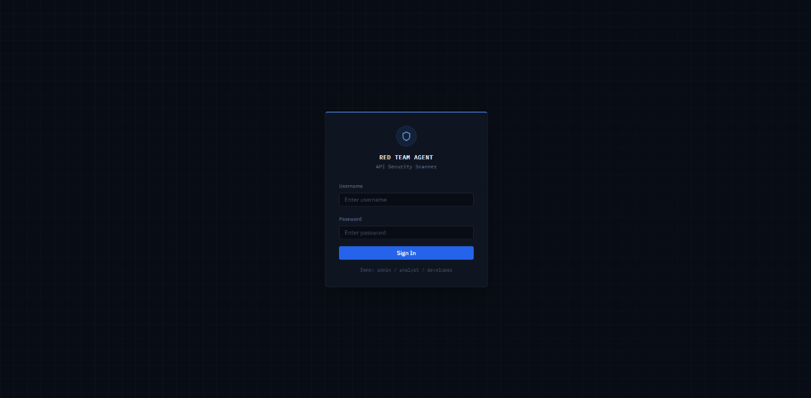
The app starts with a login screen. Three roles exist for demo: admin, security analyst, and developer. Each role sees different features:
- Security analyst: Scanning with all the overview, report, can do findings triage, the Probe Tab (manual testing), and AI Chains.
- Developer: The developer can view findings and reports that were assigned to him only.
- Admin: Has full access to all the features and user management.
Authentication uses a JWT token with a 60-minute expiration. It is stored in the frontend memory and attached as a Bearer header on every API request. Rate limiting on the login endpoint prevents brute-force attacks.

*.2 Dashboard
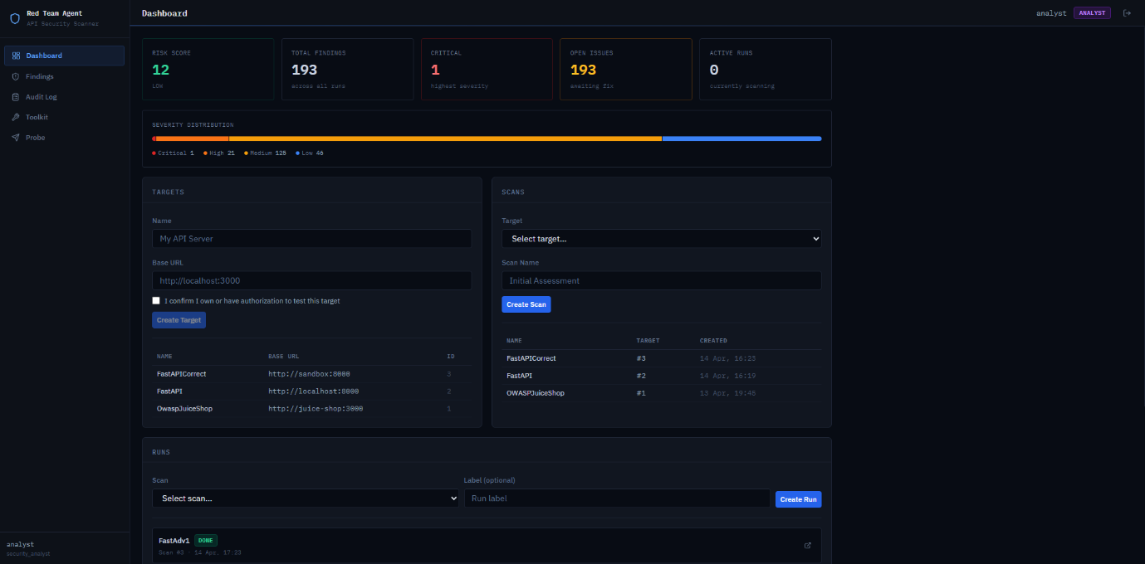
The dashboard is the landing page after login. It shows five summary fields at the top: Risk Score, Total findings across all runs, the critical findings, number of opened findings, and the number of active scans.
The left side of the dashboard is called Targets, that’s where analysts create a target by entering a name and a URL. After creating a target on the right side, a scan must be created for accountability. The user selects the target and gives the name of the scan. And the runs panel at the bottom, where a new run starts from a scan.
Target, scans, and runs were designed so the analyst can run the same scan multiple times and compare findings across the runs, for example, after fixing the vulnerabilities. Each run gets its own findings, transactions, and report.

*.3 Run Details
When the analyst clicks on a completed run, such as FastAdv1, in the dashboard, the run details open with four tabs.

*.3.1 Run Findings
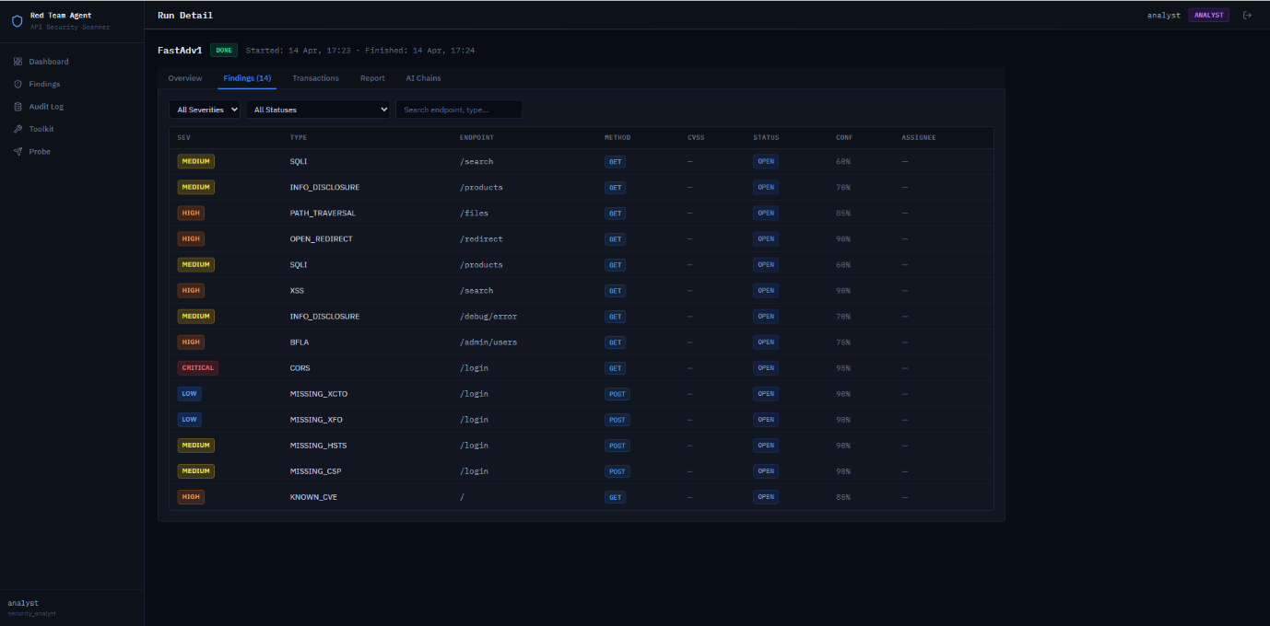
The Findings tab shows all the vulnerabilities that were found during the run. The screenshot shows 14 findings for the FastAdv1 scan.

*.3.2 Transactions
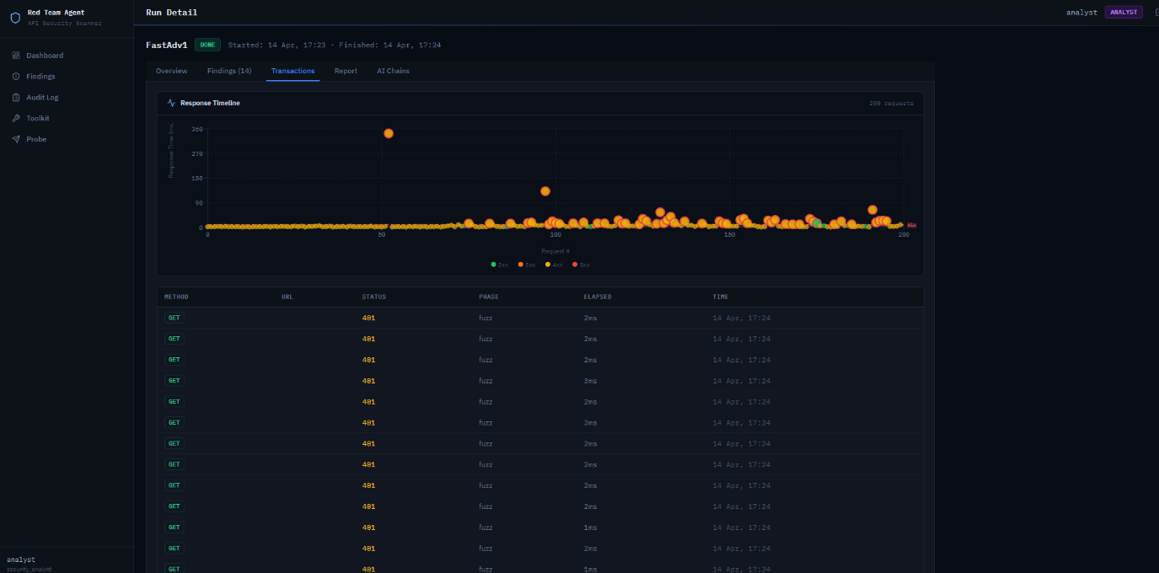
The Transactions tab shows every HTTP request that the scanner sent during the run. At the top is a response timeline chart that shows response time in milliseconds against request number, color-coded by the status of the request. It makes it easy to spot anomalies, for example, two large orange dots indicate slow responses that may be time-based SQL injection, such as SLEEP.

*.3.3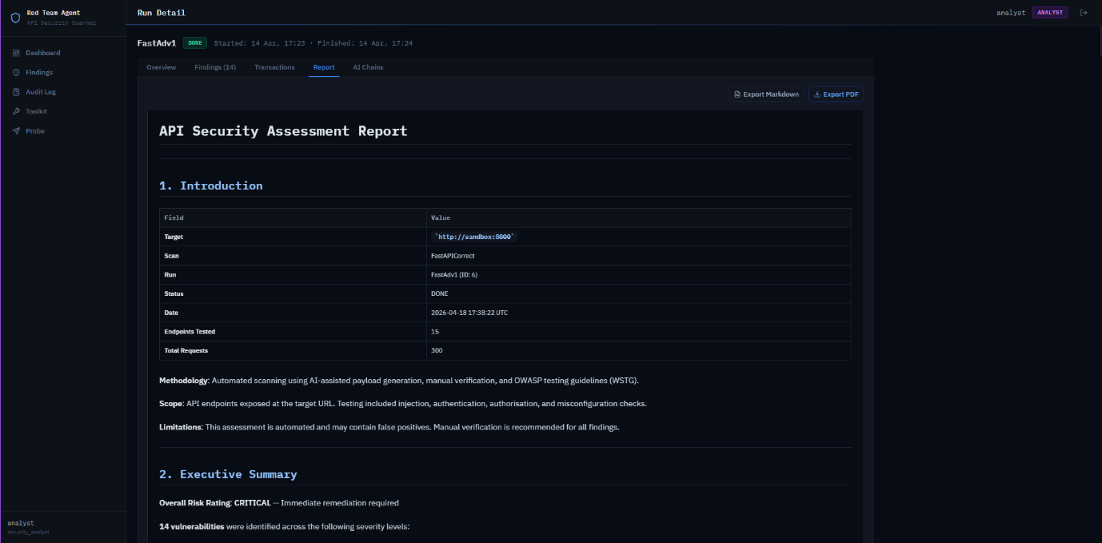
The Report tab shows an OWASP-style assessment report generated automatically from the run’s findings. The report follows the WSTG structure with sections for Introduction, where target URL, scan name, run ID, status, date, endpoints tested, and total requests written, Methodology, Scope, Limitations, Executive Summary, and then detailed findings with CWE and OWASP mapping. The analyst can export the report as MD or PDF.

*.3.4 AI Chains
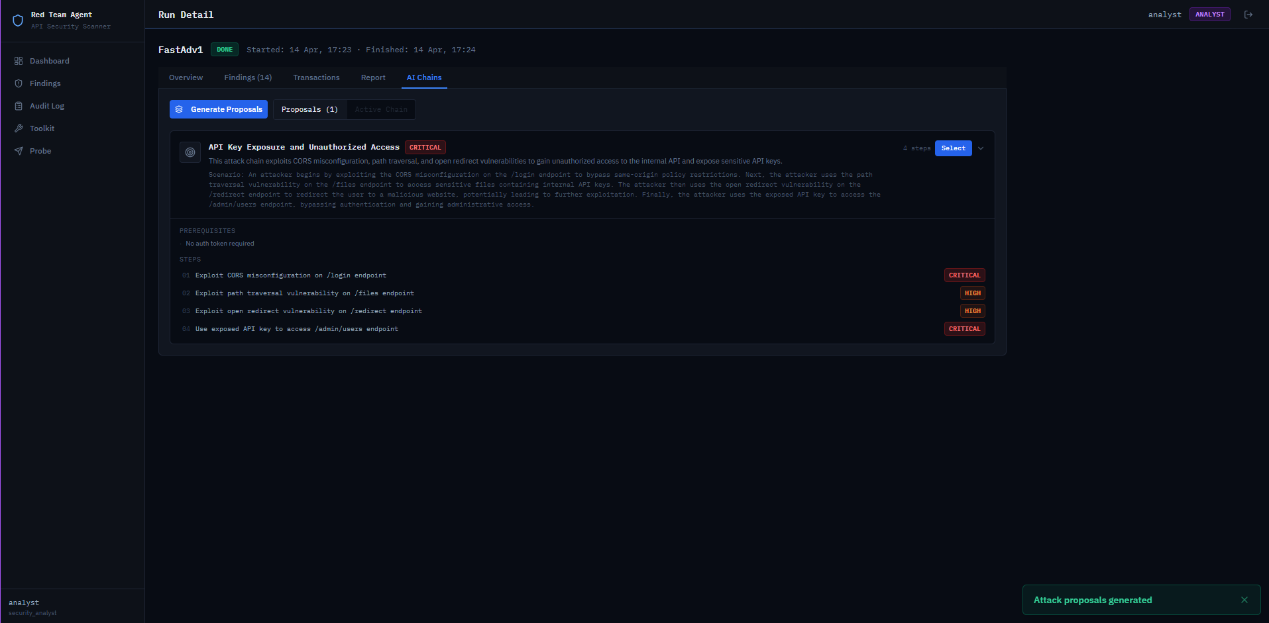
The AI Chains tab is the main AI-assisted workflow. After the scan finishes, the security analyst clicks Generate Proposal. The backend sends the top findings and discovered endpoints to the Groq API and receives a chain proposal in JSON format. The screenshot above shows the proposal called “API Key Exposure and Unauthorized Access. Each step describes the endpoint that will be attacked and explains why.
The analyst can click Select to activate the chain, then approve and execute each step individually. If the analyst doesn’t like the chain, he can click again on " Generate Proposal to get a new one.

*.4 Probe Tab

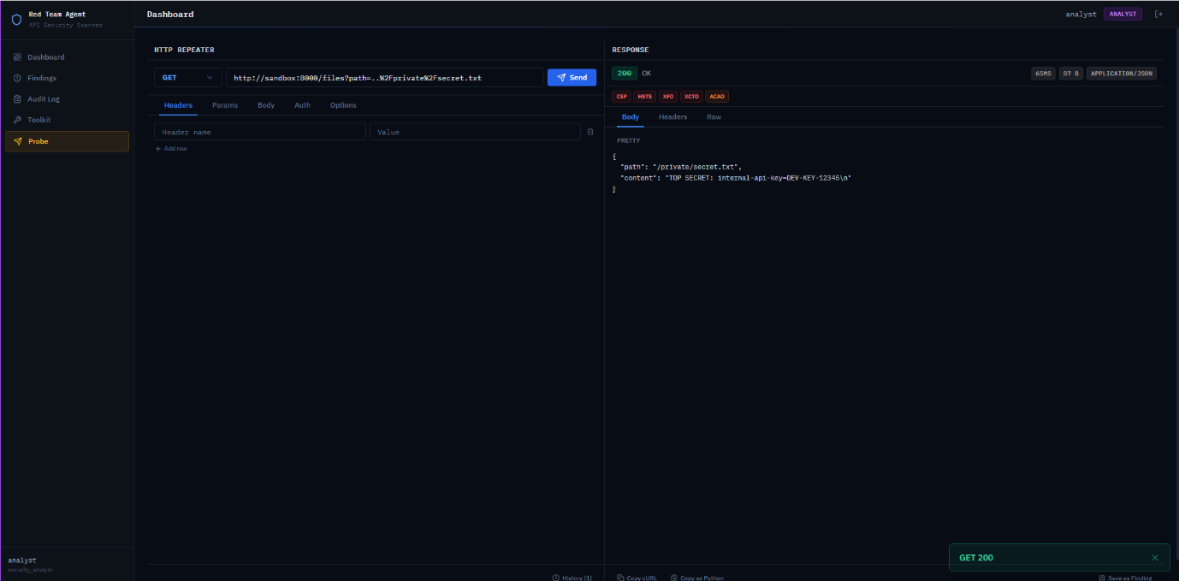
The Probe tab is a manual HTTP request editor where the analyst can create and send requests to any target. The left panel has fields for HTTP request method, URL, headers, query parameters, body, and authentication option. The right side shows the response with status code, time, size, content type, missing headers, and the response body.
In the screenshot, I sent a GET request from Path Traversal finding, and I received a 200 OK response with the file contents, confirming the path traversal finding is still there. All probe transactions are logged, and only admin and security analyst roles can use it.

*.5 Toolkit
The Toolkit tab has two tools for manual security analysis.

*.5.1 JWT Inspector
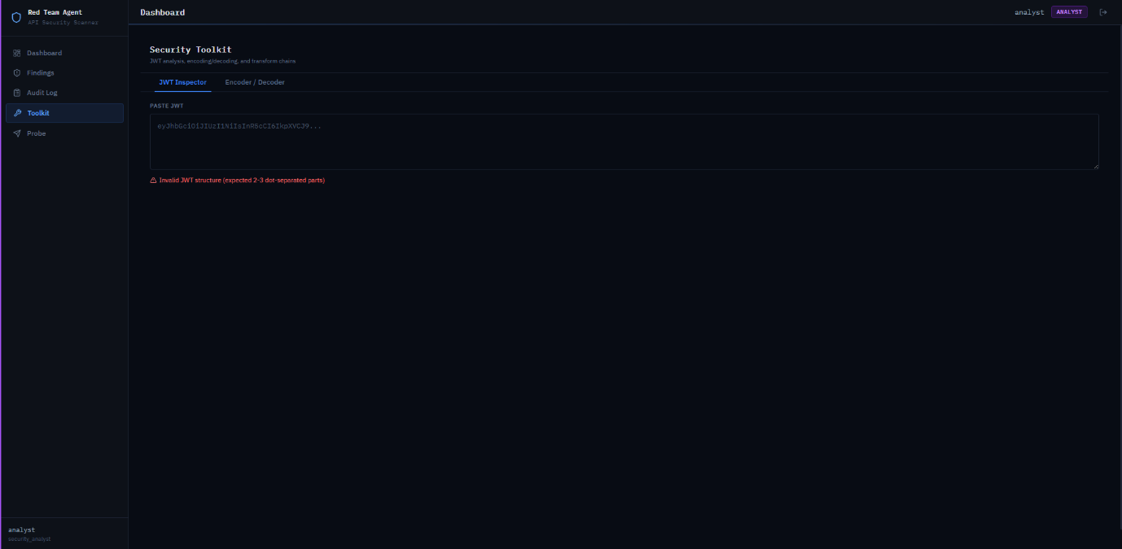
The JWT Inspector allows the analyst to paste a JWT and see the decoded header and payload. It shows the algorithm, expiry, and any unusual claims. This is useful when the analyst has a token from the target and wants to review its structure before creating another request. All processing is client-side.

*.5.2 Encoder/Decoder

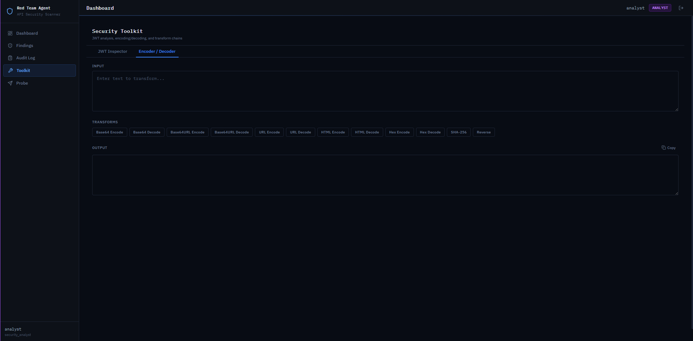
The Encoder/Decoder has Base64, Base64URL, URL, HTML entity, hex encoding and decoding, hashing, and reverse operations. The analyst enters the input field and chooses one or more operations. This is useful for creating payloads or decoding values from responses. All processing is client-side.

*.6 Audit Log

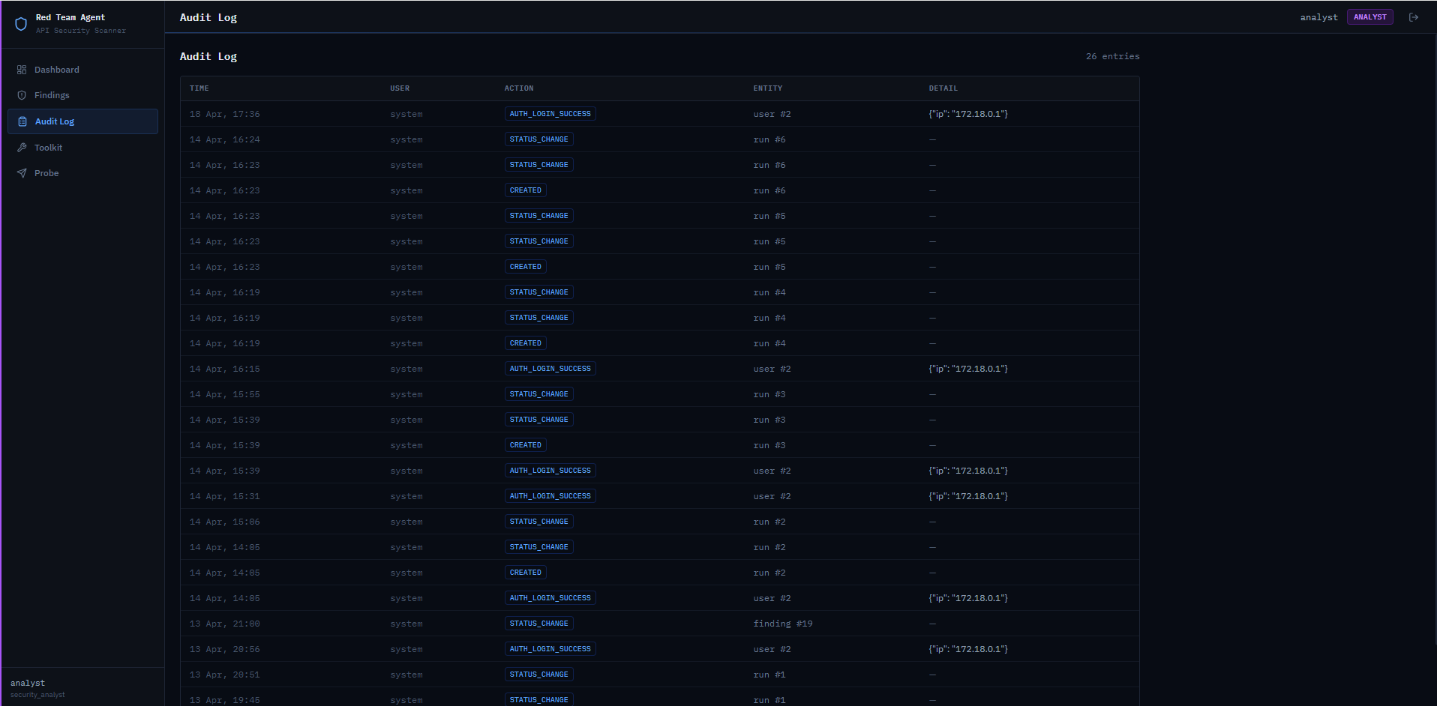
The Audit Log tab records every important action in the system. The screenshot shows entries such as login events with IP addresses, status changes on runs and findings, and created events when new runs are started. Each entry has a timestamp, the user who performed the action, the type of action, and the entity affected. This log supports accountability of the project, so every step is trackable, and answers about approved actions can be verified.

*.7 Findings

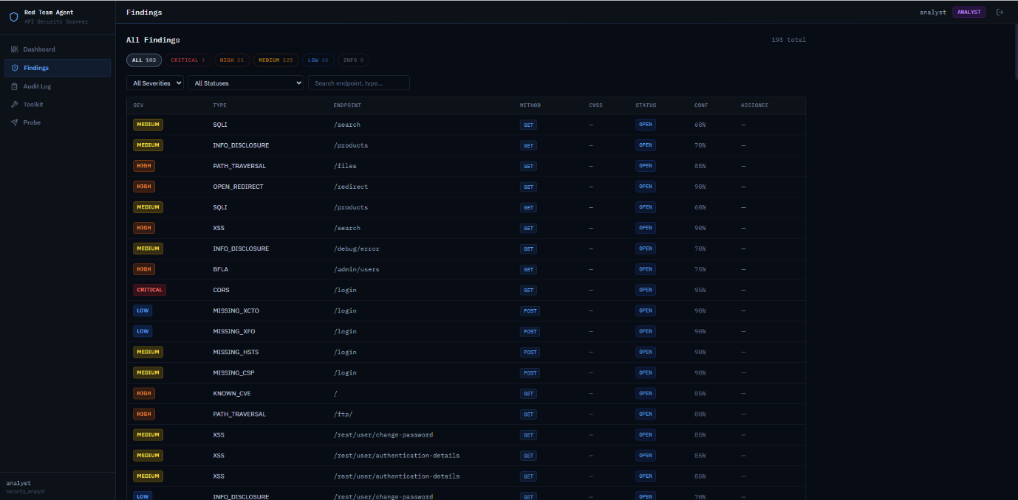
The Findings tab shows all findings across all runs.

*.7.1 Finding Details

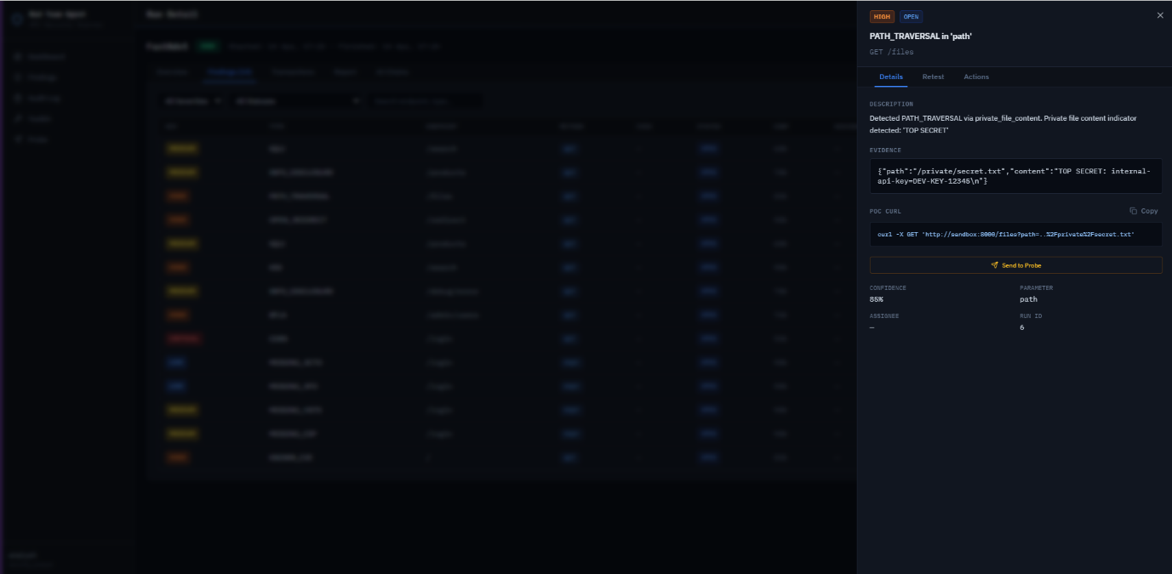
The Details tab shows the finding description, the evidence, the PoC command, a Send to Probe button that will prefill the Probe Panel with the current finding request, parameter name, and the run ID.

*.7.2 Retest
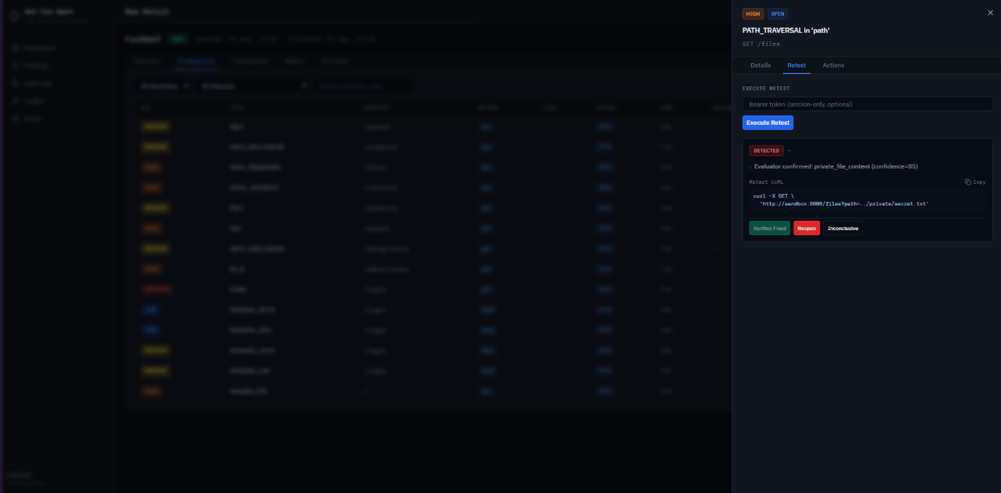
The Retest tab lets the analyst repeat the original request against the target and check whether a vulnerability was fixed. It includes an optional bearer token field for authenticated retests. After clicking Execute Retes, the evaluator analyses the response and returns one of three statuses: detected, not detected, or inconclusive.
The retest function is important for real-world scenarios. When developers fix a vulnerability, the analyst needs to verify without running a full scan.

*.7.3 Actions
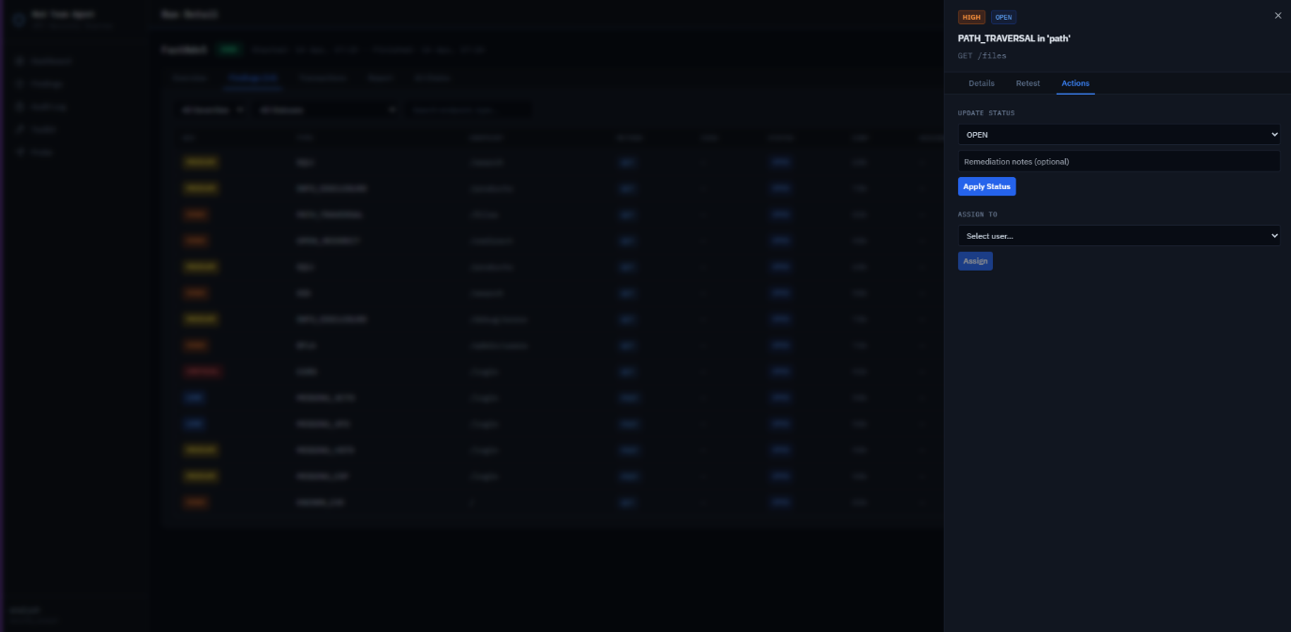
The Actions tab provides status management and assignment. The analyst can change the finding status to: open, in progress, fixed pending verification, and verified fixed. Each transition is restricted by user role; for example, a developer can mark a finding as fixed pending verification, but only a security analyst can mark it as verified fixed after retesting. All status changes and assignments are logged in the audit log.

*. Vibe-Coding Journey
This section describes the development methodology that was used to build the project from a practical perspective. Vibe-coding, the practice of building software primarily through language instruction to an AI assistant, is still a new field. My experience with it covers six months on this project, during which the tooling landscape changed faster than the project itself.

*.1 Platform Evolution: Replit, Antigravity, Claude Code
When I started the project in October 2025, Replit was probably the most mature AI-coding platform available. The initial plan was to build the red-team agent inside Replit, with external tunneling via Ngrok, so that the project that is stored on the Replit cloud could reach the Dockerized vulnerable targets running on my laptop. I spent the first few weeks learning Replit’s workflow and sketching the scanner skeleton.
On 18 November 2025, Google released Antigravity, which is the combination of a local IDE with multiple integrated models such as Gemini 3 Pro, Claude Sonner 4.5, and GPT-OSS. At that time, Antigravity had a free preview, which made it clear to move from Replit. Another benefit is that Antigravity runs locally, which removes the tunneling problem and simplifies the architecture because both the agent and the vulnerable targets could stay on the same host, connected by Docker's internal network.
In January 2026, the free preview moved to a subscription model with significantly reduced limits, and the experience that had been good in November became much slower as daily usage was smaller. I started looking for alternatives, as Antigravity uses Claude models in their app, and it’s one of the best models for coding. I decided to check Claude's options itself instead of using it via a third party. At that point, I found that with the pro subscription for Claude, you are getting Claude Code that was already matured to the point where it was being discussed across the developer community as the best AI coding assistant. I decided to test it, and after a few days, I moved the main development onto Claude Code, keeping Antigravity open as the IDE for editing and running the app while Claude was doing code.
Claude Code in the terminal for writing and refactoring code, Antigravity as the editor with its built-in preview and models for lighter tasks, and a Git repository with branches and commits underneath, that’s the combination that I used from February 2026 until the end of the project. This combo gave me full ownership of the code and history, and AI assistance that was strong enough to move the project forward by days per week instead of hours.

*.2 Prompt Engineering Skills
When I started, I thought the right prompt was the one that described everything I wanted in one very detailed message, so my prompts were too long. The assumption being that more context equals better results. In practice, this worked badly. The model would read the first half of the prompt, act on it, and after ignore the second part, or it would act on all of it, but in the process of fixing one feature, it would break another that was done before. Troubleshooting this took most of my time during October-November.
By December, I started understanding that short, structured prompts were the most important for productive work. I decided to start the project from scratch again. I’ve built the file that contains all the architecture, features, design, limitations, etc. I wrote down every bug and missing feature that I could find, and grouped them under sets of feature headings. Then I started a consistent pattern that lasted through the rest of the project and showed good results. For each feature, I start a new chat with no context, ask the model to read and analyze the relevant part of the code, explain the problems that I found, and the fixes I want. I asked AI to produce an implementation plan as a markdown file.
Reviewing the implementation plan before any code is written is one of the most important steps. If the plan was wrong, the code would be broken. When the plan is right, it is usually close to expected, and a small follow-up correction is required to finish it. If the plan is right but too big, I usually split it into different phases rather than execute one plan in a single session, as a long session can mislead the agent.

*.3 Implementation Plans and Engineering Tasks
When I learned about implementation plans, and they became the main factor of my prompts, a second important part emerged naturally. As the implementation plan is still a paragraph-level decision, the code to realize it might touch eight or ten files. To make the execution more stable and safer, I started to ask the model to convert the plan into a list of engineering tasks, where each task had three requirements: it should touch a limited number of files, it should be independently testable, and it should include explicit acceptance criteria.
The most improvement came from the acceptance criteria part. When the model knew that a task was done, only when, for example, “POST /findings/{id}/retest " returned a 200 with a 3-state verdict field, its output was measurably better than when the task was simply “add retesting”. Acceptance criteria worked as well as tests, and I could run them manually or use small .py tests to verify. When a task failed its acceptance criteria, I did not try to fix it. It was best to start a new chat, describe again, and attach the previous failure. Fresh context almost always worked better than a long running chat that had issues already.
The full development loop that I used looked like: start a new chat with no context, describe the problem and attach relevant files, ask the model to create an implementation plan in markdown, review and adjust the plan, ask the model to convert the plan into engineering tasks and export as markdown, review the tasks, ask the model to execute them. After changes to the code were made, I usually did manual testing and ran the acceptance criteria.

*.4 Working with Model Limits and Token Usage
Subscription tiers for Claude Code are defined by a five-hour usage window. It sounds generous until a complex task on Claude Opus eats through it in twenty minutes. Earlier, I would spend my quota with a messy workflow and then be locked for the rest of the window. A few habits that helped me to stay more productive and spend fewer tokens. As I am still using Google Antigravity that has the same models as Claude Code but less usage for them. I would usually write a short plan before the session of what I need to do with all the problems I have or fixes I need in a notepad. I used the Antigravity model first to write an implementation plan. If the task is not complex, I would use the cheapest models that suit the task, such as Claude Sonnet 4.5 or the Haiku model for simple edits and summaries. While using Opus for architecture questions and complex debugging, where the difference in reasoning quality actually mattered.
One more thing that should be mentioned is that the user should be careful about context. Attaching the whole repository at the start of chat is good, but expensive. Every follow-up message carries that context with it. Attaching only the needed files and asking the model to read additional files if needed through a call uses far fewer tokens. Same with asking to produce a plan and then to execute it is cheaper than asking to produce and execute in a single session. The second call can start from the plan rather than from the original description.

*.5 Model Selection: Which Model for Which Task
Based on my experience with different models, I can share my subjective opinion about which model to use for which kind of task. Claude Opus models are the right choice when the task needs reasoning about tricky bugs, designing or adding new elements to the architecture, or combining multiple constraints into a single solution. They are taking a longer time to think and are more expensive per token, but they tend to reach the right and suitable answer in one or two attempts rather than four or five with troubleshooting.
Claude Sonnet models are most suitable for everyday coding tasks. They write code at a good developer level. They are fast enough, and they cost much less than the Opus tier. For the big part of the project, Sonnet 4.5 executed all the plans and created most of the implementation plans.
Haiku models are for small, defined transformations: writing text, converting a JSON structure to a TypeScript interface, creating unit tests, and general questions. Using Hiku for these rather than Sonnet saved a surprising amount of quota across the project.
Gemini models …

*.6 An Assessment of the AI-Generated code

13. Figures and Tables

14. References
[1] Mantin, S. and Mantin, S. (2021). Digital Transformation: The leading factor for API attacks - Cyber Protection Magazine. [online] Cyber Protection Magazine. Available at: https://cyberprotection-magazine.com/digital-transformation-the-leading-factor-for-api-attacks
[2]Kost, E. (2024). How Did the Optus Data Breach Happen? [online] Upguard. Available at: https://www.upguard.com/blog/how-did-the-optus-data-breach-happen.
[3]Rago, N. (2023). Salt | T-Mobile API Breach – What Went Wrong? [online] salt.security. Available at: https://salt.security/blog/t-mobile-api-breach-what-went-wrong.
[4]Docs.n8n.io. (2025). n8n Integrations Documentation and Guides | n8n Docs. [online] Available at: https://docs.n8n.io/integrations/
[5] https://docs.replit.com/getting-started/intro-replit
[6]Google Antigravity. (2025). Google Antigravity. [online] Available at: https://antigravity.google/docs/models
[7]Weilin Zhong, R. (2024). Code Injection Software Attack | OWASP Foundation. [online] owasp.org. Available at: https://owasp.org/www-community/attacks/Code_Injection.
[8]OWASP (2019). OWASP API Security - Top 10 | OWASP. [online] owasp.org. Available at: https://owasp.org/www-project-api-security/.
[9]OWASP (2024). SQL Injection. [online] OWASP. Available at: https://owasp.org/www-community/attacks/SQL_Injection.
[10]owasp.org. (n.d.). WSTG - Latest | OWASP. [online] Available at: https://owasp.org/www-project-web-security-testing-guide/latest/4-Web_Application_Security_Testing/05-Authorization_Testing/04-Testing_for_Insecure_Direct_Object_References.
[11]OWASP (2020). Cross Site Scripting (XSS) | OWASP. [online] Owasp.org. Available at: https://owasp.org/www-community/attacks/xss/.
[12]InstaTunnel (2025). Ngrok vs. Localtunnel: The Simplicity of Open-Source Tunneling. [online] Medium. Available at: https://medium.com/@instatunnel/ngrok-vs-localtunnel-the-simplicity-of-open-source-tunneling-d21a253e4d67.
inconshreveable (2019). ngrok - secure introspectable tunnels to localhost. [online]Ngrok.com. Available at: https://ngrok.com/.
[13]Owasp.org. (2025). OWASP API Security Testing Framework | OWASP Foundation. [online] Available at: https://owasp.org/www-project-api-security-testing-framework/.
Tiangolo.com. (2025). FastAPI. [online] Available at: https://fastapi.tiangolo.com/#interactive-api-docs.
[14]OpenAI (2021). OpenAI API. [online] OpenAI. Available at: https://openai.com/api/https://docs.docker.com/compose/.
[15]Dovydas (2025). What is n8n? Intro to a workflow automation tool. [online] Hostinger Tutorials. Available at: https://www.hostinger.com/tutorials/what-is-n8n.
Tahir (2025). What is Replit AI ?: The AI-Powered Development Platform. [online] Medium. Available at: https://medium.com/@tahirbalarabe2/what-is-replit-ai-the-ai-powered-development-platform-46997a5124e5.
[16]Google Antigravity. (2025). Google Antigravity. [online] Available at: https://antigravity.google/
[17]Invicti. (2020). Scanning a RESTful API Web Service | Invicti. [online] Available at: https://www.invicti.com/support/scanning-restful-api-web-service/
[18]2018 IEEE International Conference on Artificial Intelligence and Virtual Reality (AIVR). (2018).
‌[19]Deng, G., Liu, Y., Mayoral-Vilches, V., Liu, P., Li, Y., Xu, Y., Zhang, T., Yang, L., Pinzger, M. and Rass, S. (2023). PentestGPT: An LLM-empowered Automatic Penetration Testing Tool. arXiv (Cornell University). doi: https://doi.org/10.48550/arxiv.2308.06782.
[20]Atlidakis, V., Godefroid, P. and Polishchuk, M. (2019). RESTler: Stateful REST API Fuzzing. 2019 IEEE/ACM 41st International Conference on Software Engineering (ICSE). doi: https://doi.org/10.1109/icse.2019.00083.
[21]Vaggelis Atlidakis, Godefroid, P. and Polishchuk, M. (2019). RESTler: Stateful REST API Fuzzing. [online] Microsoft Research. Available at: https://www.microsoft.com/en-us/research/publication/restler-stateful-rest-api-fuzzing/ [Accessed 16 Apr. 2026].
[22]Crozier, R. (2024). Optus breach allegedly enabled by access control coding error. [online] iTnews. Available at: https://www.itnews.com.au/news/optus-breach-allegedly-enabled-by-access-control-coding-error-608985.
‌[23]Kost, E. (2024). How Did the Optus Data Breach Happen? [online] Upguard. Available at: https://www.upguard.com/blog/how-did-the-optus-data-breach-happen.
‌[24]Wikipedia (2023). 2022 Optus data breach. [online] Wikipedia. Available at: https://en.wikipedia.org/wiki/2022_Optus_data_breach.
‌[25]Anon, (n.d.). New T-Mobile Breach Affects 37 Million Accounts – Krebs on Security. [online] Available at: https://krebsonsecurity.com/2023/01/new-t-mobile-breach-affects-37-million-accounts/.
[26]Franceschi-Bicchierai, L. (2023). T-Mobile says hacker accessed personal data of 37 million customers. [online] TechCrunch. Available at: https://techcrunch.com/2023/01/19/t-mobile-data-breach/.
‌[27]Cloudflare.com. (2021). theNET | Attack surface grows with the proliferation of APIs. [online] Available at: https://www.cloudflare.com/the-net/api-proliferation/.
‌[28]McLean, M. (2025). Gartner API Security Report - Gartner Releases a New Report. [online] Salt.security. Available at: https://salt.security/blog/api-security-hits-gartner-radar-for-predicts-2022 [Accessed 16 Apr. 2026].
‌[29]Iwuozor, J. (2022). API Attacks Have Emerged as the #1 Threat Vector in 2022. [online] Infosecurity Magazine. Available at: https://www.infosecurity-magazine.com/next-gen-infosec/api-attacks-threat-vector-2022/
[30]FastAPI (2023). FastAPI. [online] fastapi.tiangolo.com. Available at: https://fastapi.tiangolo.com/.
[31]Groq. (2024). New AI Inference Speed Benchmark for Llama 3.3 70B, Powered by Groq. [online] Available at: https://groq.com/blog/new-ai-inference-speed-benchmark-for-llama-3-3-70b-powered-by-groq
[32]Groq. (2024). Groq LPUTM Inference Engine Crushes First Public LLM Benchmark. [online] Available at: https://groq.com/blog/groq-lpu-inference-engine-crushes-first-public-llm-benchmark
[33]Huggingface.co. (2024). meta-llama/Llama-3.3-70B-Instruct · Hugging Face. [online] Available at: https://huggingface.co/meta-llama/Llama-3.3-70B-Instruct.
[34]Docker (2020). Overview of Docker Compose. [online] Docker Documentation. Available at: https://docs.docker.com/compose/.
[35]SQLite (2019). SQLite Documentation. [online] Sqlite.org. Available at: https://www.sqlite.org/docs.html.
[36]datatracker.ietf.org. (n.d.). rfc7519. [online] Available at: https://datatracker.ietf.org/doc/html/rfc7519.
[37]Usenix.org. (2025). USENIX Technical Program - Abstract - USENIX 99. [online] Available at: https://www.usenix.org/legacy/events/usenix99/provos.html.
[38]replit (2022). The collaborative browser based IDE. [online] replit. Available at: https://replit.com/.
[39]replit (n.d.). Pricing. [online] replit. Available at: https://replit.com/pricing.
[40]Anthropic.com. (2025). Claude Code overview - Anthropic. [online] Available at: https://docs.anthropic.com/en/docs/claude-code/overview.
[41]Anthropic (2025). Claude 3.7 Sonnet and Claude Code. [online] Anthropic.com. Available at: https://www.anthropic.com/news/claude-3-7-sonnet
[42]PortSwigger (2024). Burp Suite Scanner. [online] Portswigger.net. Available at: https://portswigger.net/burp.
[43]GitHub. (2022). projectdiscovery/nuclei. [online] Available at: https://github.com/projectdiscovery/nuclei.
[44]Swissky (2022). Payloads All The Things. [online] GitHub. Available at: https://github.com/swisskyrepo/PayloadsAllTheThings.
[45]danielmiessler (2019). danielmiessler/SecLists. [online] GitHub. Available at: https://github.com/danielmiessler/SecLists.
[46]CWE (n.d.). CWE - Common Weakness Enumeration. [online] cwe.mitre.org. Available at: https://cwe.mitre.org/.

13. Bibliography
API Security. (n.d.). Retrieved from OWASP: https://owasp.org/www-project-api-security/
IDOR. (n.d.). Retrieved from OWASP: https://owasp.org/www-project-web-security-testing-guide/latest/4-Web_Application_Security_Testing/05-Authorization_Testing/04-Testing_for_Insecure_Direct_Object_References
SQL Injection. (n.d.). Retrieved from OWASP: https://owasp.org/www-community/attacks/SQL_Injection
Weilin Zhong, R. (n.d.). Code Injection. Retrieved from OWASP: https://owasp.org/www-community/attacks/Code_Injection
XSS. (n.d.). Retrieved from OWASP: https://owasp.org/www-community/attacks/xss/

