MGZT Tool Testing and Evaluation Report
Azure Zero Trust Misconfiguration Scanner with Remediation Guidance and Audit Trail
Author: Michal Grzanka

Executive Summary
This report documents functional testing and a peer usability evaluation of the MGZT tool. The tool scans Azure Resource Groups for common misconfigurations aligned with Zero Trust principles, stores results in a persistent SQLite audit database, and presents findings through an interactive dashboard including beginner-friendly remediation guidance and links to official Microsoft documentation.
Three scans were captured to demonstrate measurable improvement: a baseline scan, a scan after storage remediation, and a scan after network remediation. Results show a clear reduction in High and Medium severity findings and improved resource group scores in the affected areas. Peer feedback indicates the dashboard and explanations are generally clear, with suggested refinements recorded in the improvement plan.

1. Introduction
Cloud platforms make it easy to deploy services quickly, but that speed increases the risk of insecure defaults and misconfigurations. In Azure, common issues include public storage access, overly permissive network rules, and excessive IAM permissions. These weaknesses can lead to data exposure, unauthorised access, and lateral movement.
The MGZT tool addresses this by scanning a defined set of resource groups, detecting high-impact misconfigurations, and presenting results in a format that is usable for beginners. The tool also supports an audit trail so improvements can be tracked over time.

2. System Overview
The solution consists of three main components:
- Scanner (Python): Connects to Azure, evaluates checks, produces findings and scores, and writes outputs.
- Audit trail database (SQLite): Stores every scan, resource group scores, and findings for historical tracking.
- Dashboard (FastAPI + HTML/JS): Displays scan history, findings, compare scans (diff), and trend graphs; includes remediation guidance and Learn More links.
Key outputs created per scan:
- Timestamped HTML report and JSON report for the scan.
- Updated zt_audit.db containing the complete scan history.
- Updated dashboard views driven by the database (scan list, findings, compare, trend).

3. Test Environment and Demo Setup
Testing was performed on Windows using Azure CLI authentication and a controlled Azure environment.

3.1 Controlled Resource Groups
To keep testing repeatable, four resource groups were used:
- MG-ZT-GOOD-RG: Control baseline (expected to remain stable).
- MG-ZT-DATA-RG: Storage/data exposure scenario.
- MG-ZT-NET-RG: Network exposure scenario.
- MG-ZT-IAM-RG: Identity/RBAC exposure scenario (inherited roles in university subscription).

4. Testing Methodology
Testing followed a three-scan workflow to demonstrate detection, remediation impact, and audit trail functionality. Each scan produces a timestamped report and appends results to the SQLite database.
- Scan 1 (baseline): Run the scanner against the controlled environment before remediations.
- Scan 2 (after storage fix): Apply storage remediation (reduce public/anonymous access) and re-scan.
- Scan 3 (after network fix): Apply network remediation (reduce public inbound exposure) and re-scan.

5. Results

5.1 Findings by severity across scans
Table 1 summarises total findings by severity across the three captured scans.
Scan | Timestamp | High | Medium | Low | Info
Scan 1 (baseline) | 2026-03-17T15:46:58 | 3 | 5 | 3 | 3
Scan 2 (after storage fix) | 2026-03-17T15:50:50 | 2 | 2 | 3 | 5
Scan 3 (after network fix) | 2026-03-17T15:53:02 | 1 | 1 | 3 | 5
Key observation: High and Medium findings reduced after remediation actions, showing measurable improvement.
Figure 1 visualises the same trend.
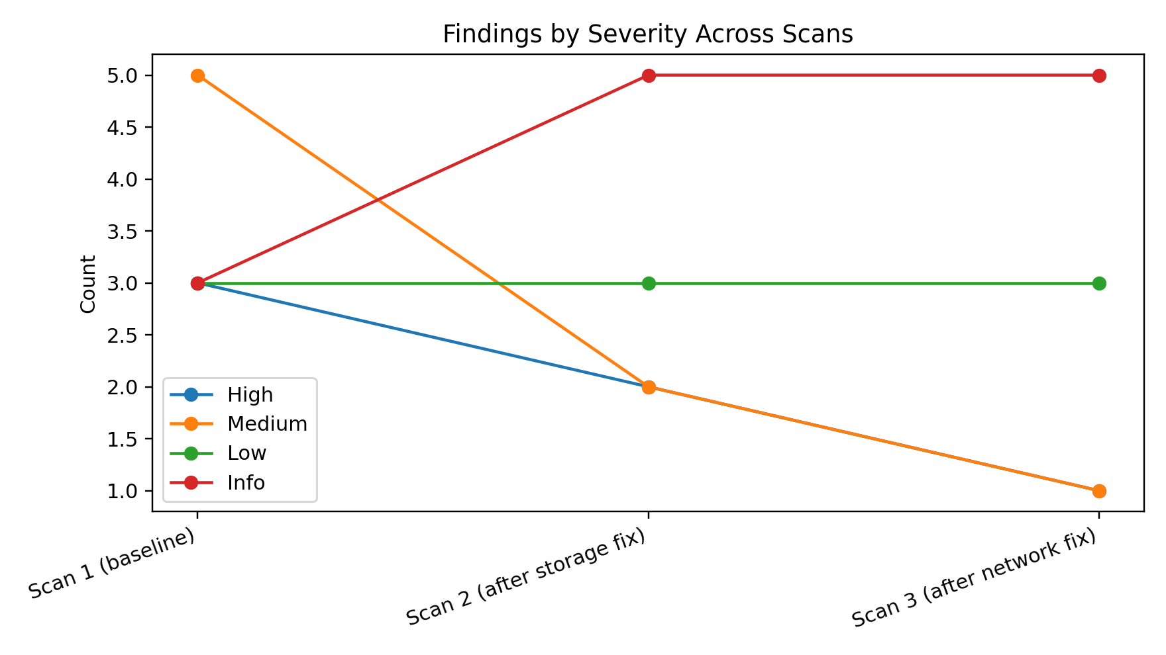
Figure 1: Findings by severity across scans.

5.2 Resource group score changes
This table summarises scores per resource group across scans. Scores provide a simple reference point for comparing scans and visualising progress.
Scan | Resource Group | Score | Label | High | Medium
Scan 1 | MG-ZT-DATA-RG | 45 | High risk | 1 | 3
Scan 2 | MG-ZT-DATA-RG | 95 | Good | 0 | 0
Scan 3 | MG-ZT-DATA-RG | 95 | Good | 0 | 0
Scan 1 | MG-ZT-GOOD-RG | 100 | Good | 0 | 0
Scan 2 | MG-ZT-GOOD-RG | 100 | Good | 0 | 0
Scan 3 | MG-ZT-GOOD-RG | 100 | Good | 0 | 0
Scan 1 | MG-ZT-IAM-RG | 75 | Needs work | 1 | 0
Scan 2 | MG-ZT-IAM-RG | 75 | Needs work | 1 | 0
Scan 3 | MG-ZT-IAM-RG | 75 | Needs work | 1 | 0
Scan 1 | MG-ZT-NET-RG | 55 | High risk | 1 | 2
Scan 2 | MG-ZT-NET-RG | 55 | High risk | 1 | 2
Scan 3 | MG-ZT-NET-RG | 85 | Good | 0 | 1
Interpretation:
- MG-ZT-DATA-RG improved from 45 → 95 after storage remediation (Scan 1 → Scan 2).
- MG-ZT-NET-RG improved from 55 → 85 after network remediation (Scan 2 → Scan 3).
- MG-ZT-GOOD-RG remained at 100 across scans as the control baseline.
Figure 2 visualises resource group score trends.
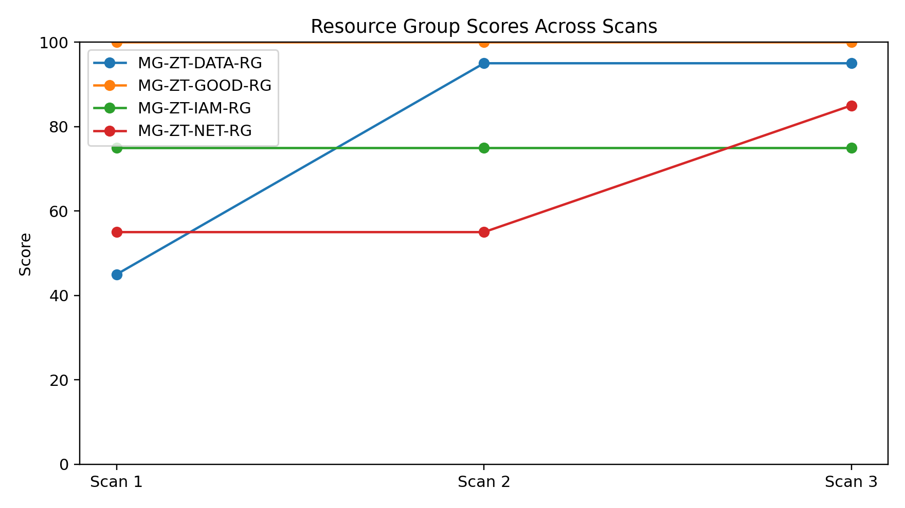
Figure 2: Resource group scores across scans.

6. Dashboard Feature Validation

6.1 Findings view and remediation guidance
The dashboard displays findings per scan with severity filtering. Each finding includes beginner-friendly guidance in a structured format (what it is, why it matters, attacker impact, fix steps, verification) and provides Learn More links to official Microsoft documentation.

6.2 Compare scans (diff)
The compare feature groups findings into new, resolved and unchanged categories, which provides a clear audit-trail view of progress between scans.

6.3 Trend graph (audit trail visual)
The trend graph uses audit database data to plot changes across scan history, supporting both overall trend and per-resource-group series.

7. Evidence Screenshots
The following screenshots were captured during testing and are included as evidence:

Figure 4 — Dashboard scan list
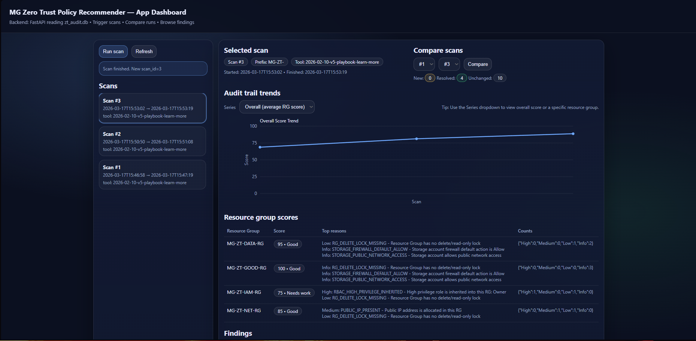
Figure 4 — Dashboard scan list.

Figure 5 — Control RG view (GOOD-RG)
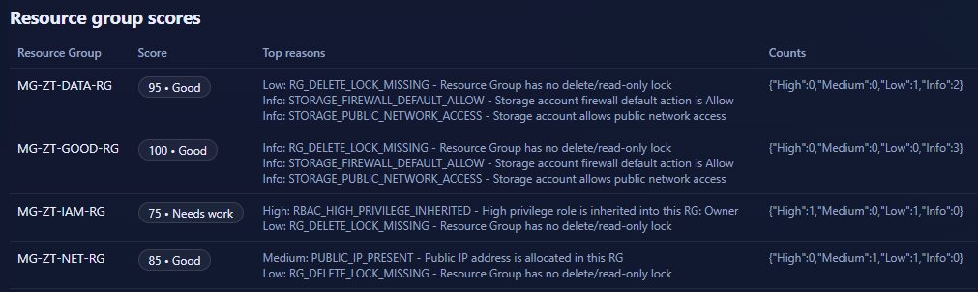
Figure 5 — Control RG view (GOOD-RG).

Figure 6 — Expanded high severity finding
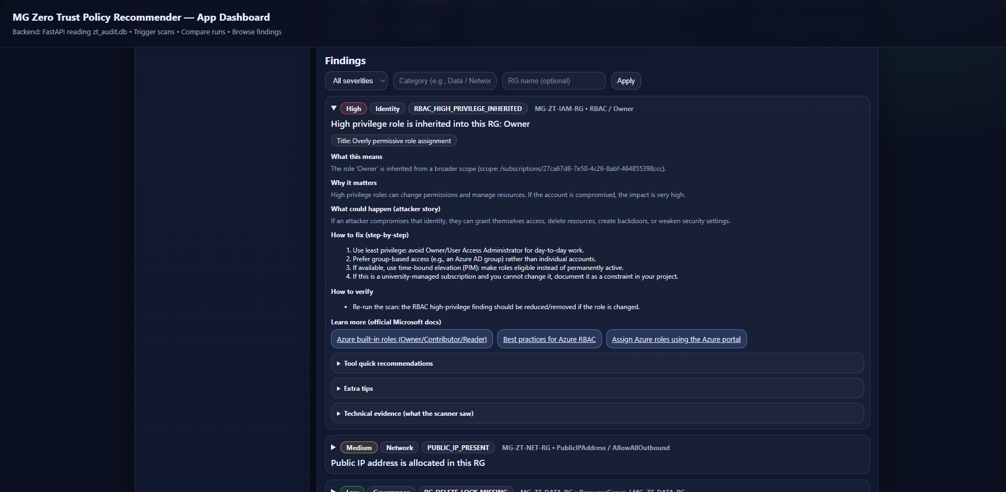
Figure 6 — Expanded high severity finding.

Figure 7 — Learn more links
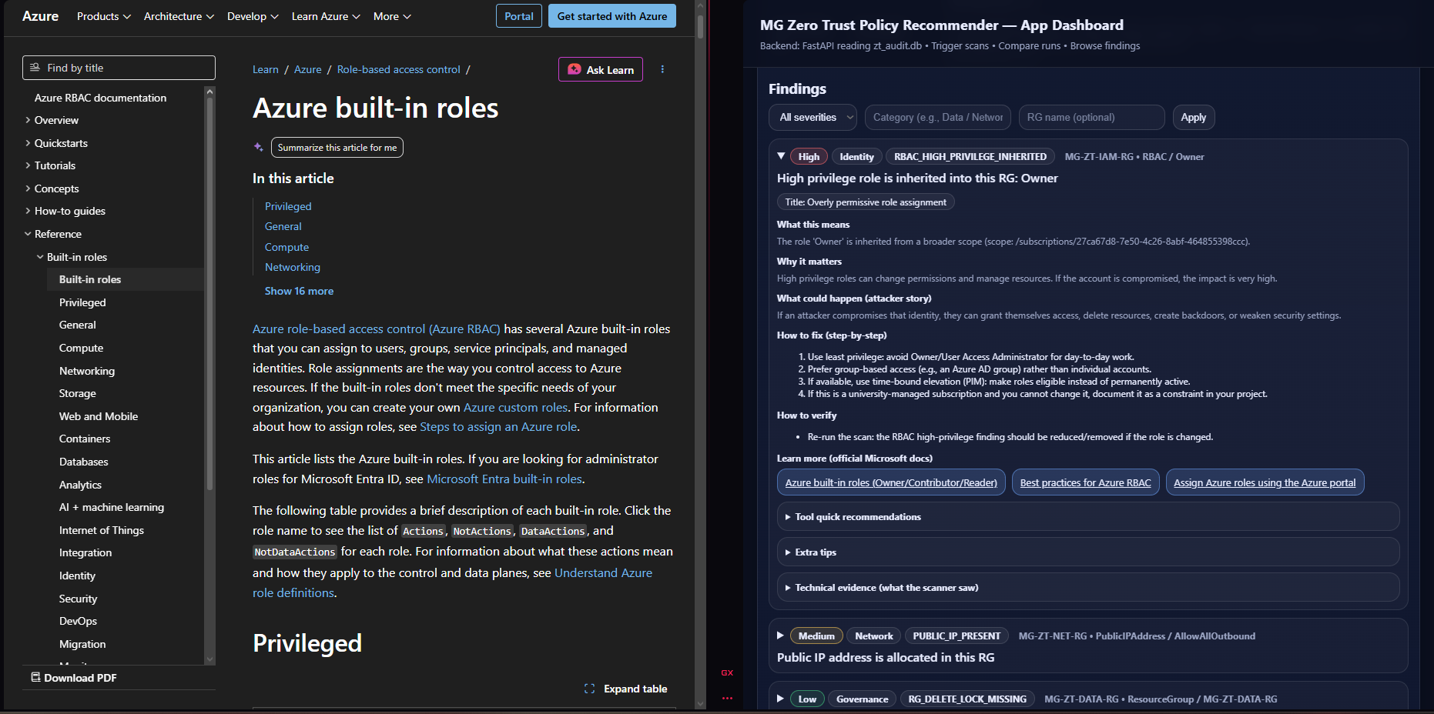
Figure 7 — Learn more links.

Figure 8 — Compare scans view
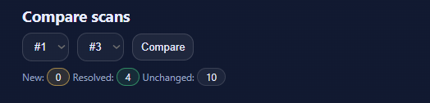
Figure 8 — Compare scans view.

Figure 9 — Trend graph (overall)
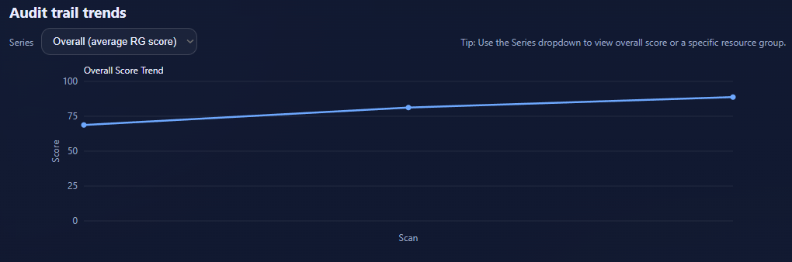
Figure 9 — Trend graph (overall).

Figure 10 — Trend graph (DATA RG)
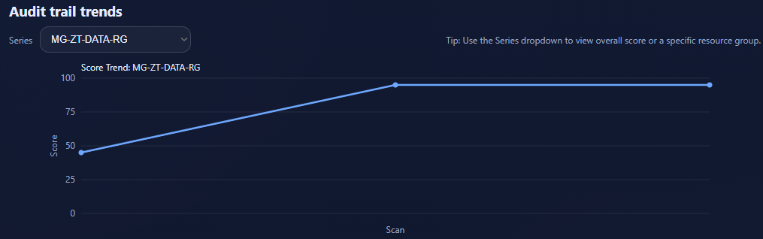
Figure 10 — Trend graph (DATA RG).

8. Peer Tester Evaluation
A peer tester was provided with the tool and questionnaire to evaluate usability and clarity. The questionnaire includes setup success, scan execution, dashboard usability, explanation quality, audit features, and overall rating.

8.1 Quantitative summary
Category | Average rating (1–5)
Setup | 4.00
Dashboard usability | 4.00
Findings & guidance | 4.33
Audit trail features | 4.50
Links & severity | 3.50
Figure 3 visualises peer evaluation category averages.
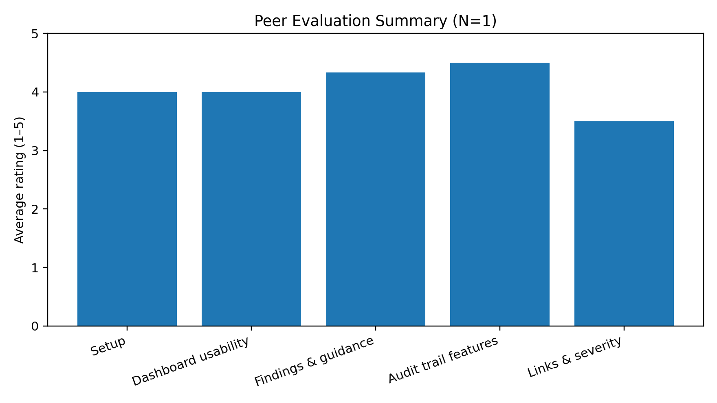
Figure 3: Peer evaluation summary (N=1).
Overall rating (1–10): mean=8.00 (N=1)

8.2 Planned improvements based on feedback
Based on the peer feedback and observed testing outcomes, the following improvements are planned for the final submission:
- Clarify scoring: briefly document how severity weights contribute to RG score and why the score is useful.
- Improve error messaging: ensure dashboard shows clear guidance when Azure authentication expires (az login).
- Expand evaluation sample if possible: collect 1–2 additional tester responses to strengthen the evaluation.

9. Limitations
- Azure authentication depends on Azure CLI login; MFA expiry can require re-login.
- University-managed subscriptions may contain inherited RBAC roles that cannot be removed; the tool flags these and this is documented as a realistic constraint.
- If storage networking is restricted too tightly, container enumeration can fail; this should be treated as a coverage limitation rather than a crash.

10. Conclusion
Testing demonstrates that the MGZT tool successfully detects Azure misconfigurations, produces consistent reports, stores an audit trail in SQLite, and presents results through a dashboard with compare and trend functionality. The evidence set (three scans, screenshots, and peer feedback) provides a strong baseline for the remaining project work, which can now focus on final documentation and presentation materials.

Appendix A — Questionnaire (structure)
The peer evaluation questionnaire includes sections for: initial information, setup/initialisation, running scans, dashboard usability, findings & explanations, Learn More links, audit trail features, accuracy & severity, overall feedback, and consent.

Appendix B — Per-question rating summary
Table B1 shows mean ratings for each numeric questionnaire item (where applicable).
Question (shortened) | Mean | N | Min | Max
Overall rating (1 = Very poor, 10 = Excellent) | 8.00 | 1 | 8 | 8
The scan history/audit trail concept is easy to understand. (1–5) | 5.00 | 1 | 5 | 5
The fix steps are clear and actionable. (1–5) | 5.00 | 1 | 5 | 5
The finding explanations are beginner-friendly. (1–5) | 5.00 | 1 | 5 | 5
The evidence shown supports the finding. (1–5) | 5.00 | 1 | 5 | 5
The trend graph helped visualise progress across scans. (1–5) | 5.00 | 1 | 5 | 5
The dashboard layout is clear and easy to navigate. (1 = Strongly d... | 4.00 | 1 | 4 | 4
Rate the clarity of the setup instructions (1 = Very unclear, 5 = V... | 4.00 | 1 | 4 | 4
Compare scans clearly showed new/resolved/unchanged. (1–5) | 4.00 | 1 | 4 | 4
The “How to verify” section is useful. (1–5) | 4.00 | 1 | 4 | 4
The “Why it’s bad” section clearly explains risk. (1–5) | 4.00 | 1 | 4 | 4
The severity filter is easy and works as expected. (1–5) | 4.00 | 1 | 4 | 4
The severity levels felt reasonable. (1–5) | 4.00 | 1 | 4 | 4
Switching between scans is intuitive. (1–5) | 3.00 | 1 | 3 | 3
The attacker/impact section helped me understand the consequences. ... | 3.00 | 1 | 3 | 3
The Microsoft documentation links were relevant. (1–5) | 3.00 | 1 | 3 | 3

