MGZT Azure Policy Recommender
Final Year Project Report
Michal Grzanka • C00286348
BSc (Hons) Cybercrime and IT Security
20 April 2026

Abstract
Cloud environments are secured through many individual configuration choices. MGZT Azure Policy Recommender is a lightweight auditing tool for Microsoft Azure that scans selected Resource Groups, detects common misconfigurations aligned with Zero Trust principles, and produces beginner-friendly remediation guidance. The system combines a Python scanner (Azure SDK) with a persistent SQLite audit database to build an audit trail across scans. A FastAPI backend exposes scan history, findings, scan comparison, and trend data to a local dashboard. The output is designed to be understandable for non-specialists while linking to official Microsoft documentation for deeper learning.

Acknowledgements
I would like to thank my supervisor for ongoing guidance and feedback throughout the project. I also thank the peer tester who evaluated the tool and provided usability feedback.

Table of Contents
This report uses Word's automatic Table of Contents. In Word: References → Table of Contents → Update Table after final edits.

1. Introduction
Moving systems into the cloud gives organisations flexibility and scalability, but it also creates a large number of security settings that must be configured correctly. Many real-world cloud incidents are caused by simple and avoidable misconfigurations such as public storage containers, overly permissive access roles, or exposing management ports to the internet. The motivation for this project was to build a tool that helps a beginner quickly spot these issues and understand what to do next, rather than receiving a technical warning with no context.

1.1 Target Audience
MGZT is intended for:
- IT students learning cloud security and Zero Trust concepts.
- Educators or demonstrators who want a simple lab tool to show the impact of misconfigurations.
- Junior administrators who want a quick, beginner-friendly audit of a small Azure environment.

1.2 Objectives
- Scan Azure Resource Groups and collect security-relevant configuration evidence.
- Detect a defined set of misconfigurations (findings) and assign severity.
- Generate a per-Resource-Group score to support comparisons and a clear visual summary.
- Persist results into an SQLite database to build an audit trail across scans.
- Provide a dashboard with filtering, scan comparison, and trend visualisation.
- Provide beginner-friendly remediation guidance and 'Learn more' links to official Microsoft documentation.

1.3 Scope
MGZT is designed as a focused educational auditing tool. The scanner can optionally restrict scanning to Resource Groups with a chosen prefix to avoid scanning unrelated Resource Groups in the same subscription.
In scope:
- Azure Resource Groups created for controlled testing (data, network, identity, and control baseline).
- A targeted set of checks covering Storage exposure, Network exposure, Identity/RBAC, and basic governance.
- Audit trail features: scan history, compare scans, and trend graphs.
Out of scope:
- Full enterprise coverage of all Azure services and policies (this is a deliberate scope limit for an FYP).
- Replacing enterprise tools such as Microsoft Defender for Cloud.
- Cloud-hosted deployment of the tool (planned separately for future work / other module work).

2. Background and Related Concepts

2.1 Zero Trust (Azure context)
Zero Trust is commonly summarised as: verify explicitly, use least privilege access, and assume breach. In practice, this pushes design choices such as reducing public exposure, restricting access to only what is required, and treating configuration drift as a security risk.

2.2 Common Azure Misconfiguration Areas
The project focuses on misconfigurations that frequently appear in small Azure environments:
- Network exposure (public IPs, permissive NSG rules, risky management ports).
- Data exposure (public blob containers, anonymous access settings, permissive storage network rules).
- Identity & access (high privilege role assignments, inherited permissions).
- Governance/resilience (missing Resource Group locks, lack of change tracking).

3. Requirements

3.1 Functional Requirements
Requirement | Description
FR1 | Run an Azure scan and collect findings for each selected Resource Group.
FR2 | Store scan results and findings in a persistent database.
FR3 | Display scan history and allow selecting a scan to view findings.
FR4 | Compare two scans to show new, resolved, and unchanged findings.
FR5 | Show an audit trail trend graph across scans.
FR6 | Provide beginner-friendly explanations and remediation steps per finding, plus ‘Learn more’ links.

3.2 Non-Functional Requirements
- Usability: a beginner should understand findings without deep Azure knowledge.
- Portability: should run on a standard Windows machine with Python and Azure CLI installed.
- Repeatability: scans should be comparable over time using stable finding keys and the audit database.
- Transparency: evidence should be shown so findings can be verified.

4. Design and Architecture
MGZT is structured as three main parts: (1) the scanner, (2) the audit database, and (3) the web application layer (backend API + dashboard). The scanner collects evidence and writes structured data into SQLite as well as human-readable HTML/JSON reports. The backend reads from SQLite and exposes endpoints used by the dashboard for viewing and comparing scans.
Figure 1 shows the high-level architecture and data flow.
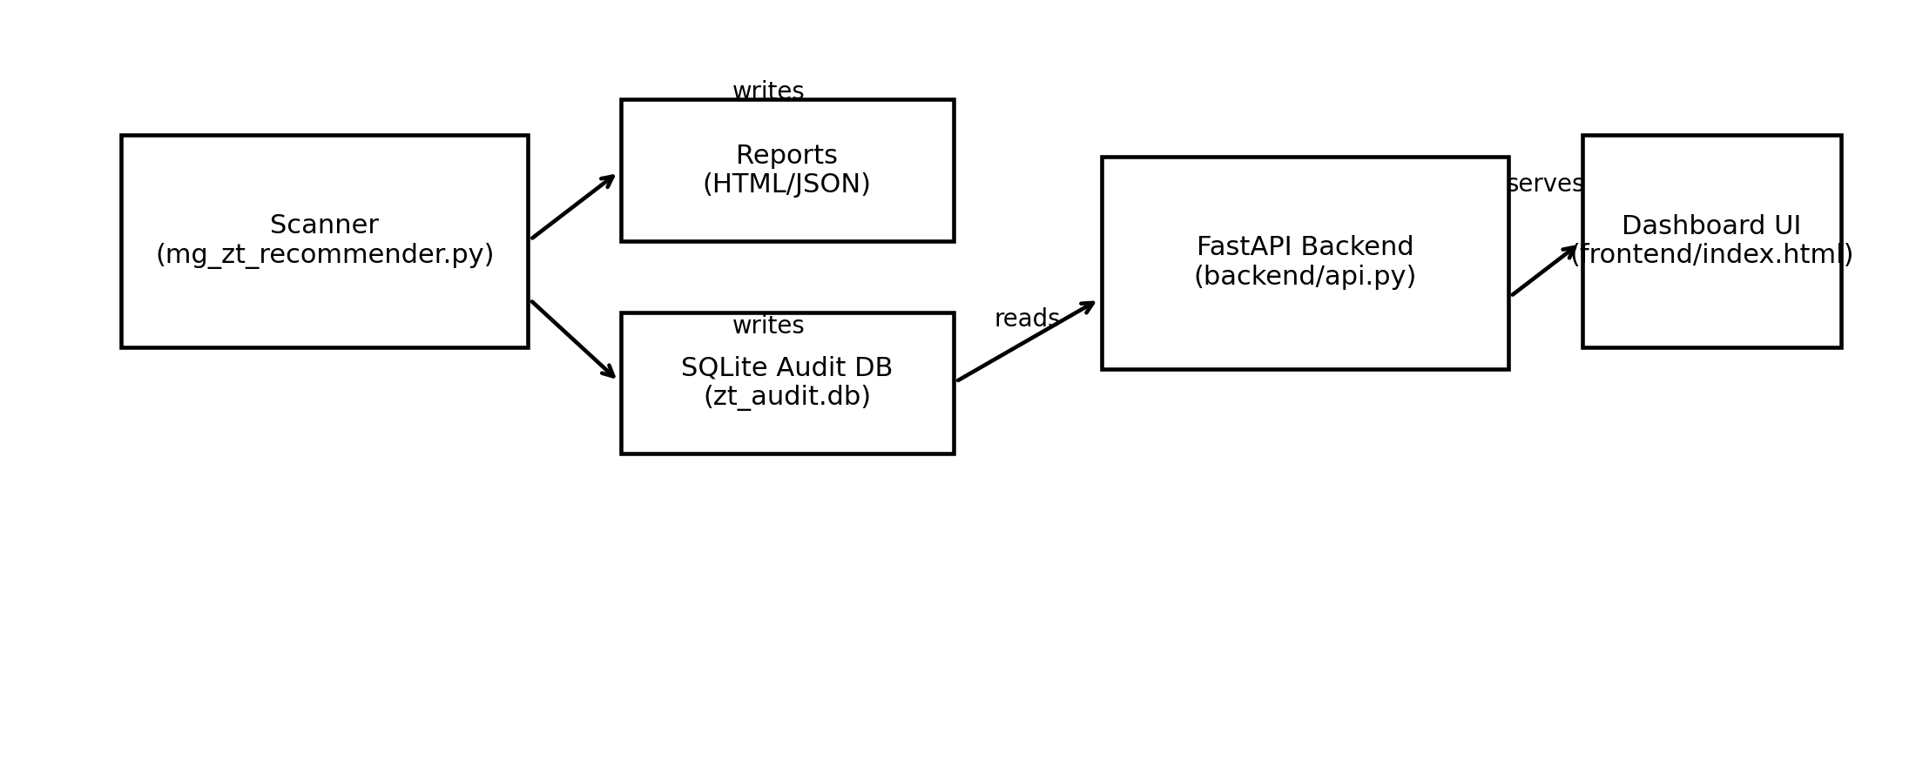
Figure 1: MGZT architecture (scanner → outputs/DB → API → dashboard).

5. Implementation

5.1 Scanner
The scanner is a Python script that authenticates to Azure using DefaultAzureCredential (typically via Azure CLI login). It enumerates Resource Groups (optionally filtered by a prefix) and runs a defined set of security checks. Each check produces either (a) a finding with severity, evidence, and recommendations, or (b) an informational coverage note when full evaluation is not possible.

5.2 Findings Model
A finding is any configuration setting, misconfiguration, or service exposure that may pose a threat to Resource Group security. Findings are standardised into a consistent structure so they can be stored, compared across scans, and displayed uniformly in the dashboard. Each finding includes: check ID, severity, category, affected resource, evidence, and remediation guidance.

5.3 Scoring Model
Each Resource Group is assigned a score (0–100) to provide a simple reference point for comparing scans and visualising overall posture. The score is derived from the number and severity of findings; High findings reduce the score more than Medium, Low, or Info findings. The score is not intended to be a formal compliance metric, but a practical way to track progress during remediation.

5.4 Audit Database (SQLite)
The SQLite database stores multiple scans together so MGZT can create an audit trail. Persisting results enables scan comparisons and trend graphs without requiring any external services.
Figure 2 summarises the database schema used by MGZT.
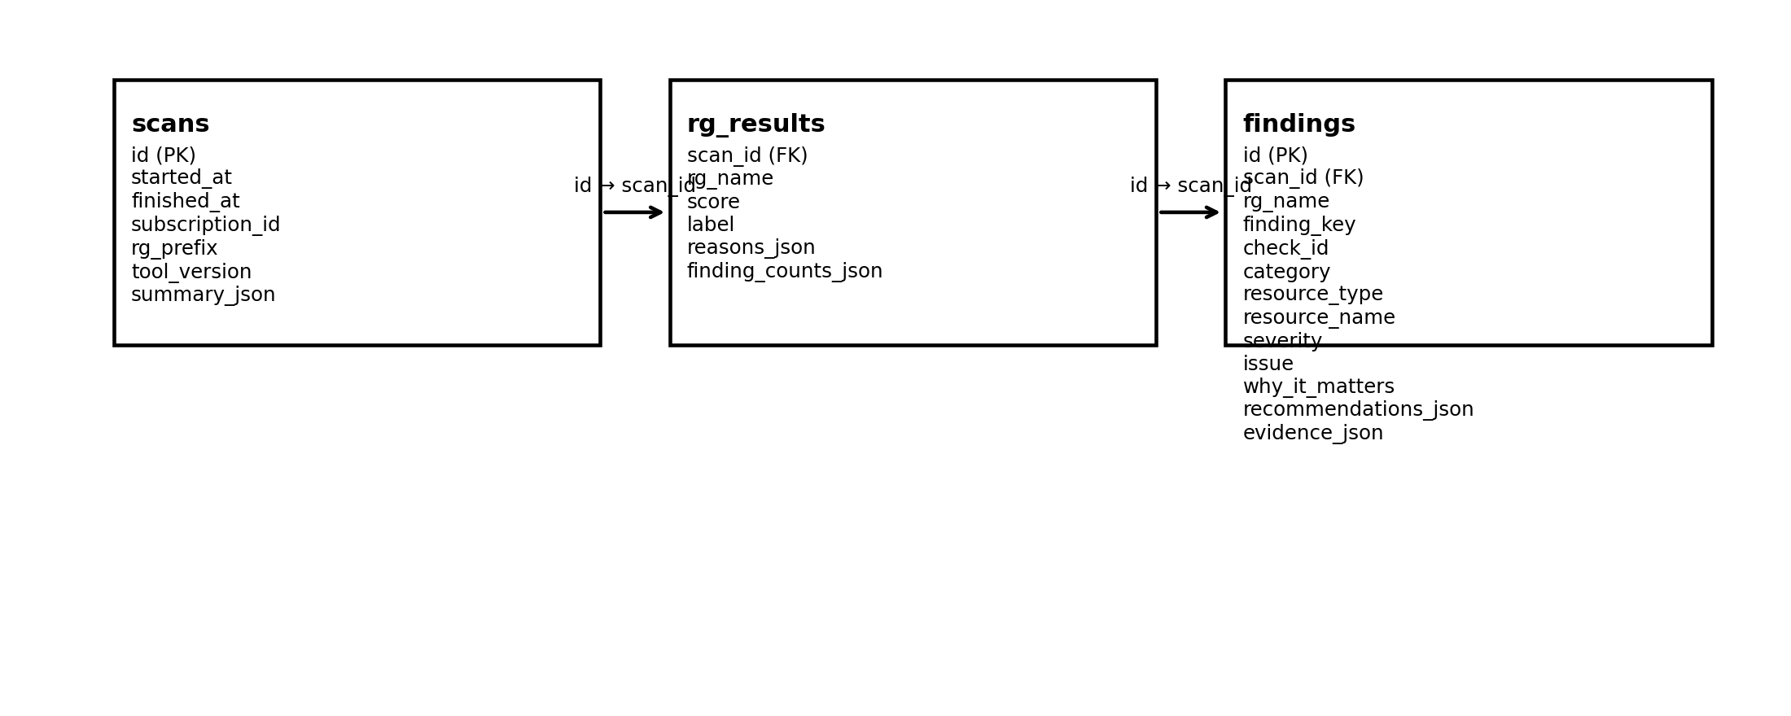
Figure 2: SQLite schema (scans, rg_results, findings).

5.5 Backend API (FastAPI)
A lightweight FastAPI backend exposes scan data stored in SQLite through endpoints such as: list scans, scan details, findings, scan diff, and trend data. It also exposes an endpoint that triggers the scanner via subprocess so a user can run new scans directly from the dashboard.

5.6 Dashboard
The dashboard is a simple web UI that loads scan history, allows selecting scans, filtering findings, and expanding each finding to show beginner-friendly guidance. It also supports scan comparison (new/resolved/unchanged) and a trend graph that visualises progress across scans.

5.7 Checks Implemented
- NSG_PUBLIC_INBOUND_ALLOW — Detects NSG inbound rules allowing traffic from the public internet.
- NSG_RISKY_PORT_PUBLIC — Detects risky management ports exposed publicly (e.g., SSH/RDP).
- PUBLIC_IP_PRESENT — Detects public IP resources allocated in the Resource Group.
- RBAC_HIGH_PRIVILEGE_INHERITED — Detects inherited high privilege RBAC roles applying to a Resource Group.
- RG_DELETE_LOCK_MISSING — Detects Resource Groups missing a CanNotDelete/ReadOnly lock.
- STORAGE_ALLOW_BLOB_PUBLIC_ACCESS — Detects storage accounts where public blob access is allowed at account level.
- STORAGE_FIREWALL_DEFAULT_ALLOW — Detects storage accounts with firewall default action set to Allow.
- STORAGE_PUBLIC_CONTAINER — Detects blob containers configured for anonymous public access.
- STORAGE_PUBLIC_NETWORK_ACCESS — Detects storage accounts reachable via public network access.

6. Testing and Evaluation

6.1 Purpose of Testing
Testing was designed to prove that MGZT works end-to-end (scan → database → dashboard), detects misconfigurations reliably, and can show measurable improvement after remediation. The evaluation also included a short peer usability review to assess clarity for beginners.

6.2 Test Environment and Scenarios
Testing used four controlled Resource Groups designed to demonstrate specific categories of issues:
- MG-ZT-DATA-RG: Storage exposure scenario (public container and permissive storage settings).
- MG-ZT-GOOD-RG: Control baseline (expected to remain stable and low-risk).
- MG-ZT-IAM-RG: Identity/RBAC scenario (inherited high-privilege role assignment).
- MG-ZT-NET-RG: Network exposure scenario (public inbound rule and risky port exposure).
Three scans were captured:
• Scan 1 (baseline): initial scan with intentional misconfigurations.
• Scan 2 (after storage fix): storage settings were remediated in MG-ZT-DATA-RG.
• Scan 3 (after network fix): NSG/public exposure was tightened in MG-ZT-NET-RG.

6.3 Expected Outcomes
Before running the scans, the following outcomes were expected:
Scenario / RG | Expected change | How it is verified
MG-ZT-DATA-RG | Storage-related High/Medium findings reduce after Scan 2; score increases. | Severity totals + RG score trend + compare scans.
MG-ZT-NET-RG | Network-related High/Medium findings reduce after Scan 3; score increases. | Severity totals + RG score trend + compare scans.
MG-ZT-GOOD-RG | Remains stable as a control baseline. | Stable score and only Info items.
MG-ZT-IAM-RG | Likely remains stable due to inherited RBAC roles (constraint). | Stable findings across scans; documented limitation.

6.4 Results
Table 1 summarises total findings by severity across the three scans.
Scan | Timestamp | High | Medium | Low | Info
Scan 1 (baseline) | 2026-03-17T15:46:58 | 3 | 5 | 3 | 3
Scan 2 (after storage fix) | 2026-03-17T15:50:50 | 2 | 2 | 3 | 5
Scan 3 (after network fix) | 2026-03-17T15:53:02 | 1 | 1 | 3 | 5
How to read Table 1: decreasing High/Medium counts indicate improved security posture.
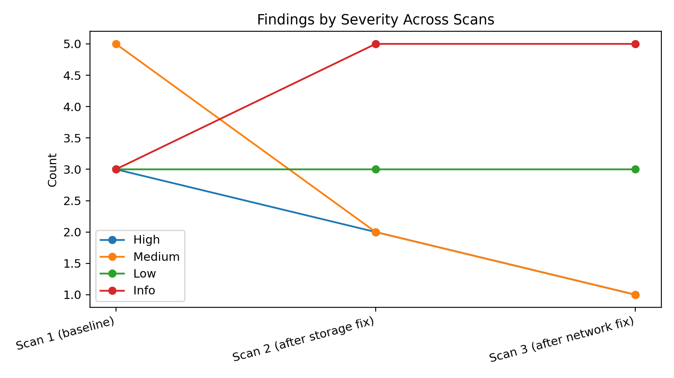
Figure 3: Findings by severity across scans.
Table 2 shows Resource Group scores and High/Medium counts per scan.
Scan | Resource Group | Score | Label | High | Medium
Scan 1 | MG-ZT-DATA-RG | 45 | High risk | 1 | 3
Scan 2 | MG-ZT-DATA-RG | 95 | Good | 0 | 0
Scan 3 | MG-ZT-DATA-RG | 95 | Good | 0 | 0
Scan 1 | MG-ZT-GOOD-RG | 100 | Good | 0 | 0
Scan 2 | MG-ZT-GOOD-RG | 100 | Good | 0 | 0
Scan 3 | MG-ZT-GOOD-RG | 100 | Good | 0 | 0
Scan 1 | MG-ZT-IAM-RG | 75 | Needs work | 1 | 0
Scan 2 | MG-ZT-IAM-RG | 75 | Needs work | 1 | 0
Scan 3 | MG-ZT-IAM-RG | 75 | Needs work | 1 | 0
Scan 1 | MG-ZT-NET-RG | 55 | High risk | 1 | 2
Scan 2 | MG-ZT-NET-RG | 55 | High risk | 1 | 2
Scan 3 | MG-ZT-NET-RG | 85 | Good | 0 | 1
How to read Table 2: the score is a quick reference for comparing posture per Resource Group.
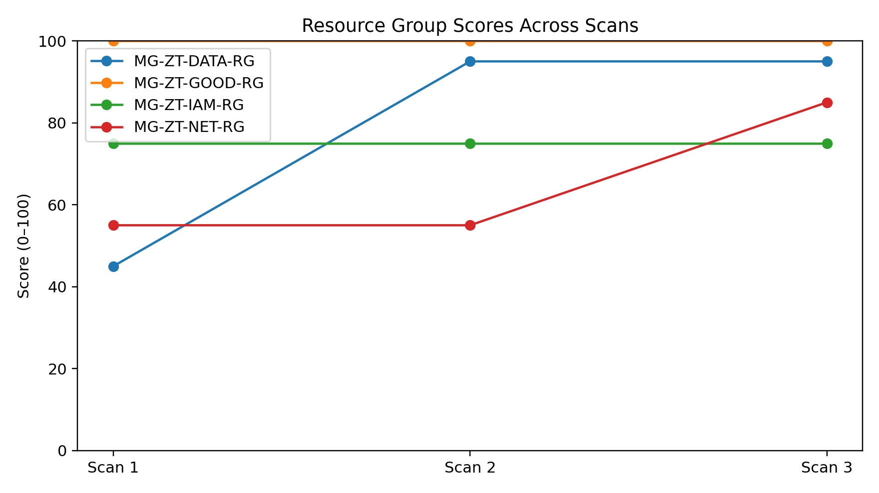
Figure 4: Resource Group scores across scans.

6.5 Evaluation of Results Against Scenarios
The results match the expected outcomes: MG-ZT-DATA-RG improved significantly after the storage remediation (score 45 → 95 and a reduction in Medium findings), and MG-ZT-NET-RG improved after the network remediation (score 55 → 85 and a reduction in High/Medium findings). MG-ZT-GOOD-RG stayed stable as a control baseline. MG-ZT-IAM-RG remained unchanged, which is consistent with inherited RBAC roles being outside the student's control in the university subscription.

6.6 Peer Usability Evaluation (Questionnaire)
A peer tester evaluated setup, scan execution, dashboard usability, explanation clarity, audit features, and overall usefulness. Table 3 summarises average ratings grouped by category (1–5 scale). Note: the current sample size is N=1.
Category | Average rating (1–5)
Setup | 4.00
Dashboard usability | 4.00
Findings & guidance | 4.33
Audit trail features | 4.50
Links & severity | 3.50
Overall, the peer ratings suggest that the dashboard and the beginner explanations are clear, with the lowest rating area being documentation links/severity interpretation. This is recorded as an improvement area for future work.

7. UI Evidence (Screenshots)
Figures 5–9 provide supporting screenshots from the dashboard.
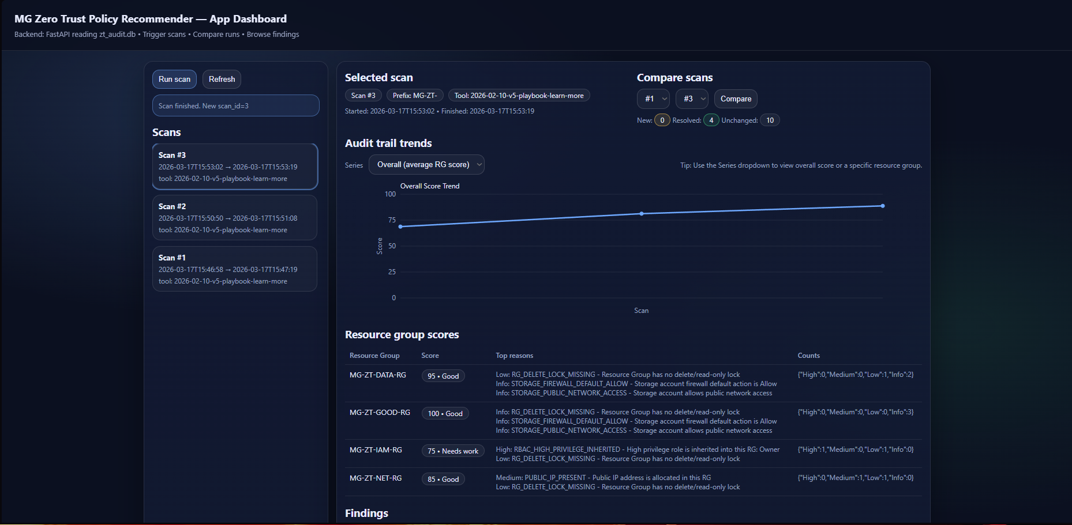
Figure 5: Dashboard scan list (audit trail).
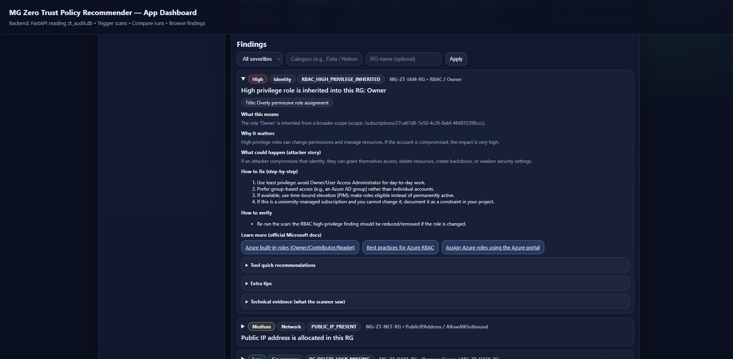
Figure 6: Example High severity finding (collapsed).
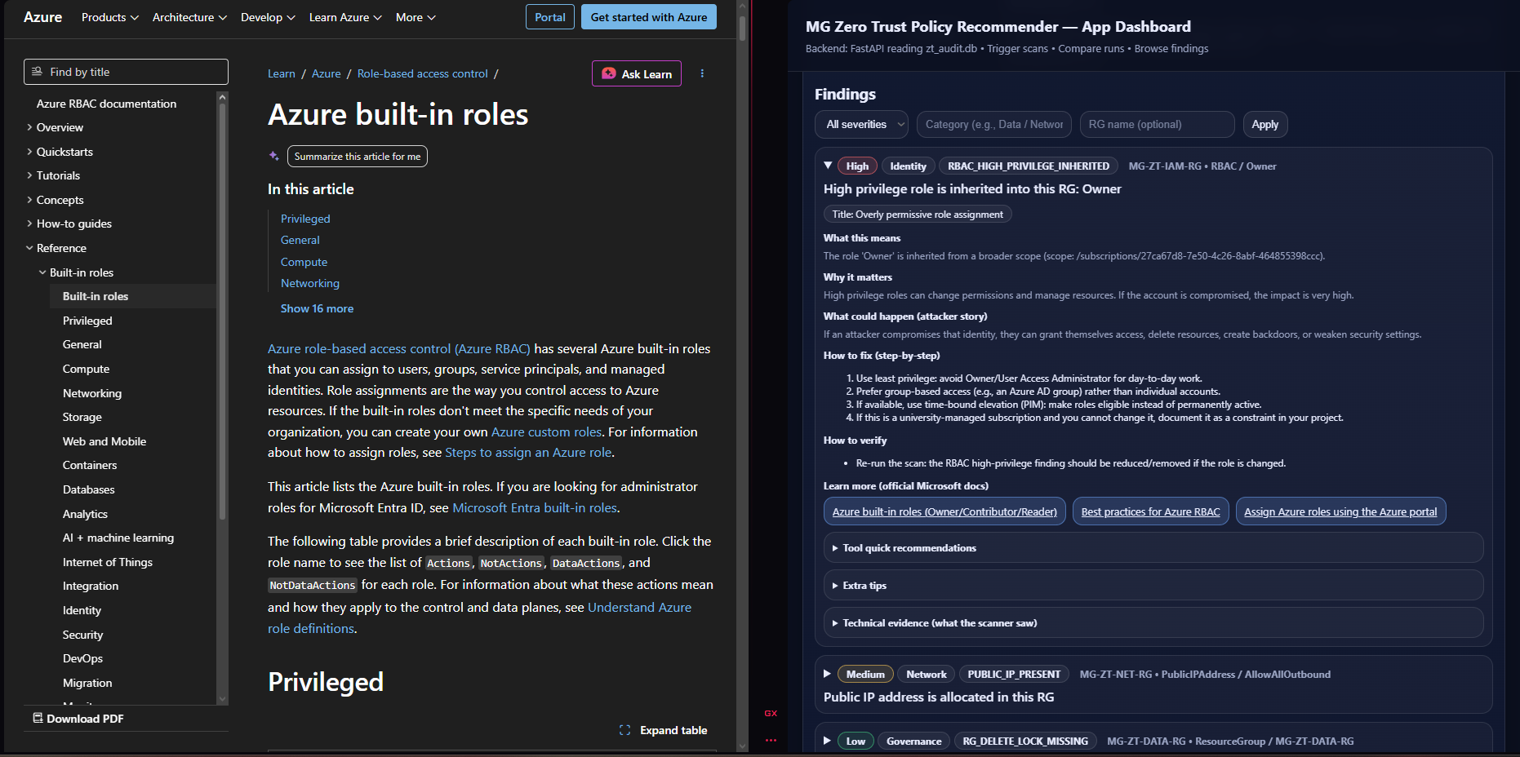
Figure 7: Expanded guidance with Learn More links.

Figure 8: Compare scans (diff view).
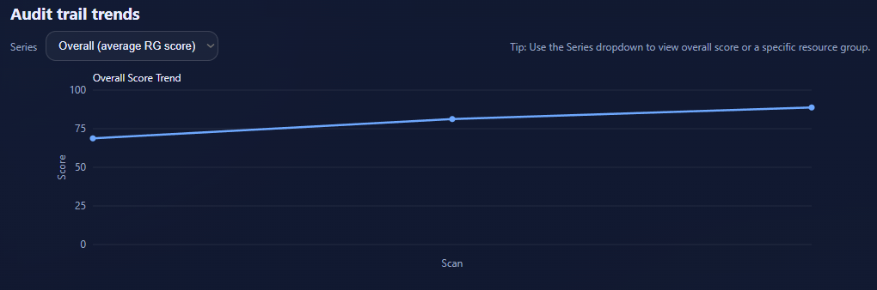
Figure 9: Trend graph (overall average RG score).

8. Discussion

8.1 Strengths
- Beginner-friendly findings that explain what the issue is, why it matters, attacker impact, fix steps, and verification.
- Audit trail features (scan history, compare scans, trend graphs) make security improvement measurable over time.
- Lightweight and portable: runs locally with Python and Azure CLI, with minimal dependencies.

8.2 Limitations
- The check set is intentionally limited in scope to keep the project demonstrable and explainable within an FYP timeframe.
- Accuracy can depend on Azure permissions and subscription-level policies; some checks may be partially evaluated if access is restricted.
- Inherited RBAC roles in a university-managed subscription can produce findings that cannot be remediated by a student user; these must be documented as constraints.
- Peer evaluation sample size is currently small (N=1).

9. Reflection and Project Review

9.1 Problems Encountered and Resolutions
- Azure authentication and MFA expiry: resolved by documenting re-login steps and providing an Azure login helper script.
- Python version incompatibility (3.14) causing dependency build failures: resolved by documenting supported versions (3.11/3.12) and rebuilding the venv when needed.
- Windows script execution limitations: resolved by using CMD runners instead of PowerShell-only scripts.
- Packaging reliability: learned not to ship a virtual environment in the final product and to keep the run workflow simple for testers.

9.2 What Was Achieved
- A working Azure scanner with a consistent findings model, evidence, and remediation guidance.
- A persistent SQLite audit trail storing multiple scans for comparison.
- A dashboard that displays scan history, filters findings, compares scans, and shows trend graphs.
- Testing evidence demonstrating measurable improvements across controlled remediation steps.

9.3 What Was Not Achieved
- Cloud-hosted execution of the tool (planned as future work / separate module work).
- Additional check coverage beyond the current set (could be expanded in future work).

9.4 What Was Learned
This project strengthened practical understanding of Azure security misconfigurations, Zero Trust concepts (least privilege and reduced exposure), and the engineering required to turn checks into a usable tool. Key learning areas included Azure authentication flows, RBAC/NSG/storage configuration, storing results for audit trail comparisons, and presenting findings in a beginner-friendly way.

9.5 What I Would Do Differently
- Collect peer feedback earlier to guide the UI and explanation style sooner.
- Design the data model and scoring rules earlier, then keep them stable to reduce rework.
- Add simple automated tests for core functions (e.g., stable finding keys, DB writes).

10. Conclusion and Future Work
MGZT Azure Policy Recommender demonstrates an end-to-end workflow for auditing Azure configurations: scanning selected Resource Groups, normalising findings, persisting results for an audit trail, and presenting a beginner-friendly dashboard. Testing showed measurable improvements after remediation actions, and peer feedback suggests the tool is generally clear and usable for beginners.
Future work could include:
- Expanding the check library (e.g., Key Vault hardening, logging/diagnostics coverage).
- Improving exclusion/deduplication logic for known inherited roles in managed subscriptions.
- Adding export options (PDF/CSV) from the dashboard.
- Optional cloud deployment of the dashboard/scanner for centralised use.

References
- Microsoft Learn. Azure network security groups overview.
- Microsoft Learn. Azure Storage network security overview.
- Microsoft Learn. Configure anonymous read access for containers and blobs.
- Microsoft Learn. Best practices for Azure RBAC.
- Microsoft Learn. Lock your Azure resources to protect your infrastructure.
- NIST. Zero Trust Architecture (SP 800-207).

Appendix A: Resource Groups Used for Testing
The following Resource Groups were created to support repeatable testing. Each group was designed to demonstrate a category of misconfiguration or act as a control baseline.

MG-ZT-GOOD-RG
Control baseline. Intended to remain stable with no High/Medium findings. Contains a storage account with safer public access settings (no public containers).
Baseline findings (Scan 1):
- Info — RG_DELETE_LOCK_MISSING: Resource Group has no delete/read-only lock
- Info — STORAGE_FIREWALL_DEFAULT_ALLOW: Storage account firewall default action is Allow
- Info — STORAGE_PUBLIC_NETWORK_ACCESS: Storage account allows public network access

MG-ZT-DATA-RG
Storage exposure scenario. Baseline includes a public blob container and permissive storage settings to demonstrate data exposure findings.
Baseline findings (Scan 1):
- High — STORAGE_PUBLIC_CONTAINER: Storage container is public (blob)
- Medium — STORAGE_ALLOW_BLOB_PUBLIC_ACCESS: Storage account allows blob public access
- Medium — STORAGE_FIREWALL_DEFAULT_ALLOW: Storage account firewall default action is Allow
- Medium — STORAGE_PUBLIC_NETWORK_ACCESS: Storage account allows public network access
- Low — RG_DELETE_LOCK_MISSING: Resource Group has no delete/read-only lock

MG-ZT-NET-RG
Network exposure scenario. Baseline includes an NSG inbound rule allowing SSH from any source and a public IP resource to demonstrate attack surface risks.
Baseline findings (Scan 1):
- High — NSG_RISKY_PORT_PUBLIC: NSG exposes risky port 22 to the public internet
- Medium — NSG_PUBLIC_INBOUND_ALLOW: NSG has an inbound rule that allows traffic from the public internet
- Medium — PUBLIC_IP_PRESENT: Public IP address is allocated in this RG
- Low — RG_DELETE_LOCK_MISSING: Resource Group has no delete/read-only lock

MG-ZT-IAM-RG
Identity/RBAC scenario. Used to demonstrate inherited high-privilege role assignments (e.g., Owner) applying to the Resource Group.
Baseline findings (Scan 1):
- High — RBAC_HIGH_PRIVILEGE_INHERITED: High privilege role is inherited into this RG: Owner
- Low — RG_DELETE_LOCK_MISSING: Resource Group has no delete/read-only lock

Appendix B: Peer Evaluation Questionnaire (Full Text)

Section 1 — Initial Information
- Tester name/initials; Date; Device/OS; Azure/Cloud experience: None/Beginner/Intermediate/Advanced

Section 2 — Setup & Initialization
- Download/extract successful? (Yes/No) + If no, what went wrong?
- Run tool using provided instructions/CMD runner? (Yes/No) + If no, error?
- Prereqs already installed: Python / Azure CLI / None
- Setup time: <5 / 5–10 / 10–20 / >20 minutes
- Clarity of setup instructions (1–5)

Section 3 — Running Scans
- Initial scan successful? (Yes/No)
- Scan appears in dashboard history? (Yes/No/Not sure)
- Results load correctly (findings populated)? (Yes/No/Not sure)
- Scan duration: <1 / 1–3 / 3–5 / >5 minutes
- Any authentication issues? (No/Yes) + Describe

Section 4 — Dashboard Usability (1–5)
- Layout is clear; Audit trail easy to understand; Severity filter works; Switching between scans is intuitive

Section 5 — Findings & Explanations (1–5)
- Beginner-friendly explanations; Why it's bad; Attacker impact; Fix steps; How to verify; Evidence supports finding

Section 6 — Learn More Links
- Used Learn More? (Yes/No); Links relevance (1–5)

Section 7 — Audit Trail Features
- Ran at least two scans (Yes/No/Not attempted); Used Compare (Yes/No/Not attempted); Compare clarity (1–5); Viewed Trend Graph (Yes/No/Not attempted); Trend usefulness (1–5)

Section 8 — Accuracy & Severity
- Severity feels reasonable (1–5); Describe one finding in own words; Any false positives? (No/Yes) + Describe

Section 9 — Overall Feedback
- Overall rating (1–10); Most useful feature; Most confusing part; Improve first; Additional features expected

Section 10 — Consent
- Consent to use feedback in MGZT evaluation section (Yes/No)

