Project Specification
Phishing SiMULator Tool
Stephen Foley
C00282842

Table of Contents
1. Project Definition 2
1.1 Project Overview: 2
1.2 Key Objectives 2
2. Deliverables 4
2.1 Core Deliverables: 4
2.2 Non-Core Deliverables (Optional Extras) 7
3. User Groups 8
3.1 Administrators and Instructors 8
3.2 End Users 8
4. Success Metrics 8
4.1 Technical Performance Metrics 9
4.2 Behavioural Outcome Metrics 9
4.3 User Satisfaction Metrics 9
4.4 Security Metrics 9
5. Precedent and Innovation 9
6. Project Steps: 10
6.1 Iterations of my project: 10
6.2 Testing 11
6.3 Development Environment 13
7. Conclusion 14
8. References: 15

Project Definition

Project Overview:

Phishing remains one of the most prominent cyberattack methods globally, with incidents involving spear phishing, SMS phishing (smishing), email compromise, and QR-code-based “quishing” increasing over the past five years. These attacks exploit trust, urgency, and the behaviour of people to bypass technical defences and infiltrate organisational infrastructures. The proposed platform will emulate real-world social engineering threats through targeted email and QR simulations, realistic website clones, scheduled multi-round campaigns, and training modules. By blending research with practical training, the tool aims to assess and improve participant resilience, yielding measurable data and actionable insights for instructors and security teams.

Purpose and scope:

    - Deliver a phishing simulation environment/tool that is easy to use.
    - Enable campaigns within academic and small enterprise settings.
    - Provide a design for future extension, such as SMS phishing.

Expected impact:

  - Enhanced user awareness and reduced click rates from students or other end users.
  - Reporting of findings for participants.

Key Objectives
Core simulation capabilities: Targeted email and QR code exploit vectors, simulated website environments, and risk-aware user groups.

Administrative control: Flexible scheduling, user group assignment, allow/deny list configuration, and monitoring.

User-centric training: Micro-learning modules triggered by risky actions, reinforcing detection tactics.

Analytics and profiling: Real-time event logging, dynamic risk scoring, and longitudinal performance tracking.

Ethical compliance: Informed consent workflows, debrief processes, and data minimisation.

Deliverables

Core Deliverables:

Targeted Email Phishing Engine

Functional requirements:

    - Template creation interface with variable fields (name, role, department).
    - Preview and test-send mode to a selected user/group.

  - Acceptance criteria:

    - Admin can launch five distinct email templates in under five minutes.
    - All test emails route to mailboxes successfully.

QR Code Phishing Module

  - Functional requirements:

    - QR generator supporting PNG/SVG export.
    - Mobile/desktop detection logic for redirection.

  - Acceptance criteria:

    - QR codes scan reliably with standard smartphone apps.
    - System logs device type, OS, and timestamp for each scan.

Campaign Scheduler

  - Functional requirements:

    - Calendar-based UI for one-off and recurring campaigns.
    - Randomised send-time algorithm to mimic real threat timing.

  - Acceptance criteria:

    - Ability to schedule daily, weekly, and monthly campaigns with a cohort size up to 500 users.
    - Reports confirm schedule adherence over a one-month pilot.

Website Cloning and Sanitisation

  - Functional requirements:

Automated crawler to fetch HTML, CSS, and images from URLs.

Sanitiser to strip external JavaScript, disable forms, and remove analytics.

Allow users to paste source website code into a text box in the event they do not want to paste a URL.

Acceptance criteria:

Cloned pages visually match the original page.

Real-time Click-through and Submission Logging

Functional requirements:

Event stream capturing email open, link click, QR scan, and simulated form submission.

Data store with timestamp, IP address, user agent, and geolocation (if available).

Acceptance criteria:

Event log grows proportionally to campaign size with zero data loss.

Admin UI displays live event feed with a less than five-second latency.

Immediate Training Feedback

Functional requirements:

Library of short “red flag” explanations for common phishing tactics.

Automatic launch of a training on click or form submit attempt.

Acceptance criteria:

Training displays within five seconds of a click event.

The user can complete micro-learning module and close it to return to normal browsing.

Risk Profiling Engine

Functional requirements:

An algorithm combining click behaviour, time-to-click, submission attempts, and scenario difficulty.

Dashboard showing individual and cohort risk scores over time.

Acceptance criteria:

Risk score correlates with observed click-through rates.

Cohort filtering by risk level functions as expected in UI.

Non-Core Deliverables (Optional Extras)

User Reporting Button

Functional requirements:

The “Report Phish” button is embedded in simulated emails.

Server logic to treat reports as positive behaviours and log accordingly.

Acceptance criteria:

At least 90% of participants can locate and use the button in tests.

Gamified Awareness Quizzes

Functional requirements:

Quiz builder supporting multiple choice and true/false questions.

Leaderboard for friendly competition.

Acceptance criteria:

Admin can author quizzes in under ten minutes.

User Groups

Administrators and Instructors

Roles and responsibilities:

Design and launch campaigns; configure risk thresholds; review analytics; export reports.

Use cases:

Lecturer schedules monthly phishing test for 200 students with varying scenario difficulty.

IT staff review cohort risk trends and schedule refresher training for high-risk groups.

End Users

Characteristics:

Students and staff with diverse technical proficiency.

Varying familiarity with phishing tactics and security awareness.

Use cases:

User receives email, scans QR code, interacts with cloned site, and completes micro-learning.

Participant uses the “Report Phish” button to demonstrate detection skills.

Success Metrics

Technical Performance Metrics

System uptime: ≥ 99% during scheduled campaign windows.

Event logging reliability: Zero event loss at a scale of 1,000 interactions per day.

Response latency: Training feedback appears within 1 second of the click.

Behavioural Outcome Metrics

Click-Through Rate (CTR) Reduction: Average CTR decrease ≥ 20% by the third campaign.

Training Completion Rate: ≥ 90% of users complete micro-learning after click events.

Risk Score Improvement: Median risk score reduction ≥ 15% after four weeks.

User Satisfaction Metrics

Usability survey rating: Mean score ≥ 4.0 out of 5 on clarity, ease of use, and feedback relevance.

Net Promoter Score (NPS): Target NPS ≥ 30 for admins and participants.

Qualitative feedback: Thematic analysis of open-ended survey responses for positive sentiment.

Security Metrics

Less than 5% of participants click on suspicious links/scan QR codes.

Users realise the website/link is fake and have learned to recognise common phishing tactics.

Precedent and Innovation

Application | Core Similarities | Features | Drawbacks
Lucy Security | Multi-vector campaigns , scheduler , reporting | QR code vector, dynamic risk profiling, and in-situ training | More enterprise-oriented for bigger corporations
GoPhish | Email campaigns , Website cloning | Open source and easy to use. | No QR code attack vectors, limited built-in analytics or microlearning , has not been updated in two years
Microsoft Attack Simulator | Schedule phishing tests, basic feedback | Automates campaigns in large orgs, Easy M365 integration | Relies on the Microsoft ecosystem, no website cloning, no risk engine
My Tool | Scheduled campaigns, Multi-vector attack methods | Email templates, QR code generator , real-time reporting and feedback | May lack some advanced features due to time limitations

Project Steps:

Iterations of my project:

Stage 1 October – November

Build a script that will run from CLI-based commands and launch a web server containing basic functionality.

Research and plan project steps and estimate how long it will take me to implement each function.

Work on the Research document.

Stage 2 December – February

Build out core functions such as website cloner, SMTP, QR code creator and other features.

Run Alpha tests with a select group of students to confirm that the Phishing simulator works.

Stage 3 March – April

Add finishing touches to the UI to ensure it looks appealing and works correctly.

Fix any bugs that may be present.

If time allows, I could add the optional features I talked about earlier, such as a user reporting button or a quiz that admins can assign to users.

Testing

Test Group 1

This group will be students from my class who will be informed about this tool and agree to take part in a test. It will be a simple test to confirm the functionality of my tool.

Sample diagram of how a campaign will work.
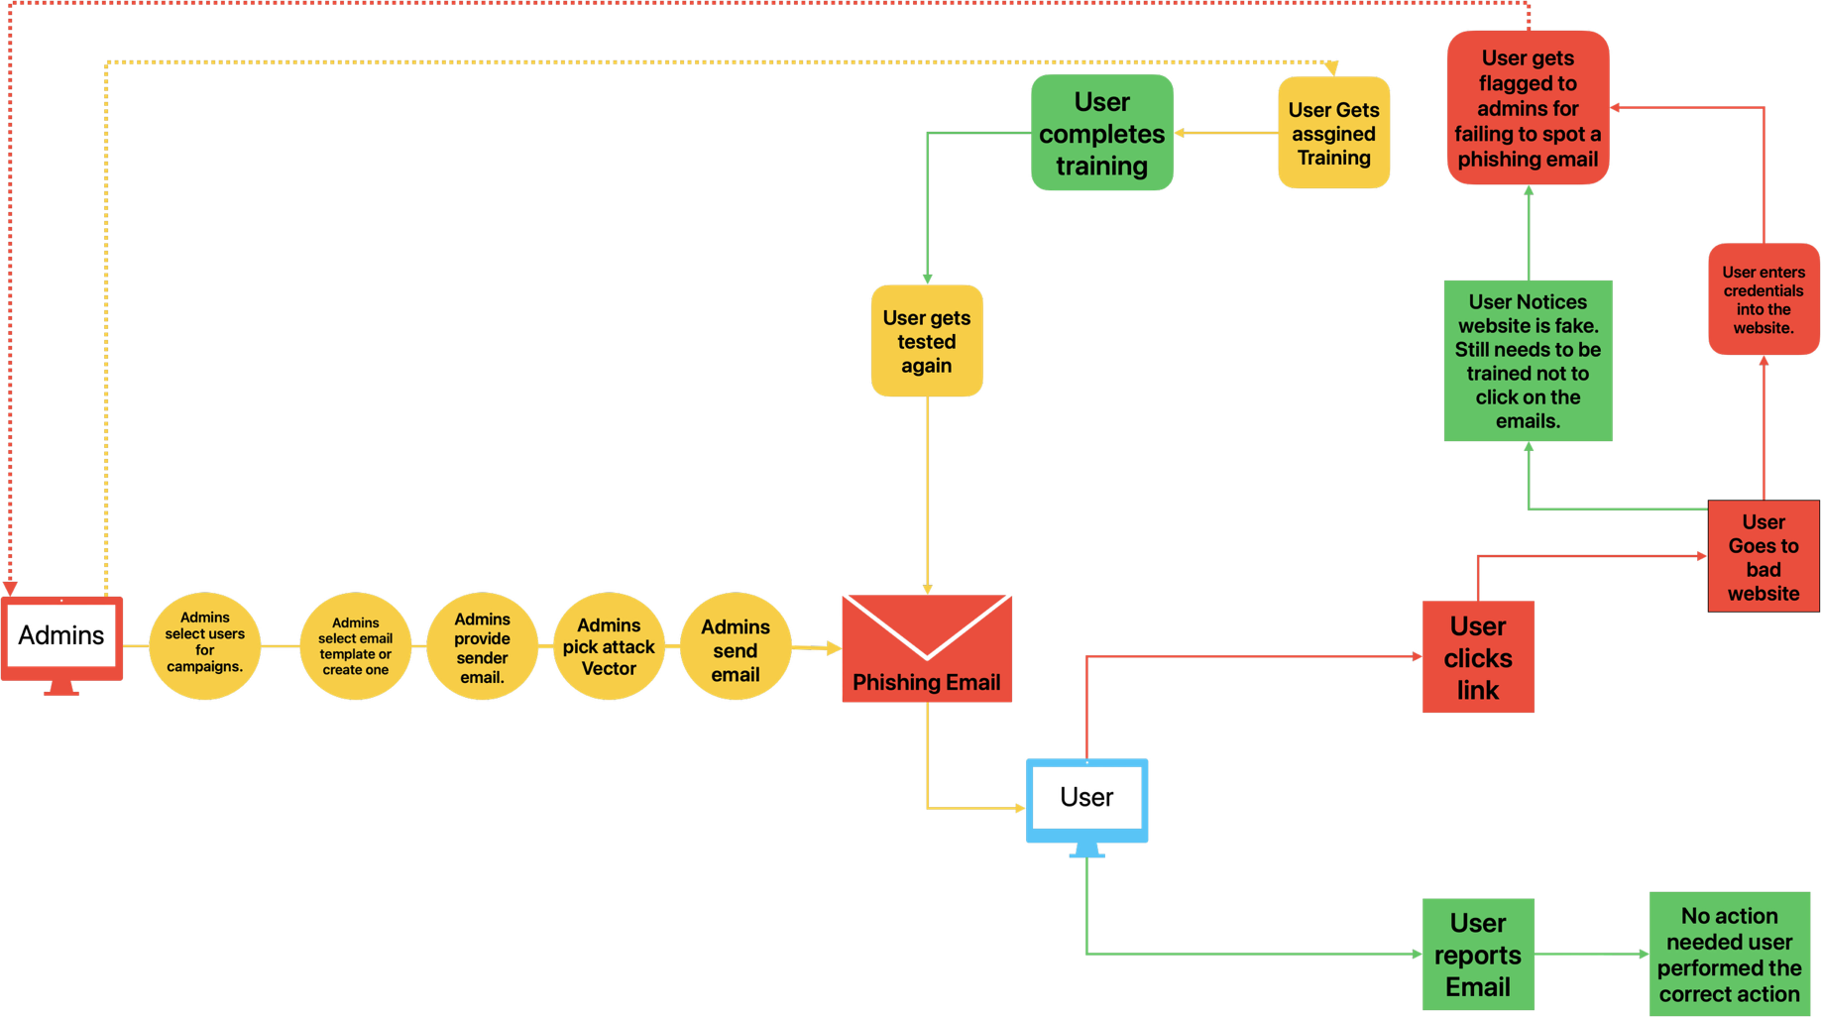

Test Group 2

With the college’s permission, test a staff selection with more advanced attack vectors such as quishing.

Development Environment

Technologies I will Use

Programming Languages:

Python: This programming language is a straightforward programming language to understand and use. It is also lightweight and easy to set up for web environments.

JavaScript (JS): Needed for a lot of web coding functionality, such as form validation.

HTML & CSS: Boilerplate languages for designing a website

SQL: SQL will be used to store data for each campaign.

Bash can be used for automating functions such as starting/stopping the web environment.

Conclusion

Unlike existing tools, my project is designed to offer a unique combination of features which are better suited to small organisations and academic environments. It will have advanced features such as quishing, attack simulation, risk profiling, and immediate feedback for both administrators and end users. These features are present in some existing tools, but each of these has its drawbacks and lack some key features. My tool aims to be easy of use, open source, and up-to-date with the most modern attack vectors.

One challenge I could face is getting the college to agree to let me test the tool with a small group of users within the college environment due to security concerns. Another challenge I could face is finding groups of people outside of college to test my tool on that may not fall for the phishing email due to me informing them and getting their consent to participate in a phishing simulation.

In conclusion, my tool will allow administrators to launch campaigns to test users in their environments with the most up-to-date phishing tactics. The key features of my tool will be ease of use, website cloning, QR code generator, randomised scheduled campaigns and more social engineering and phishing attack methods.

References:

- Abnormal Security (2025) What Is QR Code Phishing (Quishing)? Available at: https://abnormal.ai/glossary/qr-code-phishing-attacks.

- Barracuda (2024) Threat Spotlight: The evolving use of QR codes in phishing attacks. Available at: https://blog.barracuda.com/2024/10/22/threat-spotlight-evolving-qr-codes-phishing-attacks.

- Beu, N. et al. (2023) ‘Falling for phishing attempts: An investigation of individual differences’, Computers & Security. Available at: https://www.sciencedirect.com/science/article/pii/S0167404823002237.

- BlueVoyant (2023) 8 Phishing Types and How to Prevent Them. Available at: https://www.bluevoyant.com/knowledge-center/8-phishing-types-and-how-to-prevent-them.

- Canham, D., Dawkins, R. and Jacobs, R. (2024) Investigating Differential Phishing Susceptibility. NIST Human-Centred Cybersecurity. Available at: https://csrc.nist.gov/csrc/media/Projects/human-centered-cybersecurity/documents/Canham-Dawkins-Jacobs_2024_Not%20All%20Victims%20Are%20Created%20Equal%20-%20Investigating%20Differential%20Phishing%20Susceptibility.pdf.

- Cloudflare (2024) What is quishing? Available at: https://www.cloudflare.com/learning/security/what-is-quishing/.

- CycSafe (2021) Social engineering attacks: a phishing case simulation. Available at: https://www.cybsafe.com/research-library/social-engineering-attacks-a-phishing-case-simulation/.

- CycSafe (2023) Measuring the effectiveness of security awareness programs. Available at: https://www.cybsafe.com/blog/measuring-the-effectiveness-of-security-awareness-training/.

- CyberPilot (2020) Whitelisting Overview – For Phishing Simulations. Available at: https://www.cyberpilot.io/cyberpedia/whitelisting-overview-for-phishing-simulations.

- CrowdStrike (2024) What is Phishing? Techniques and Prevention. Available at: https://www.crowdstrike.com/en-us/cybersecurity-101/social-engineering/phishing-attack/.

- Guardian Digital (2024) Protection Against Phishing Attacks: A Complete Guide. Available at: https://guardiandigital.com/resources/blog/guide-on-phishing.

- Hoxhunt (2025) QR Code Phishing (Quishing) Explained. Available at: https://hoxhunt.com/blog/quishing/.

- Infosec IQ (2023) Phishing Simulator: 2000+ Realistic Templates. Available at: https://www.infosecinstitute.com/iq/phishing-simulations/.

- IJACSA (2025) Phishing Simulation as a Proactive Defense. Available at: https://thesai.org/Downloads/Volume16No6/Paper_104-Phishing_Simulation_as_a_Proactive_Defense.pdf.

- INKY (2020) What is Whitelisting and Blacklisting in Email Security? Available at: https://www.inky.com/en/blog/what-is-whitelisting-and-blacklisting-in-email-security.

- IRONSCALES (2024) Clone Phishing. Available at: https://ironscales.com/guides/phishing-prevention/clone-phishing.

- KnowBe4 (2024) Create a Clone Phishing Test. Available at: https://support.knowbe4.com/hc/en-us/articles/11457524666387-Create-a-Clone-Phishing-Test.

- KnowBe4 (2025) Whitelisting Guide. Available at: https://support.knowbe4.com/hc/en-us/articles/203645138-Whitelisting-Guide.

- MetaCompliance (2025) How To Measure The Success Of Your Security Awareness Training. Available at: https://www.metacompliance.com/blog/cyber-security-awareness/how-to-measure-the-success-of-your-security-awareness-training-program.

- MicroMinder (2024) Analysing Security Training Impact. Available at: https://www.micromindercs.com/blog/effectiveness-of-security-awareness-training.

- NCSC Ireland (n.d.) Quick Guide: QR Code Phishing & Scams. Available at: https://www.ncsc.gov.ie/pdfs/Quick_Guide_QR_Code_Phishing_Scams.pdf.

- Omdia (2021) Strategies for assessing cybersecurity awareness training effectiveness. Available at: https://cybeready.com/wp-content/uploads/2021-Omdia-Companion-Strategies-for-assessing-cybersecurity-awareness-training-effectiveness-1-1.pdf.

- Prümmer, J. et al. (2025) ‘Assessing the effect of cybersecurity training on End-users’, Computers & Security. Available at: https://www.sciencedirect.com/science/article/pii/S016740482400511X.

- Przymus, Z. et al. (2024) ‘The human factor in cybersecurity: from risk profiles to diagnostics’, Procedia Computer Science. Available at: https://www.sciencedirect.com/science/article/pii/S1877050924026383.

- Schöps, M. et al. (2024) ‘A Case Study of the Effects of a Simulated Phishing’, USENIX Security. Available at: https://www.usenix.org/system/files/usenixsecurity24-schops.pdf.

- SentinelOne (2025) Cyber Security Risk Assessment: Step-by-Step. Available at: https://www.sentinelone.com/cybersecurity-101/cybersecurity/cyber-security-risk-assessment/.

- Thomopoulos, G. (2023) ‘Methodologies and Ethical Considerations in Phishing Research’, Proceedings of ACM. Available at: https://dl.acm.org/doi/10.1145/3609987.3609990.

- TitanHQ (2025) How Clone Phishing Works. Available at: https://www.titanhq.com/phishing-protection/how-clone-phishing-works/.

- Trend Micro (2024) QR Codes: Convenience or Cyberthreat? Available at: https://www.trendmicro.com/en_us/research/24/g/mitigate-risk-of-QR-code-phising-attacks.html.

- Unit 42 (2025) Evolution of Sophisticated Phishing Tactics: The QR Code. Available at: https://unit42.paloaltonetworks.com/qr-code-phishing/.

