Project Spec & Plan
Michael O’Neill – c00262983
Supervisor
Christopher staff

Contents
Introduction 2
Project Overview 2
Who it’s for 4
Inspiration 5
Use Case diagram 6
Use Cases 7
Google Chrome Extension API (JavaScript/HTML/CSS) 9
Large Language Model (Llama 3, PyTorch/TensorFlow) 9
Backend Infrastructure (Python, FastAPI/Flask) 9
Web Scraping and Search Modules (BeautifulSoup, Selenium, Requests) 9
WHOIS and Domain Reputation APIs 10
Machine Learning Libraries (scikit-learn, XGBoost, Pandas, NumPy) 10
Deliverables 10
Plan 12
References 14

Introduction
- With phishing attacks on the rise and posing severe risks to individuals and organizations, this project leverages advanced AI techniques to help users identify suspicious communications disguised as legitimate messages from well-known companies. The solution focuses on integrating a fine-tuned Large Language Model (LLM), specifically Llama 3, to validate suspicious emails or messages by checking publicly available rules, regulations, and official statements pertaining to target companies. This way, the AI can guide users by referencing the real company’s policies, increasing trust in detection, and decreasing false positives for legitimate communication. According to AAG (2025) For Q1 2022, LinkedIn was the most imitated brand for phishing attempts globally. The top 5 most imitated brands in Q1 2022 were:
  - LinkedIn (52%)
  - DHL (14%)
  - Google (7%)
  - Microsoft (6%)
  - FedEx (6%)

Project Overview
This project is designed as a practical, human approach for detecting phishing attacks that impersonate real organizations, focusing especially on emails and messages that attempt to steal credentials or commit fraud. At its core is a Chrome browser extension powered by a pre-trained Llama 3 Large Language Model (LLM), which is further fine-tuned on current phishing datasets to keep pace with emerging threats.
How does it work in the real world?
When the extension scans an email or message, it doesn’t just look for suspicious phrases instead it investigates the organization the message claims to be from. The system checks the age and reputation of the sender’s website using live WHOIS data. New domains that suddenly appear in communications are flagged as suspicious, since established companies rarely rely on recently created domains for official correspondence.
The extension then launches a targeted search across that company’s own website running advanced queries that look for official statements about security, privacy, and fraud such as “will never ask,” “phishing,” or “scam” in combination with the organization's site. This allows the AI to find direct evidence on what data the company will (and won’t) request from users. That evidence, together with the content of the received email, is sent to the LLM for context-based analysis.
Unlike traditional approaches that simply label messages as “malicious” or “safe,” this system provides users with a specific, evidence-based recommendation. For example, if a message claims to be from Amazon’s IT department and asks for a password, the AI can find Amazon’s official policy stating they never request credentials by email, and present the user with a clear warning based on that real company statement.

Supplier invoice fraud:
This is a tactic where attackers trick companies into changing supplier payment details. Here is the automated steps the Chrome extension and its AI backend take in response to supplier invoice fraud scenarios
- Checks whether the sender’s domain and account match previous legitimate interactions.
- Scans for discrepancies in payment instructions compared to supplier’s official recommendations, using published business practices or prior emails.
- Warns users if the instructions differ from verified supplier communications or known company guidance e.g. “The payment instructions in this email do not match those provided previously by your supplier. Please verify directly with your accounts team.”

Technical Summary:
- Chrome extension frontend scans emails and messages in real time.
- AI backend leverages Llama 3, fine-tuned on up to date phishing and fraud datasets.
- Policy retrieval module runs automated searches to find relevant company policies, using dynamic queries like (“"will never ask" OR "never request" OR "never email you for" OR phishing OR scam OR fraud OR suspicious site:company.com”).
(“security policy" OR "fraud warning" OR "phishing advice" OR "scam alerts") site:company.com”)
("account safety" OR "protect yourself" OR "common scams") site:company.com)
- The system uses WHOIS and domain reputation checks to gauge sender legitimacy.
- User notifications are deeply contextual, linking warnings to specific company statements and highlighting any red flags found.
Why this works:
This application allows users to independently verify claims in suspicious messages, making high level cybersecurity reasoning accessible to everyone whether you’re receiving a fake bank email, a fraudulent supplier invoice, or an unexpected password reset notice. Instead of forcing users to search for policies themselves, the extension quickly analyses, searches, and explains its findings in natural language.
Imagine opening an email that looks real but suddenly asks for your login details. Instead of guessing, you’ll receive a prompt:
“This message might be malicious. The company’s official website states they never ask for credentials via email. The sender’s website was created only last week please proceed with caution.”
In summary, this project delivers a modern, adaptive defence against phishing and invoice fraud using AI’s deep understanding and fact-based analysis to keep users safe against increasingly sophisticated scams.

Who it’s for
This application is designed for a wide range of users who rely on email and web communication especially those who face risks of phishing, invoice fraud. The extension is valuable for individual internet users, employees in organizations (from technical staff to those in finance or administration), and business owners who need to spot and prevent attacks targeting their payments or credentials.
It helps people who may not have much prior knowledge about phishing or common scams by automating technical checks and providing plain language warnings, without requiring them to search for information themselves. The extension is a powerful tool for companies as it detects fraudulent emails including internal threats by checking sender reputation, message consistency, and policies directly from trusted organizations.
Whether you’re reviewing payment instructions, checking requests from suppliers, or just browsing everyday emails, this tool allows both experienced professionals and everyday users to make safer decisions by reducing risk for individuals and organizations alike.

Inspiration
The rising complexity of phishing attacks especially those that mimic real organizations or attempt to redirect payments has made traditional email warnings and simple filters feel outdated. While working on this project, one of the big motivations was seeing firsthand how easy it is for both everyday people and experienced professionals to be tricked by convincing emails asking for login information, payment details, or urgent action. News stories and recent high-profile cases of supplier invoice fraud, where companies lost thousands due to a single deceptive email, really highlighted that this wasn’t just a problem for big corporations, anyone could be a target. According to the RTE (2025) the total value of fraudulent payments in Ireland increased to €160 million in 2024 - up nearly 25% from the previous year.
Another driving force is the gap between the technical defences available to security experts and ordinary users. The idea was to build a tool that would “think” like a cybersecurity professional by fact checking claims, verifying company policies, and checking for red flags while making the intelligence accessible and easy to act on, even for people unfamiliar with phishing tactics.

Use Case diagram
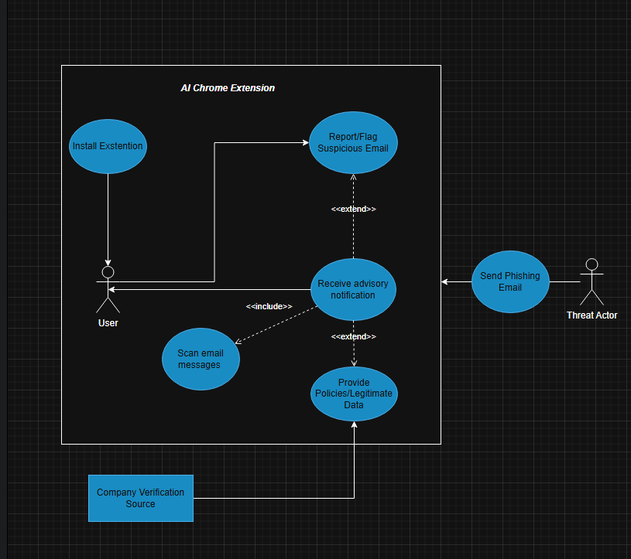

User:
The user is the person/organisation running the AI Chrome Extension to protect themselves from phishing attacks and fraudulent emails. They start with installing the Extension and then scanning email messages either on demand or automatically. After a scan they may receive an advisory notification (warning/informative message). If the extension detects something suspicious the user can take further action by reporting or flagging the email

Threat Actor:
The Threat Actor represents a cybercriminal or attacker attempting to deliver a phishing or invoice fraud email to the User. They send a phishing email, which is received and scanned by the User’s extension.

Company Verification Source:
This actor provides external data or policy statements for the extension to verify suspected phishing claims (e.g., the company’s official website, WHOIS records).

Use Cases

Use Case | Install Extension
Actors | User
Description | User Installs the AI Extension to enable email phishing detection
Precondition | User has access to the Chrome browser and the extension is available for installation.
Main Success Scenario | The user successfully adds the extension to their browser.
Postcondition | The extension is operating and ready to scan incoming emails/messages.

Use Case | Scan Email Messages
Actors | User
Description | Scans email for potential phishing/fraud risks manually/automatically
Precondition | Extension is installed and email/message is available for scanning
Main Success Scenario | The extension analyses the content and starts the detection process
Postcondition | Results from the analysis are prepared for user review

Use Case | Receive Advisory Notification
Actors | User
Description | the extension delivers an advisory notification, highlighting whether the message is safe or suspicious
Precondition | An email/message has been scanned and analysed.
Main Success Scenario | User receives a clear, evidence-based notification about message safety.
Postcondition | User is informed and can decide how to respond to the message.

Use Case | Report/Flag Suspicious Email
Actors | User
Description | If prompted by the advisory notification, the user can report or flag the suspicious email/message for further investigation
Precondition | Advisory notification indicates suspicion or fraud.
Main Success Scenario | Email/message is successfully flagged and logged for action.
Postcondition | Suspicious message is marked, and the User is informed

Use Case | Company Verification Source
Actors | User
Description | The extension queries external sources (such as the organization’s official website, WHOIS data, or public advisories) to verify the legitimacy and policies referenced in the email/message.
Precondition | Extension identifies a message as potentially risky and requires external data for verification.
Main Success Scenario | Extension retrieves accurate, up to date policy data for comparison.
Postcondition | Advisory notification is enhanced with relevant supporting evidence from real policy statements.

Use Case | Threat Actor
Actors | User
Description | The threat actor attempts to deliver a phishing or fraudulent message to the user's inbox
Precondition | Threat actor has the means to send messages to the user.
Main Success Scenario | Email reaches the user’s inbox and is detected by the extension.
Postcondition | Extension scans and processes the email message to warn the user.

Technologies

Google Chrome Extension API (JavaScript/HTML/CSS)
The user facing part of the project is a Chrome browser extension. The Chrome Extensions API provides the foundation for integrating the tool directly into users’ browsers. Using JavaScript for the main logic, HTML for structuring the popup and notification UI, and CSS for styling, you can monitor a user’s inbox or browsing activity in real-time.
With the extension, users can scan messages, view warnings or risk scores, and interact with recommendations all without requiring them to jump between apps or platforms.
https://developer.chrome.com/docs/extensions/reference/api

Large Language Model (Llama 3, PyTorch/TensorFlow)
At the heart of the detection engine lies a large language model (LLM) which will be Llama 3 and this will utilize natural language understanding to phishing detection. The LLM will be fine-tuned on recent phishing and fraud datasets. It can interpret the language and intent in emails far better than static rules or traditional filters. Libraries such as PyTorch or TensorFlow provide the backend support for training, inference, and model serving, so the LLM can process new emails and output human readable verdicts on demand.​
Meta Llama 3 Official Model Card (HuggingFace): https://www.perplexity.ai/search/i-am-a-cybersecurity-student-i-Bku_MM70ThSVGGyatgiWOg

Backend Infrastructure (Python, FastAPI/Flask)
The extension communicates with a Python powered backend service, built using either FastAPI or Flask. This server acts as an intermediary layer receiving message data from the extension, running model inference, coordinating policy lookups, and aggregating results. FastAPI has high speed and asynchronous capabilities, making sure users get near instant feedback. Flask is also popular for its simplicity and scalability. This structure means upgrades such as integrating new models or adding data sources can happen independently from the extension’s interface.​

Web Scraping and Search Modules (BeautifulSoup, Selenium, Requests)
To fact check email claims against official company stances, the system will use web scraping libraries like BeautifulSoup or frameworks like Selenium. These modules run automated searches with carefully crafted queries (e.g., “will never ask” + site:company.com), crawl official websites, and pull authentic statements. The Requests library is essential for reliable web and API calls.

WHOIS and Domain Reputation APIs
One important check is verifying the sender’s domain age and trustworthiness. WHOIS APIs allow the extension to fetch metadata on any domain like its creation date. This helps flag recently registered or suspicious domains that attackers often use. In addition, domain reputation feeds or commercial threat intelligence APIs can further inform the system when a source is risky or blacklisted.​

Machine Learning Libraries (scikit-learn, XGBoost, Pandas, NumPy)
Machine learning tools such as scikit-learn and XGBoost will be used for tasks like feature engineering, secondary classifiers, or analysing URL patterns. Python data science libraries, especially Pandas and NumPy, support data management, cleaning, and research useful exploration. These libraries make ongoing model training, dataset augmentation, and systematic evaluation both feasible and efficient.​

Deliverables
The success of this AI-powered Chrome Extension project relies on the development, validation, and delivery of all essential components and features. The goals are divided into two main groups: core deliverables necessary for the fundamental functioning of the extension, and non-core deliverables that provide additional value, education, or polish. Combined, these deliverables will create a smart, accessible tool for real world phishing and business fraud protection. For a timeline of each deliverable, see the Project Plan section.

Development Core Deliverables
1. Extension Deployment & User Setup
- Testing to cover compatibility with Chrome browser and proper permissions for email/message access.
2. Message Scanning & Analysis
- Core functionality: when an email or web message arrives, the extension can automatically or on user demand scan the content of an email which will scan for suspicious elements (unusual language, requests, links, or attachments).
- Accuracy and performance will be tested with a representative sample of legitimate and phishing/fraud messages.
3. LLM-based Threat Assessment
- Integrates the fine-tuned Llama 3 model to deeply analyse text for risks, mimicking expert reasoning by considering language, intent, and context.
- The backend must be robust enough for real time communication with the extension, returning advice quickly(“this might be suspicious because…..”)
4. Company Policy & WHOIS Verification Module
- The extension will run automatic web searches and use API lookups (WHOIS/domain reputation) to verify if the sender’s domain is legitimate and to pull official company policies about data and payment requests.
- Ensures advisories aren’t just based on “gut feeling,” but cite up to date evidence.
5. Risk Advisory & User Notification System
- Notifies users if a message appears suspicious, providing contextual explanations and direct links to relevant company statements or fraud advisories.
- Design must minimize false positives and present findings clearly, supporting decision making for both technical and non-technical users.

6. Supplier Invoice Fraud Workflow
- Specialized checks comparing incoming “invoice” or “payment instructions” emails with previous legitimate correspondence and published supplier policies.
- Includes tools for flagging mismatched bank details, urgent payment requests, or new account numbers.
- This workflow will be tested using real invoice fraud case scenarios to ensure it recognizes nuanced social engineering attempts.
7. Feedback & Reporting Mechanism
- Allows users to flag false positives/negatives, submit suspicious emails for further analysis, and provide usability feedback.
- Supports continuous improvement of both the machine learning model and data sources.
8. Security & Privacy Safeguards
- The extension will be tested for common extension vulnerabilities and data leakage.
Document Core Deliverables
1. Project Specification Document
- Formal spec outlining the scope, requirements, stakeholders, technical choices, and schedule of the extension project.
2. Research Document
- Details on why certain models, datasets, and detection approaches were chosen, includes analysis of current threat trends and limitations of legacy tools.
3. Presentation
- Visual summary: key findings, workflow diagrams, and screenshots for sharing at conferences, with supervisors, or as part of a final submission.
4. Final Documentation
- Post-project reflection covering achievements, lessons learned, testing results, and possible future improvements.

Non-Core Deliverables
1. User Tutorials & FAQs
- Clear, step by step instructions and “how to” guides for using the extension, understanding advisory messages, and responding to suspicious communications.
2. Additional Security Resources
- Curated library of links and references for users interested in learning more about phishing, scam detection, and online safety. Providing added value to those wishing to go deeper.
3. Sample Dataset & Sandbox
- Demonstration/testing tools, such as downloadable sample phishing/fraud messages, so users or reviewers can see the extension in action in a “safe” training environment.

By assembling these deliverables, the project will not only deliver a working tool but also empower users with the knowledge, training, and resources needed to stay safe from increasingly sophisticated online threats. This structure also ensures the project meets both academic and criteria for a cybersecurity solution.

Plan

Documentation Plan
Phase | Key Activities | Start Date | End Date
Specification & Planning | Define requirements, initial research, deliverables breakdown | Oct 2025 | Oct 24th 2025
Research Doc | Research more on my project | Nov 2025 | Dec 2025
Presentation | PowerPoint showcasing my project | Jan 2026 | Jan 5th 2026
Final Report | A Report on my project and progression in developing it | April 2026 | April 24th 2026
Final Product |  | April 2026 | April 24th 2026

Development Plan
Phase | Key Activities | Start Date | End Date
System Design | Extension architecture, UI/UX mock-ups, use case diagrams | Jan 6th 2026 | Jan 12th 2026
Dataset Collection/Prep | Gather phishing datasets, policy info sources, supplier fraud cases | Jan 12th 2026 | Jan 31st 2026
LLM Model Integration | Fine-tune Llama 3, implement model backend, initial model benchmarking | Feb 10st 2026 | Mar 1st 2026
Extension Development | Code Chrome extension, integrate frontend/backend, UI development | Mar 1st 2026 | Apr 1st 2025

References

AAG (2025) The Latest 2025 Phishing Statistics. Available at: https://aag-it.com/the-latest-phishing-statistics (Accessed 24th October 2025)
RTE (2025) 40% rise in fraudulent payments in Ireland - Central Bank. Available at: https://www.rte.ie/news/business/2025/1017/1539050-central-bank-payment-fraud-statistics-2024 (Accessed 24th October 2025)
Google Chrome (2025) Chrome Developer Manual. Available at: https://developer.chrome.com/docs/extensions/reference/api (Accessed 24th October 2025)
Meta Llama 3 Official Model Card (2025) Hugging Face. Accessed at: https://www.perplexity.ai/search/i-am-a-cybersecurity-student-i-Bku_MM70ThSVGGyatgiWOg

