FINAL YEAR PROJECT REPORT
PhishGuard
A Chrome Extension for AI Augmented Detection
Michael O’Neill
Student Number: C00262983
Supervisor: Christopher Staff
South East Technological University

Table of Contents
Table of Contents 2
1. Project Overview 3
1.1 Key Objectives 3
1.2 Key Achievements 3
2. Introduction 4
3. Background and Related Work 5
3.1 Business Email Compromise 5
3.2 Rule-Based vs. Machine Learning Detection 5
3.3 Large Language Models for Phishing Detection 5
4. System Design and Architecture 6
4.1 Architecture Overview 6
4.2 Architecture Diagram 6
4.3 Signal Extraction and Scoring 6
4.4 Policy Evidence Retrieval 7
4.5 LLM Integration and Prompt Design 7
5. Setup Guide 8
5.1 Before Starting 8
5.2 Installation Steps 8
Step 1 — Install Python dependencies 8
Step 2 — Install and configure Ollama 8
Step 3 Add your SerpAPI key 8
Step 4 Start the backend server 8
Step 5 — Load the Chrome Extension 8
5.3 Running the System 9
5.4 Troubleshooting 9
6. Project Deliverable 9
6.1 Extension Interface 9
6.2 Technologies 9
7. Evaluation and Testing 10
7.1 Standard Phishing test 10
7.2 Filter Bypass test 10
7.3 Limitations 10
8. General Issues 11
8.1 Problems Encountered 11
8.2 Achievements 11
9. What I Learned 12
9.1 Learning Outcomes 12
10.Conclusion 12

1. Project Overview
PhishGuard is a Chrome browser extension that detects phishing emails and Business Email Compromise (BEC) attacks in real time inside Gmail. It combines a rule-based scoring engine with a locally hosted large language model (LLM) to give users both a structured risk score and a reasoned, evidence-backed assessment of suspicious emails.

1.1 Key Objectives
• Detect Business Email Compromise and supplier invoice fraud in real time inside Gmail.
• Build a two mode system: a rule engine for fast, auditable scoring and an AI layer for contextual reasoning.
• Ground AI assessments in real brand policy evidence rather than generic advice.
• Demonstrate the measurable difference between rule only and AI augmented detection.

1.2 Key Achievements
• Chrome Extension: A fully functional Gmail integrated extension with a toggle that switches between rule-engine mode and AI mode.
• Three Stage Backend Pipeline: Signal extraction, real time policy retrieval via SerpAPI, and LLM reasoning via Llama 3.
• Four emails designed to score zero on the rule engine were all correctly identified as attacks by the AI layer.
• Policy Evidence Cards: The popup renders clickable links to the real company's published policies that the AI used to reach its verdict.

2. Introduction
Phishing has become a serious everyday problem for both individuals and organisations as more communication has moved to email over the last decade, attackers have adapted and the most damaging category they've developed is Business Email Compromise. Unlike mass phishing attacks that send out millions of identical messages, BEC attacks are targeted and personal as an attacker impersonates a CEO to pressure a finance employee into sending money or spoofs a suppliers to redirect an invoice payment to a new bank account.
Despite sustained investment in technical controls and awareness programmes, phishing remains the most frequently reported cybercrime and email continues to be one of the dominant attack vectors. BEC losses billions every year and that figure only counts cases that were actually reported. The tools that exist to fight this are either expensive enterprise platforms well beyond the reach of smaller organisations or basic rule based filters that flag keywords like 'urgent' and 'wire transfer' without any understanding of context.
This project set out to explore whether a locally hosted language model could help users spot phishing emails especially those involving supplier invoice fraud and BEC style payment

3. Background and Related Work

3.1 Business Email Compromise
BEC is defined less by technical sophistication than by social engineering the attacks tend to share three consistent features, impersonation of a trusted party, a manufactured sense of urgency and a request that bypasses normal authorisation channels.

3.2 Rule-Based vs. Machine Learning Detection
Rule-based fraud detection systems have been around for decades and remain widely deployed because they're fast, auditable and easy to explain. Comparisons of rule-based and AI-augmented fraud detection have found that rule-based systems produce false positive rates of around 95%, while hybrid ML-augmented systems can reduce that figure by 50–60%.

3.3 Large Language Models for Phishing Detection
Recent evaluations of LLMs on phishing have found that they pick up on subtle contextual cues that rule based systems miss things like an inconsistency between the claimed sender and the email's writing style.
PhishGuard takes a different approach to most LLM-based systems in two different ways, First it uses a small, open source model (Llama 3) running entirely on the user's own machine. Second, rather than relying on the model's training data alone, it retrieves real policy pages from the real company's website at scan time giving the model something concrete and verifiable to reason against.

4. System Design and Architecture

4.1 Architecture Overview
PhishGuard consists of four Chrome extension components and a Python backend the content script reads the rendered Gmail message. The background service worker (background.js) coordinates messaging between the page, popup, and backend. The popup interface (popup.html / popup.js) is what the user sees when they click the extension icon. The Python backend (Pish.py, FastAPI) executes the full threestage detection pipeline.
The toggle determines how much of the pipeline runs. With it off, only Stage 1 executes the rule engine scores the email and the popup shows signal bullets and risk level. With it on, all three stages run: signals are extracted, policy pages are fetched from SerpAPI and the LLM writes its verdict using both.

4.2 Architecture Diagram
The diagram below illustrates the full system architecture, the three stage backend pipeline and how the AI toggle controls which stages run.
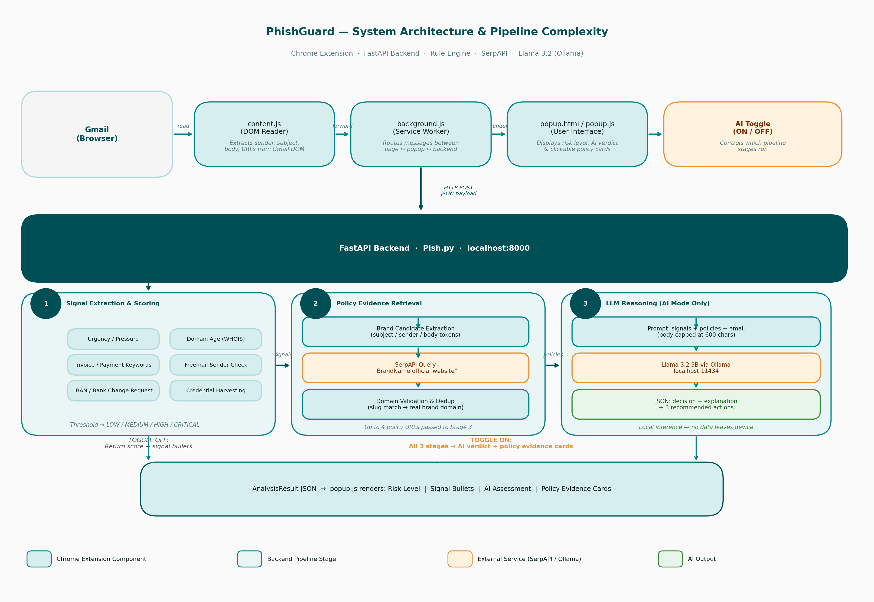

4.3 Signal Extraction and Scoring
The rule engine scores emails across five weighted signal categories: urgency and pressure language, invoice and payment keywords, bank account change requests, phishing language (account suspension, credential prompts) and domain anomalies. Score thresholds map to risk levels: CRITICAL at 10 or above, HIGH at 6, MEDIUM at 3, LOW below that.
Domain analysis runs on both the sender's domain and any URLs in the email body, WHOIS is queried for any non freemail sender (gmail,outlook etc…) a domain under 30 days old adds 3 points to the score, since freshly registered domains are a strong indicator of fraud infrastructure. Freemail senders add 2 points if the email claims to represent a company, because legitimate suppliers use their own corporate domain.

4.4 Policy Evidence Retrieval
When the backend identifies a brand in the email by scanning the subject, sender display name and body for capitalised tokens it looks up the real brand domain not the spoofed one used in the email. An earlier version searched the fraud domain and returned nothing useful the current implementation always queries the legitimate brand. Up to four policy results are retrieved per scan, filtered for relevance against the signal type.
These results are also rendered in the popup as clickable evidence cards under "Policies Used by AI" so the user can read the source policy themselves rather than taking the AI's word for it.

4.5 LLM Integration and Prompt Design
The LLM is served locally via llama 3 on startup, Pish.py checks that llama 3 is running, the prompt passes the sender address, subject, URLs, domain age, triggered signal categories, policy evidence snippets (capped at 120 characters each) and the first 600 characters of the email body. The pre computed risk level and rule engine verdict are deliberately withheld passing them caused the model to echo the filter output rather than reason independently.
The model is instructed to return JSON only with three fields: a decision category, a 2-3 sentence explanation referencing specific signals and policy evidence and three recommended actions. A multi-stage parser handles common failure modes and a plain-text salvage function extracts useful sentences if parsing still fails.

5. Setup Guide
This section provides a complete step by step guide to installing and running PhishGuard locally. The system is intended to run on a standard Windows. No cloud account or paid subscription is required beyond a SerpAPI key.

5.1 Before Starting
Ensure the following are installed on the machine:
• Python 3.10 or higher
• Google Chrome
• Ollama
A SerpAPI key is also required for the policy retrieval stage (free tier: 100 searches/month)

5.2 Installation Steps

Step 1 — Install Python dependencies
Open a terminal in the project folder and run:
pip install fastapi uvicorn requests python-whois

Step 2 — Install and configure Ollama
Download and install Ollama from https://ollama.com/download. Open a terminal and pull the Llama 3.2 3B model:
ollama pull llama3.2:3b
This download is approx. 2 GB, Once complete, Ollama will run automatically in the background.

Step 3 Add your SerpAPI key
Open Pish.py in any text editor. Find the line near the top that reads:
SERPAPI_KEY = "your_key_here"

Step 4 Start the backend server
In a terminal, navigate to the project folder and run:
uvicorn Pish:app --host 127.0.0.1 --port 8000 --reload
You should see output confirming the server is running on http://127.0.0.1:8000. The backend must be running for the extension to work.

Step 5 — Load the Chrome Extension
1. Open Google Chrome and navigate to chrome://extensions/
2. Enable Developer Mode using the toggle in the top right corner.
3. Click "Load unpacked" and select the phishguard folder from the project directory.
4. The PhishGuard icon will appear in the Chrome toolbar.

5.3 Running the System
Once the backend is running and the extension is loaded:
1. Open Gmail in Chrome and navigate to any email.
2. Click the PhishGuard icon in the toolbar.
3. The popup will display the risk level and signal bullets (toggle OFF mode).
4. Enable the AI toggle in the popup to run the full three stage pipeline. The first AI scan will take 4-8 seconds while Llama generates a response.
5. In AI mode, the popup shows the AI's verdict and clickable evidence cards linking to the real brand's published policies.

5.4 Troubleshooting
Ollama not running" error in popup
Ensure Ollama is installed and the llama3.2:3b model has been pulled.
Run: “ollama list” you should see llama3.2:3b in the output.

“No policies found” for a brand
Check your SerpAPI key is correct in Pish.py.
Free tier allows 100 searches/month, check your usage at serpapi.com/dashboard.

Backend not responding
Confirm the uvicorn server is running in a terminal.
Navigate to http://127.0.0.1:8000/docs — you should see the FastAPI docs page.

Extension not appearing in toolbar
Pin the extension: click the puzzle icon in Chrome toolbar click the pin next to PhishGuard.

6. Project Deliverable

6.1 Extension Interface
The PhishGuard popup is the primary user facing component. In rule engine mode (toggle off), it displays a colour coded risk badge (LOW / MEDIUM / HIGH / CRITICAL), a list of triggered signal categories explaining what the rule engine found and the sender domain details. In AI mode (toggle on), the signal bullets are hidden and replaced with the AI's natural language verdict, 2-3 sentence assessment that references specific policy evidence followed by three recommended actions and a set of clickable policy evidence cards.
The toggle's visual design was intentional: switching between modes on the same email makes it immediately visible that the modes have changed. A user can see exactly what the rule engine catches and what the AI adds on top.

6.2 Technologies
• Python / FastAPI - backend pipeline and REST API
• JavaScript - Chrome extension (content.js, background.js, popup.js)
• Llama 3.2 3B via Ollama - local LLM
• SerpAPI - real-time web search for brand policy pages
• whois - domain registration age lookup
• HTML / CSS - popup UI and extension interface

7. Evaluation and Testing

7.1 Standard Phishing test
The standard test consists of six emails: four phishing variants and two legitimate control emails. The phishing samples cover CEO invoice fraud, an IT credential harvesting request, a supplier payment redirect and a PayPal brand impersonation using a spoofed domain.
With the toggle off, the rule engine correctly flagged all four phishing emails at HIGH or CRITICAL risk and classified both legitimate emails as LOW. With the toggle on, the AI added grounded assessments to each result. For the PayPal impersonation email, the model's verdict referenced PayPal's published security policy fetched from paypal.com by SerpAPI noting the direct contradiction between PayPal's stated policy of never requesting credentials by email and what the email was asking for.

7.2 Filter Bypass test
The filter bypass test is the more revealing test, four emails were constructed to score zero on the rule engine: no keyword hits, corporate looking sender domains, and no URLs. The emails were a CEO gift card request, an IT helpdesk credential request using language outside the keyword list, a supplier redirect and a payroll notification diverting salary to a new account.
With the toggle off all four showed LOW risk with no flags exactly as designed. With the toggle on, the AI correctly identified the attack pattern in every case. The payroll notification was flagged as a diversion attack, with the model correctly identifying the "disregard if not you" line as a social engineering technique designed to suppress the recipient's instinct to query the change.

7.3 Limitations
The tests are small and synthetic, which is the most significant limitation of this evaluation. A rigorous assessment would need a labelled dataset of real BEC emails and formal precision, recall, and F1 metrics rather than a pass/fail result across ten emails. The Llama 3.2 3B model is considerably smaller than the frontier models and its tendency toward malformed JSON required substantial prompt engineering and a multi-stage parser to handle reliably.
LLM inference adds 4-8 seconds which could affect usability in practice. SerpAPI policy retrieval also depends on the impersonated brand appearing explicitly in the email text as a recognisable token, unknown or obscure brands may receive no policy evidence.

8. General Issues

8.1 Problems Encountered
The most persistent problem throughout development was brand detection reliability in the policy retrieval stage. An early version used a hardcoded dictionary of brand names mapped to their domains which worked for known brands but not for smaller brands. Replacing this with a dynamic pipeline extracting individual capitalised tokens from the subject line passing each through SerpAPI and validating that the returned domain slug matches the brand name produced a more general solution but still could be improved on.
A second problem was the LLM producing malformed JSON markdown code fences around the output block, single quotes, trailing commas. Each of these was handled using parsing and a plaintext salvage path was added for cases where parsing still failed after all cleanup steps.

8.2 Achievements
• Fully functional Chrome extension integrated with Gmail, passing real DOM content to a local backend.
• Dynamic brand detection pipeline replacing a hardcoded list, the system can now identify brands it has never seen before.
• Four emails correctly classified by the AI despite scoring zero on the rule engine.
• Clickable policy evidence cards giving the user a way to independently verify the AI's assessment.
• Privacy preserving architecture so no email content leaves the device.

9. What I Learned

9.1 Learning Outcomes
The biggest technical lesson from this project was how much behaviour falls between the rules. Writing the four emails that are phishing attacks but score zero on the rule engine showed that rule based systems can only catch what they've been explicitly told to look for. The moment an attacker writes around the keyword list, the filter is structurally blind and it's a fundamental limitation of the approach.
I also learned a lot about the practical gap between what a language model can do in principle and what it reliably does in production. Llama 3.2 3B is capable of contextual reasoning over email text, but its output format is inconsistent enough that a significant amount of development effort went into parsing and salvaging its responses. The 8B model is noticeably more reliable
Working with SerpAPI for real time policy retrieval taught me how much depends on the quality of a web search query getting the brand name wrong even slightly returns completely irrelevant results. The domain validation step was essential to prevent the system from using unrelated pages as evidence.

10.Conclusion
PhishGuard delivers a functional Chrome extension that implements a three-stage BEC detection pipeline inside Gmail. The system demonstrates in two distinct ways that AI augmentation adds real value beyond rule based analysis.
The policy retrieval stage is the key architectural differentiator by fetching real fraud warning and payment policy pages from the impersonated company's website and passing them into the LLM prompt, the system produces assessments backed by verifiable evidence rather than pattern matching alone. The user sees not just a risk level but a reasoned explanation and the source policies behind it

